ADF:

It’s a cloud ETL and data integration services

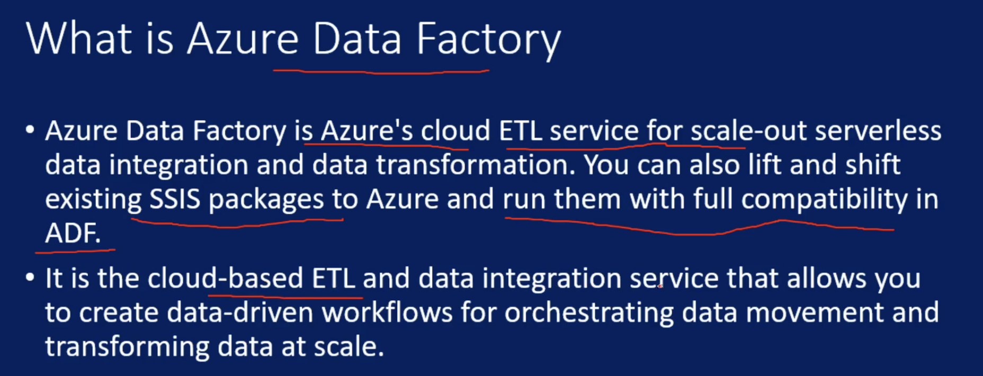

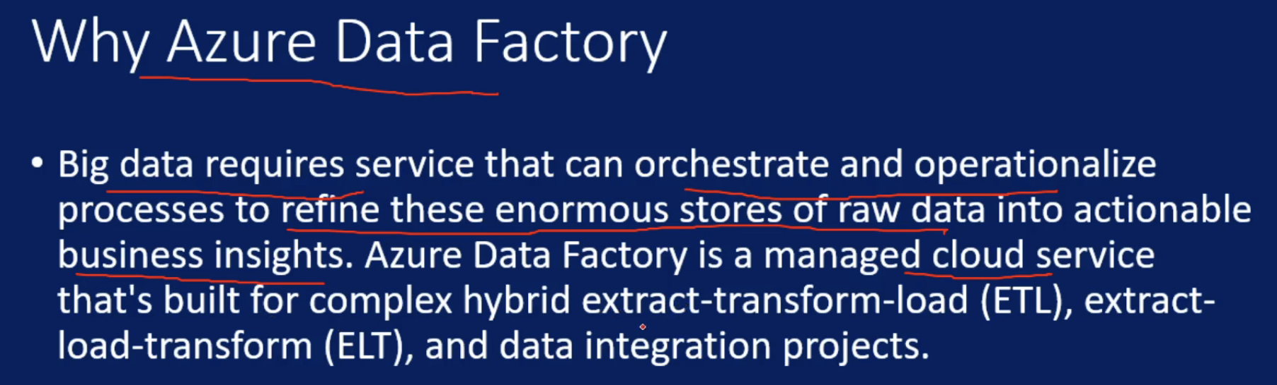

Different ways to work with ADF:

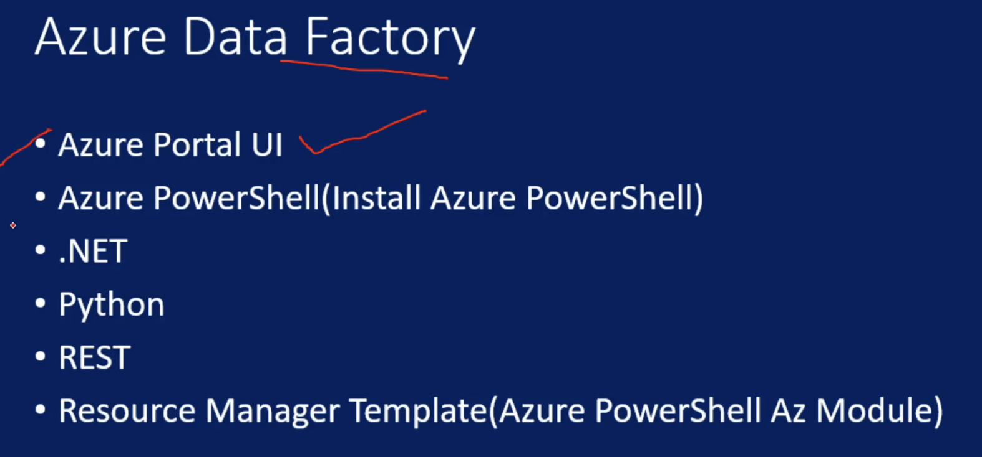

Pipelines & activity:

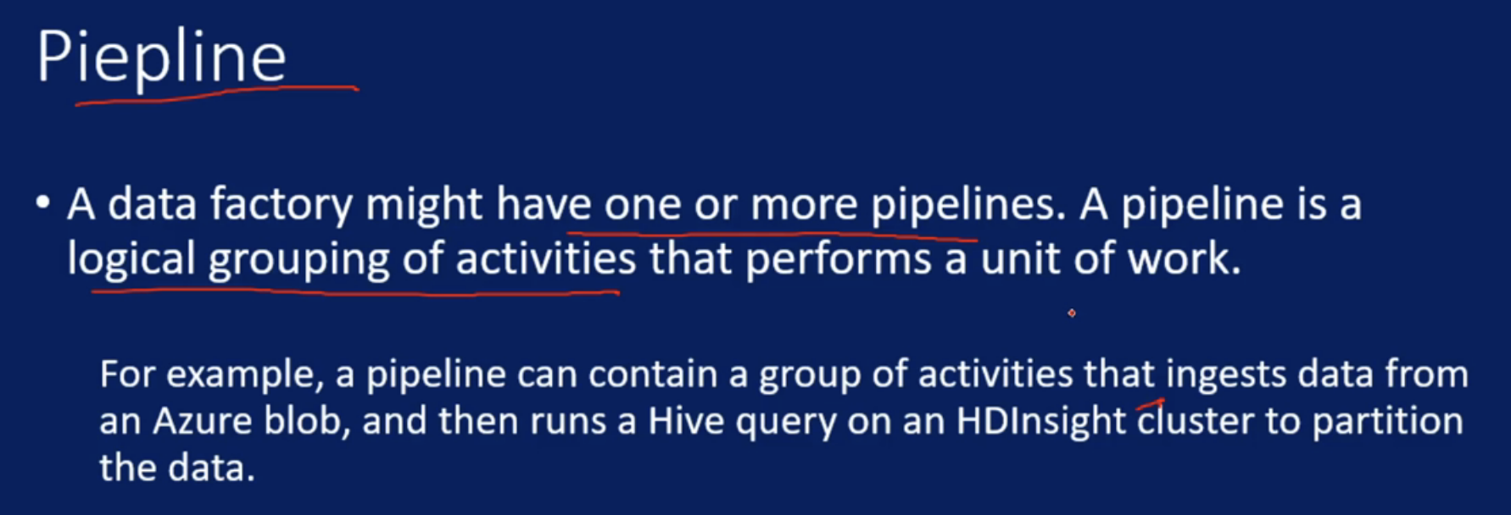

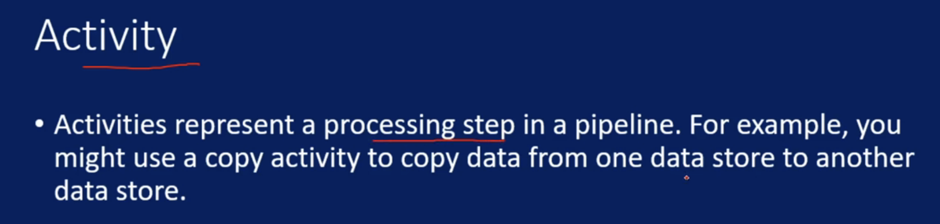

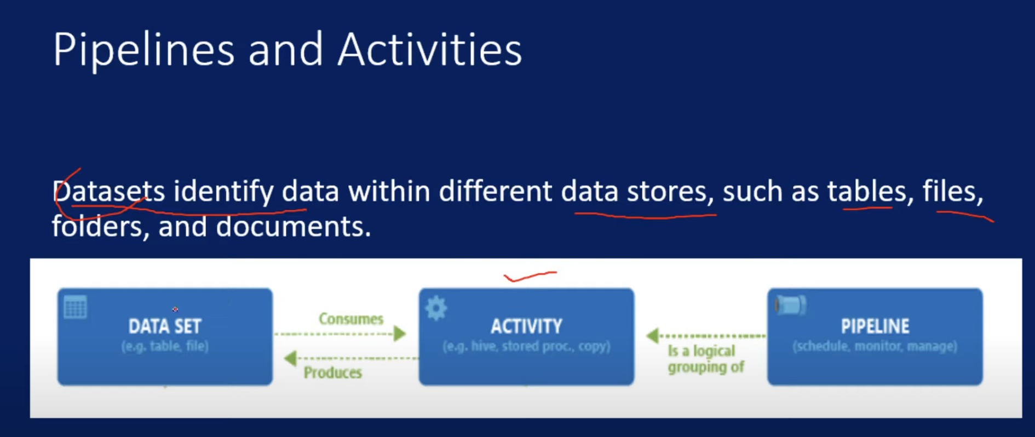

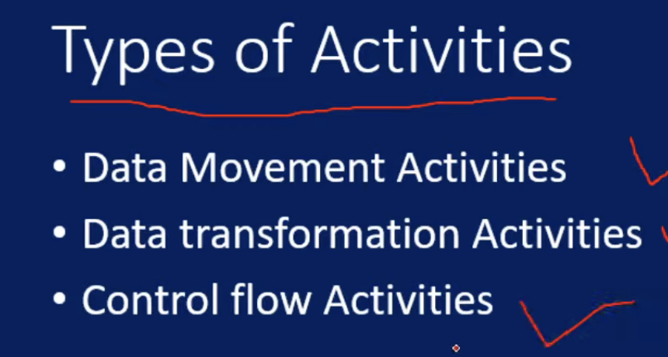

Linked Services & Datasets:

We have around 65 datasources supported

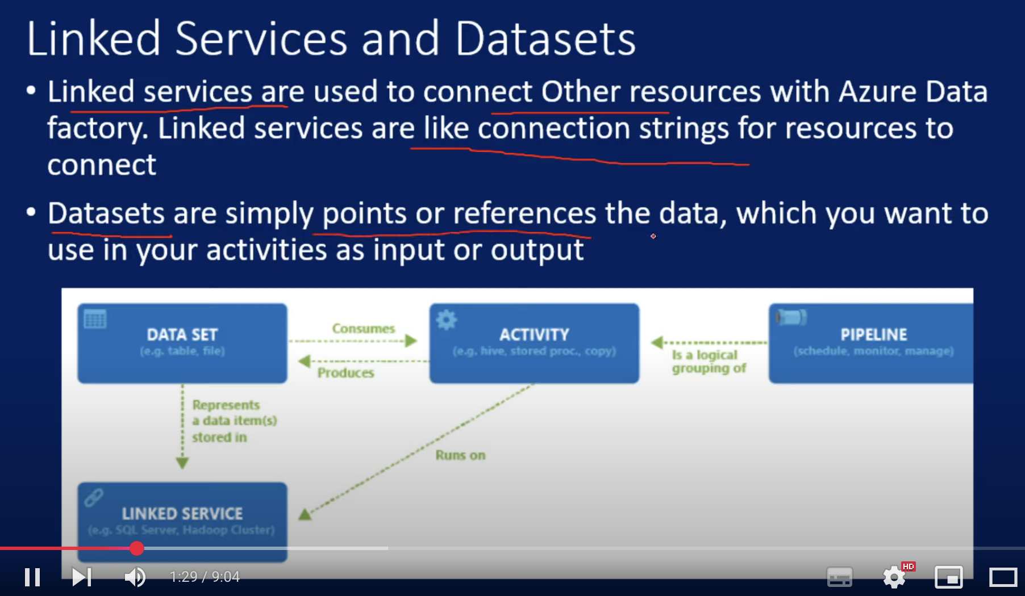

Triggers:

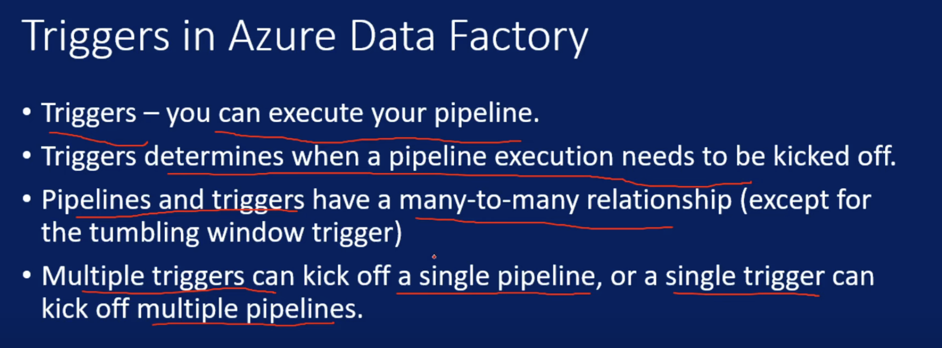

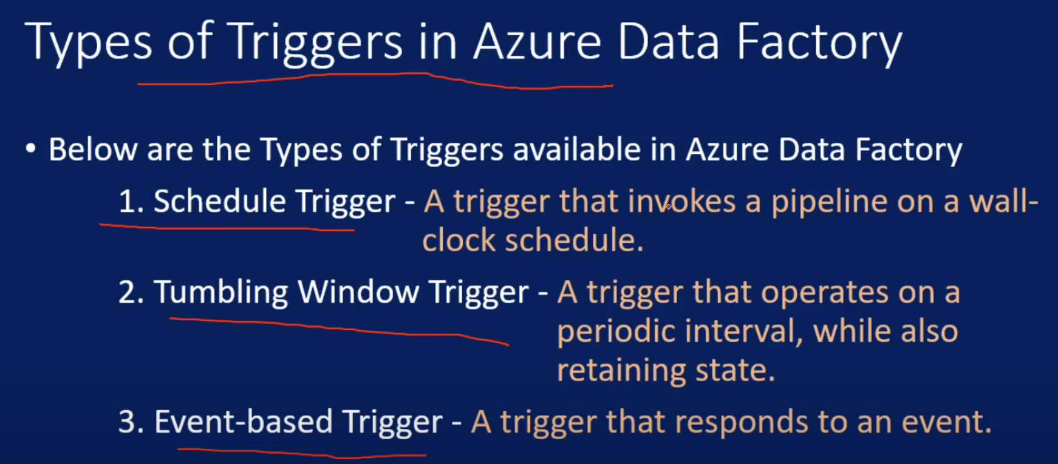

Schedule Trigger:

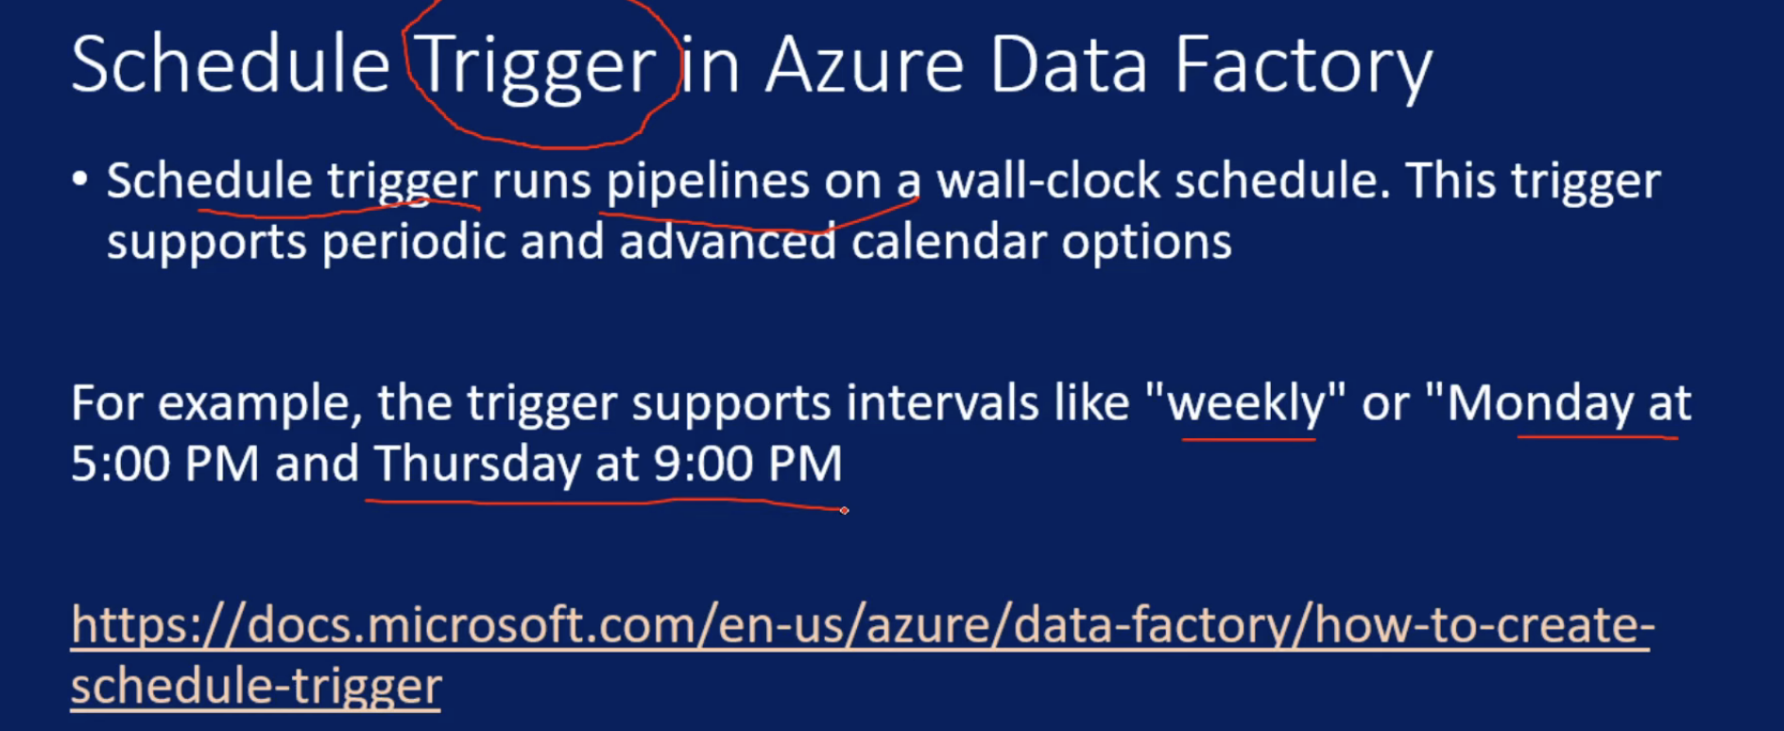

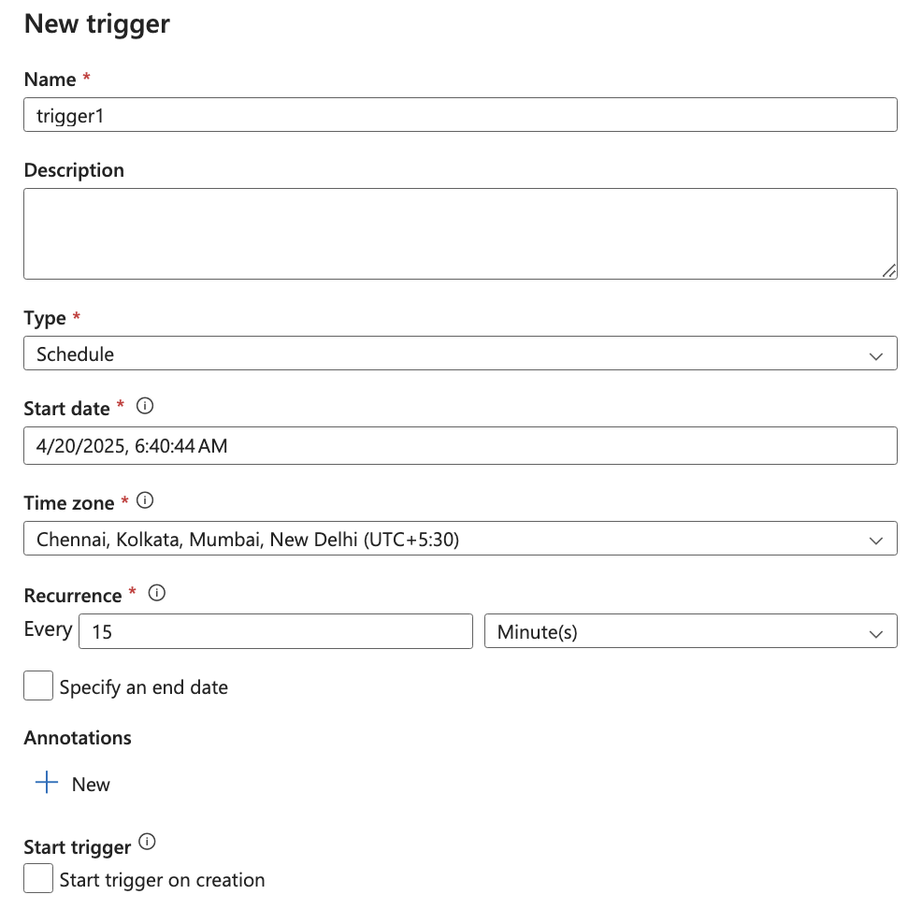

Tumbling Window Trigger:

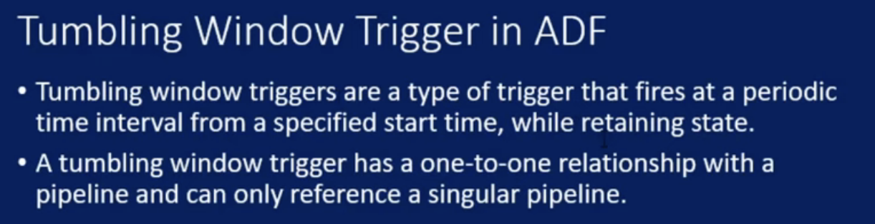

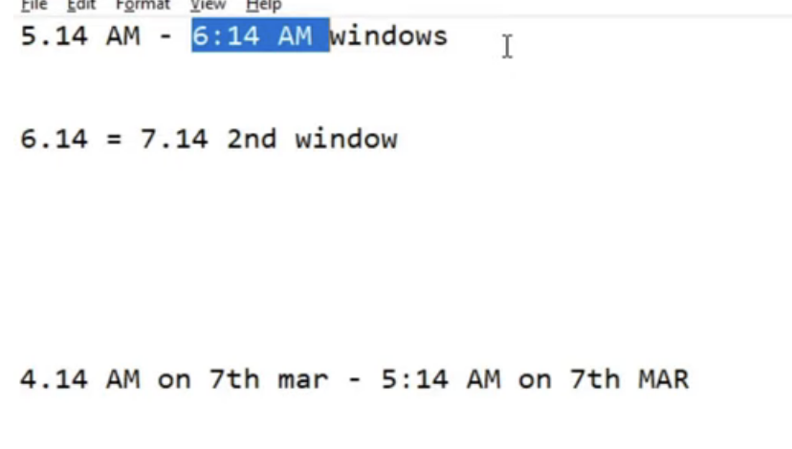

Here it creates window and each run will start at the end

Tumbling will work for historical days as well

We can add delay for each run and for historical run, I can set concurrency and we can set retry

| **Feature** | **Schedule Trigger** | **Tumbling Window Trigger** |
| --- | --- | --- |
| **Purpose** | Triggers pipelines at specified times, like a cron job. | Triggers pipelines in a recurring, interval-based fashion where each window is processed sequentially. |
| **Triggering behavior** | Starts the pipeline at the scheduled time, even if previous runs are still ongoing. | Waits for the previous window's pipeline to complete before triggering the next. Ensures ordered execution. |
| **State awareness** | Stateless — doesn’t track the state of runs. | Stateful — tracks the state and success/failure of each window. |
| **Use case** | Ideal for simple, periodic jobs that don't depend on data slices or past execution. | Ideal for time-sliced data processing (e.g., hourly file ingestion), where window-based consistency matters. |
| **Retry behavior** | No built-in retry for missed runs (e.g., if ADF is paused). | Can retry missed windows when pipeline fails or after outages. |
| **Concurrency** | Can have multiple overlapping runs. | Ensures one run per window at a time — no overlap. |
| **Dependency support** | No support for dependency between windows. | Supports dependency chaining between tumbling windows. |
| **Late data handling** | Not designed for late data. | Supports late arrival with “retry” and “delay” settings. |

Tumbling window Trigger Dependency:

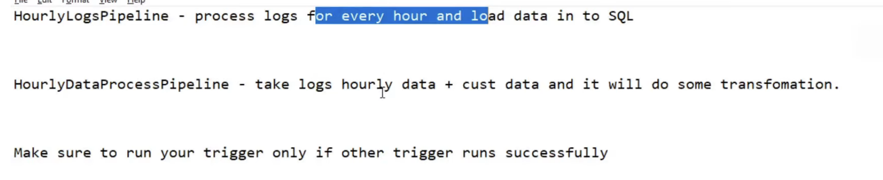

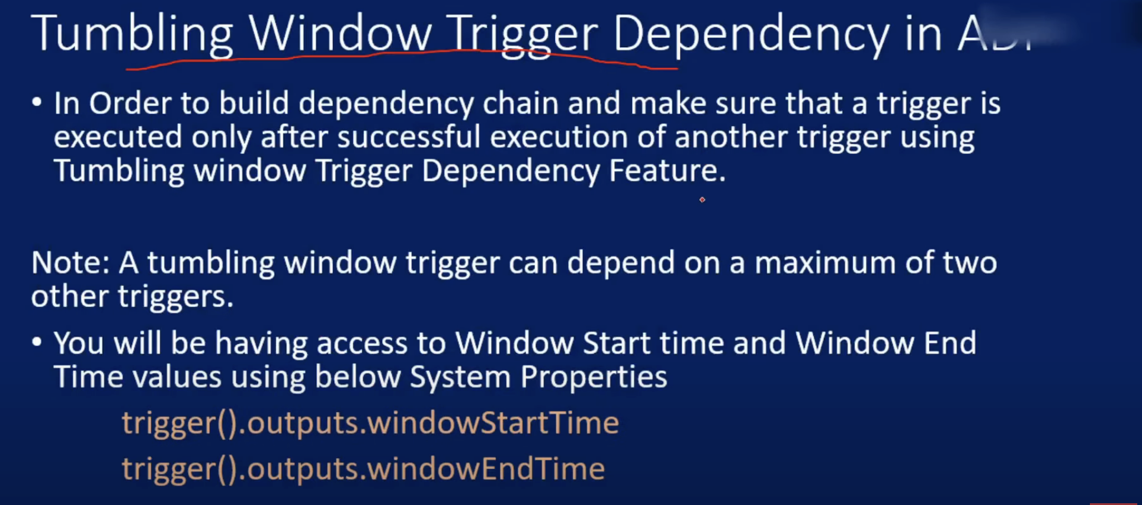

Offset:

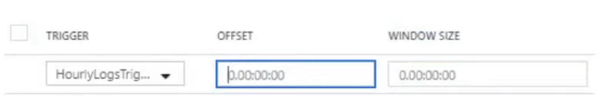

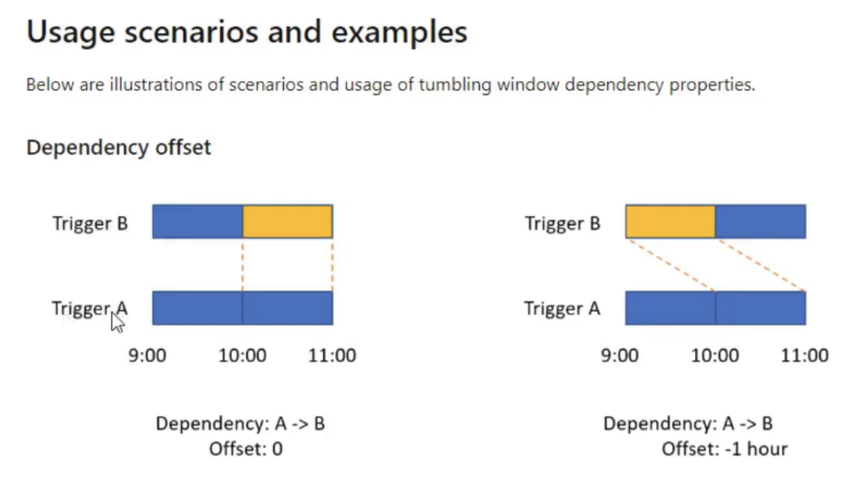

windowSize:

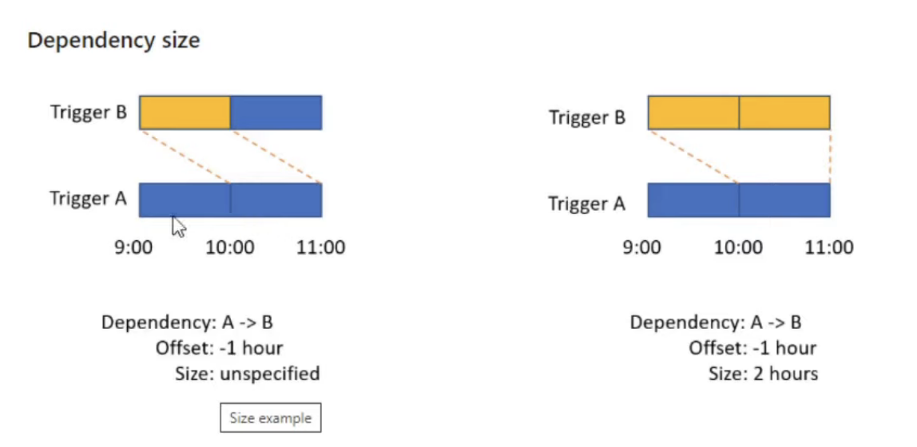

Self Depedency:

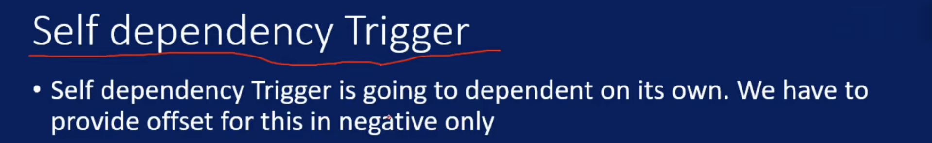

For self dependency offset is mandatory

Event Based Trigger:

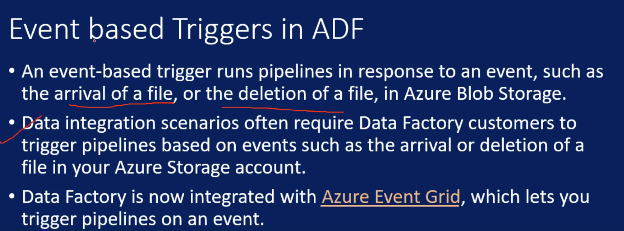

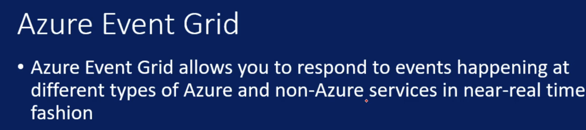

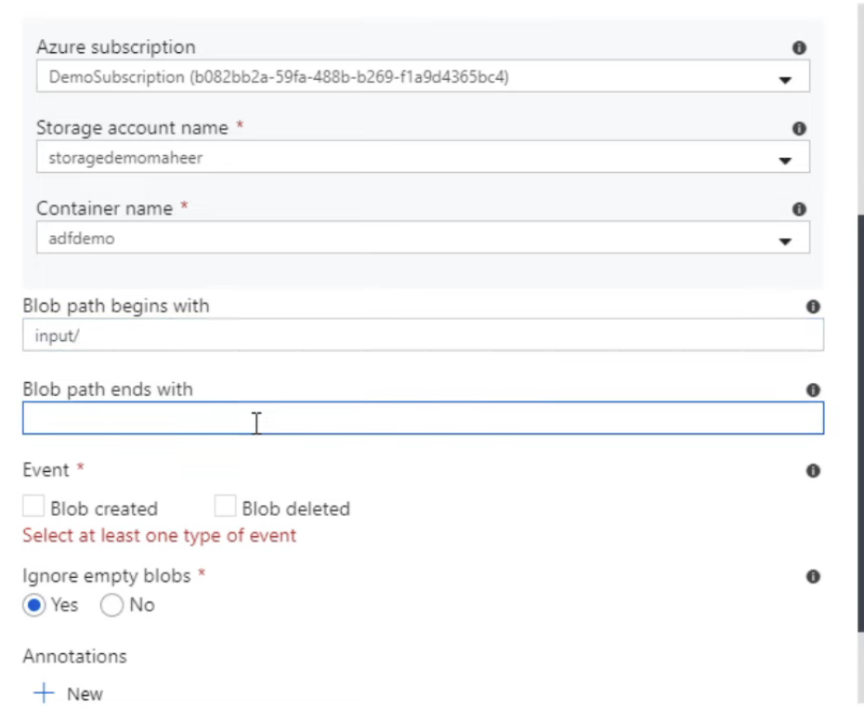

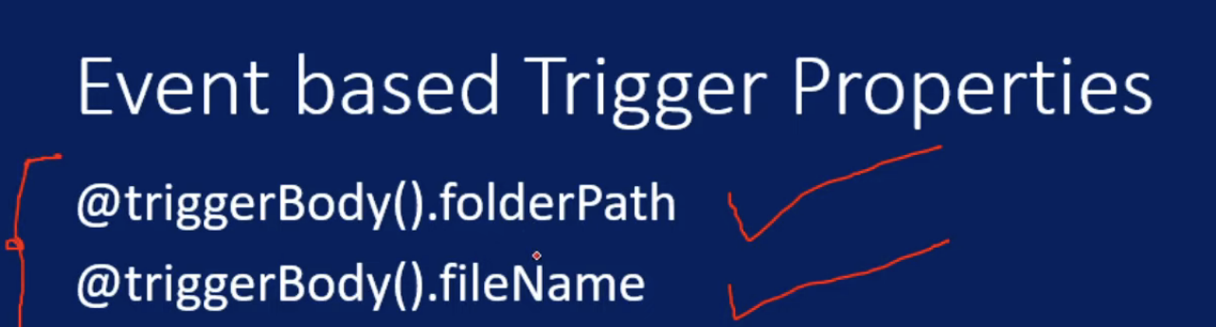

Integration Runtime:

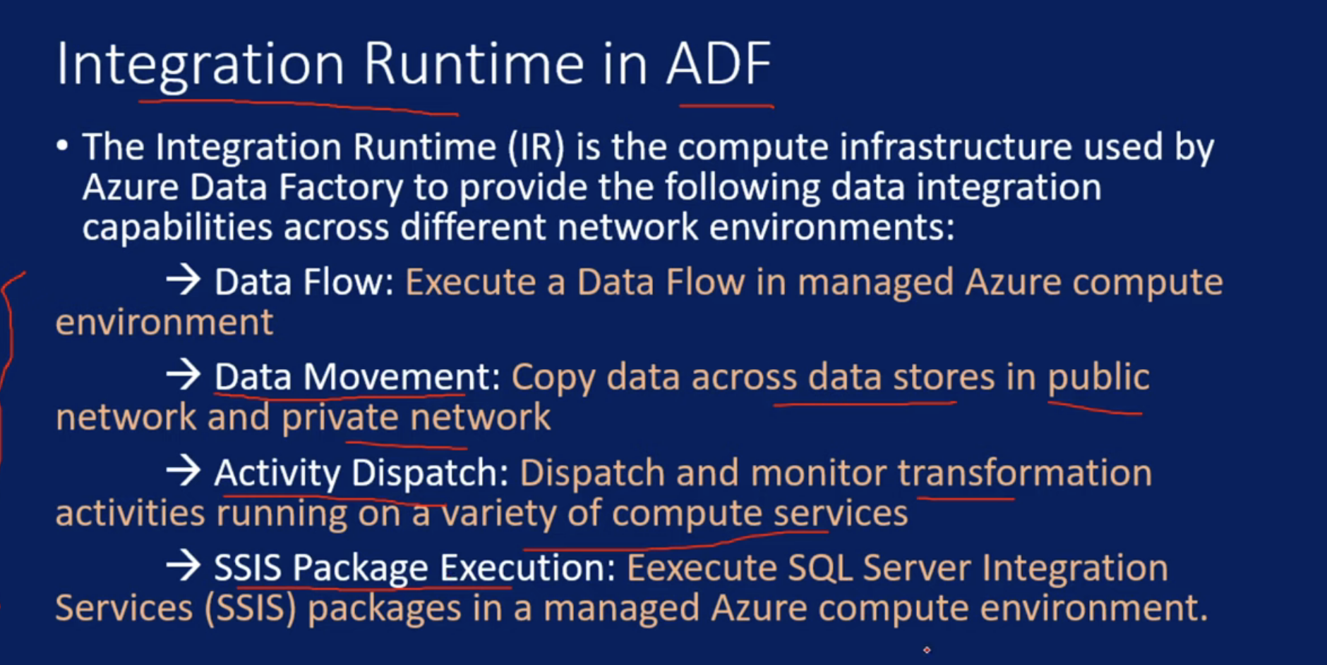

Integration Service acts as bridge between linked service and activity

Under linked service we will find Integration Service

Activity and Linked services uses Integration runtimes to perform tasks

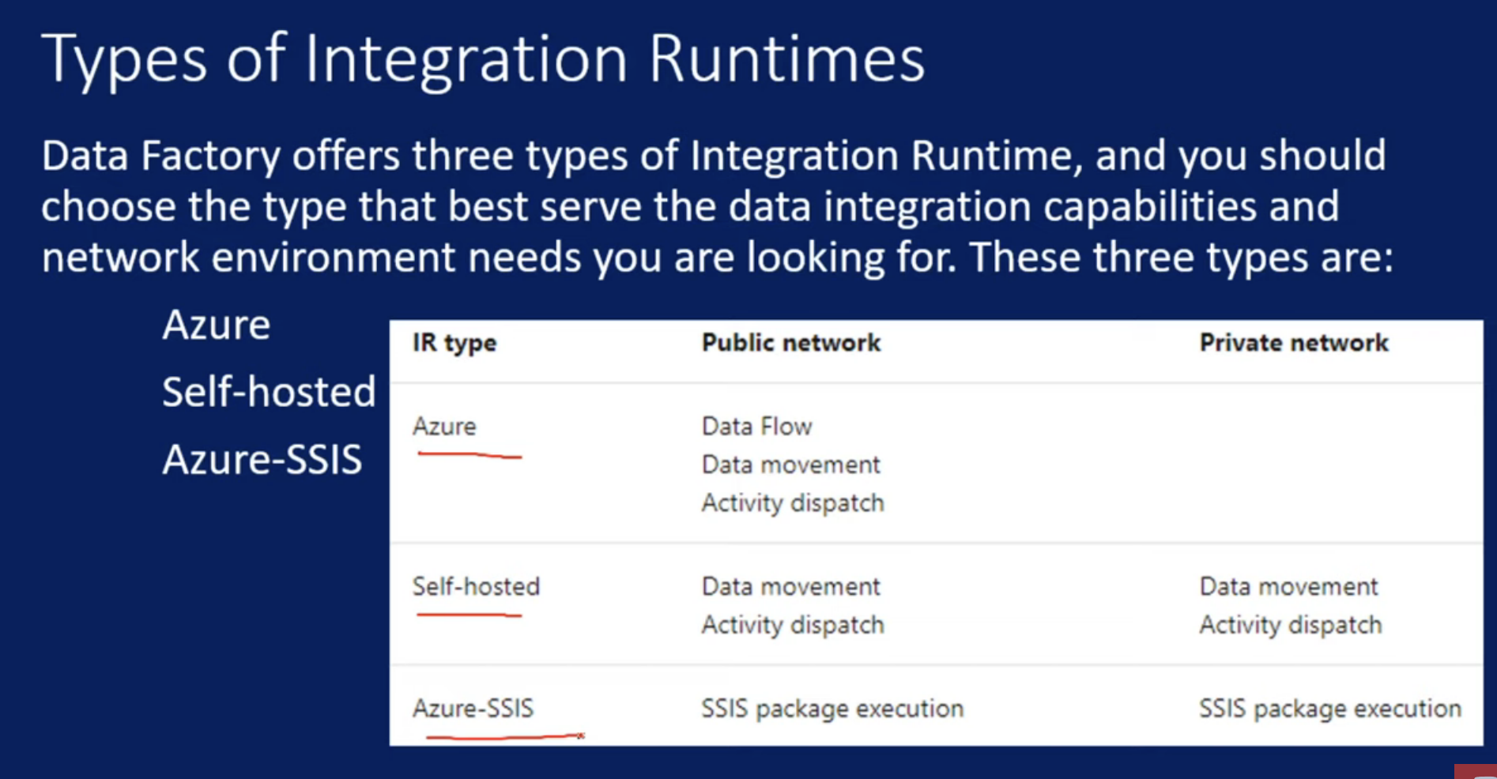

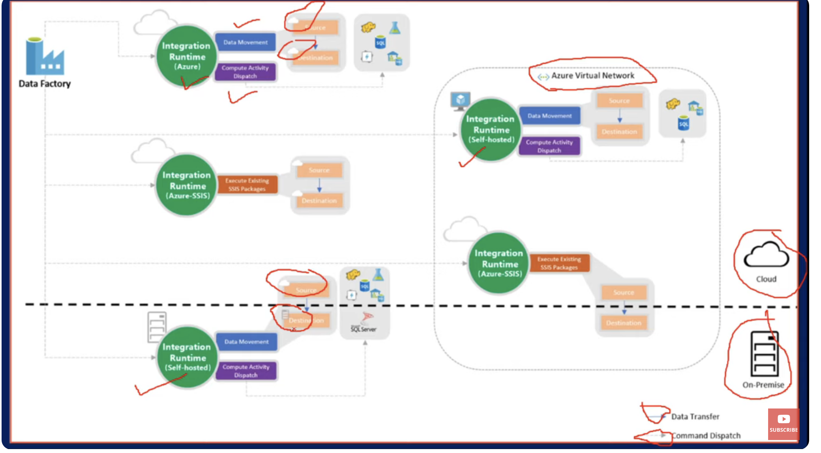

If my source and destination is on azure cloud then we can use Azure Integration runtime

If resources belong to private network then we can use selfhosted

If source is on cloud and destination on on-prem we can use self hosted

IR SSIS we can use in executing existing SSIS packages

Azure Integration Runtimes:

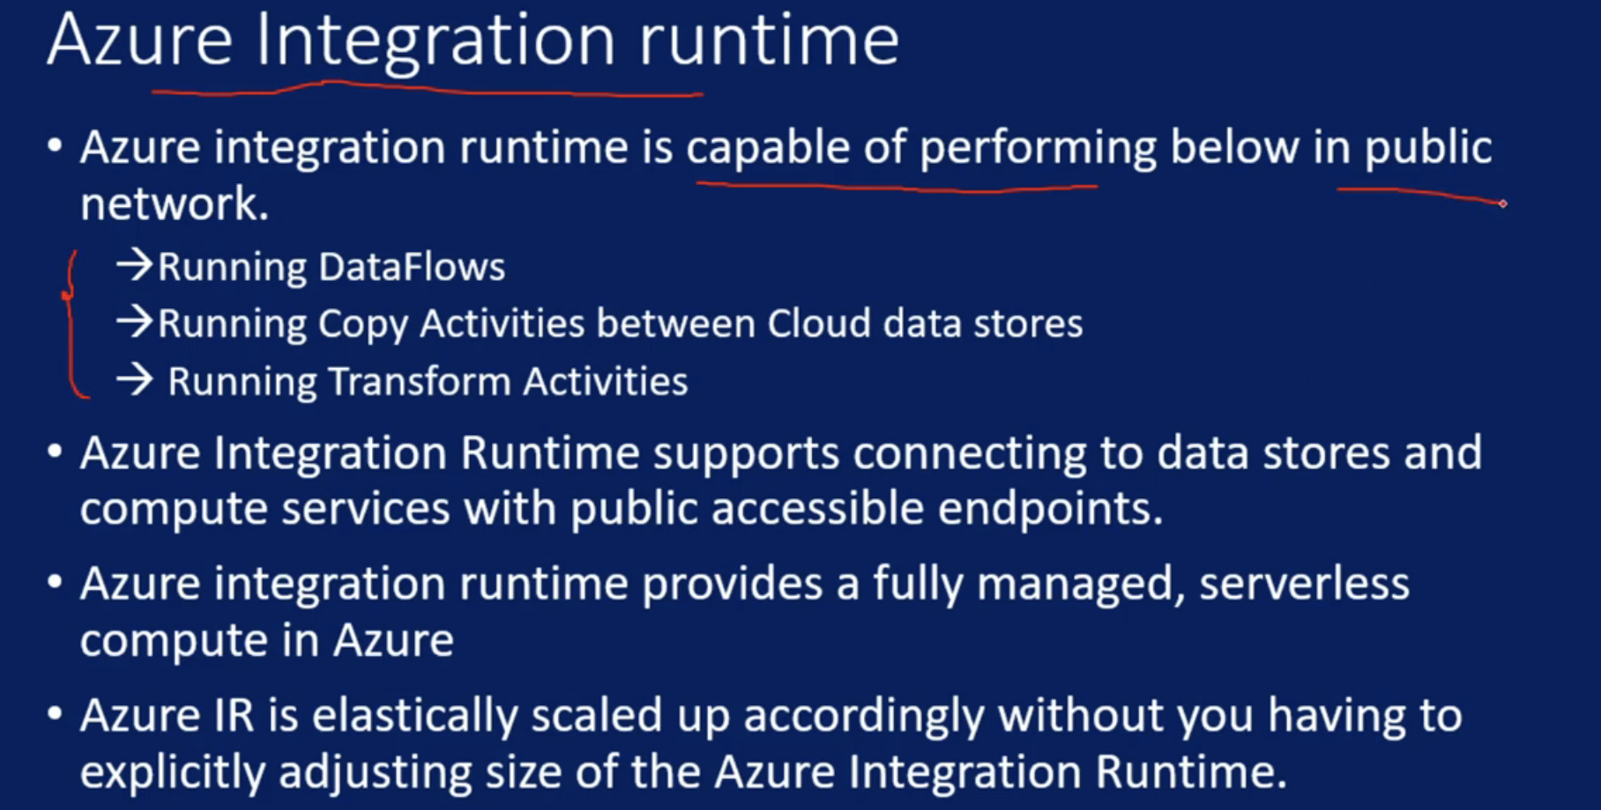

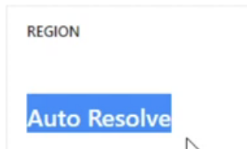

Region is auto resolve since IR will be created based on the location automatically

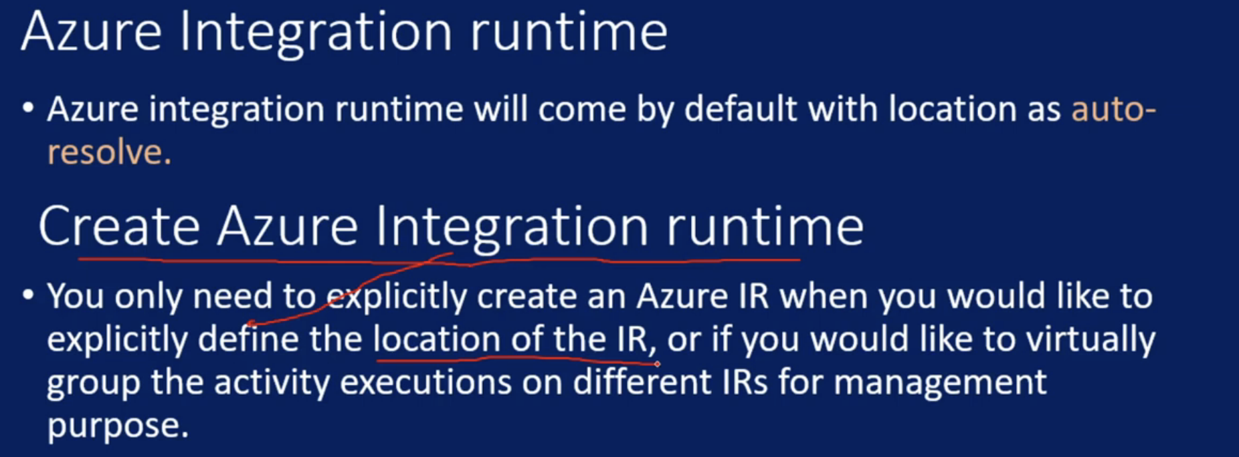

Self Hosted Integration Runtimes:

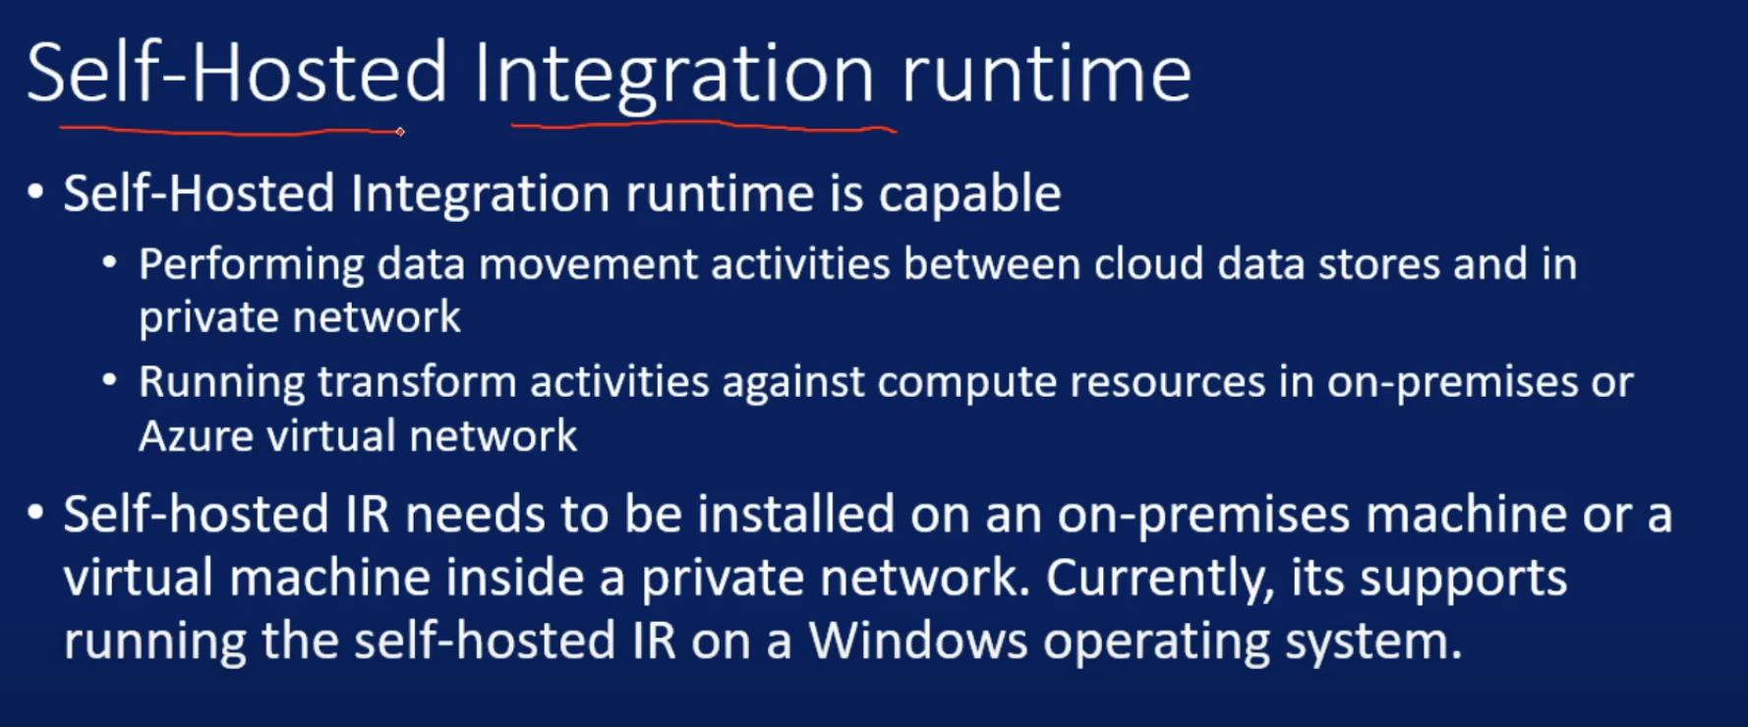

Suppose I want data movement from on-prem to cloud or viceverse or on-prem to on-prem then I need to setup self-hosted IR on on-prem

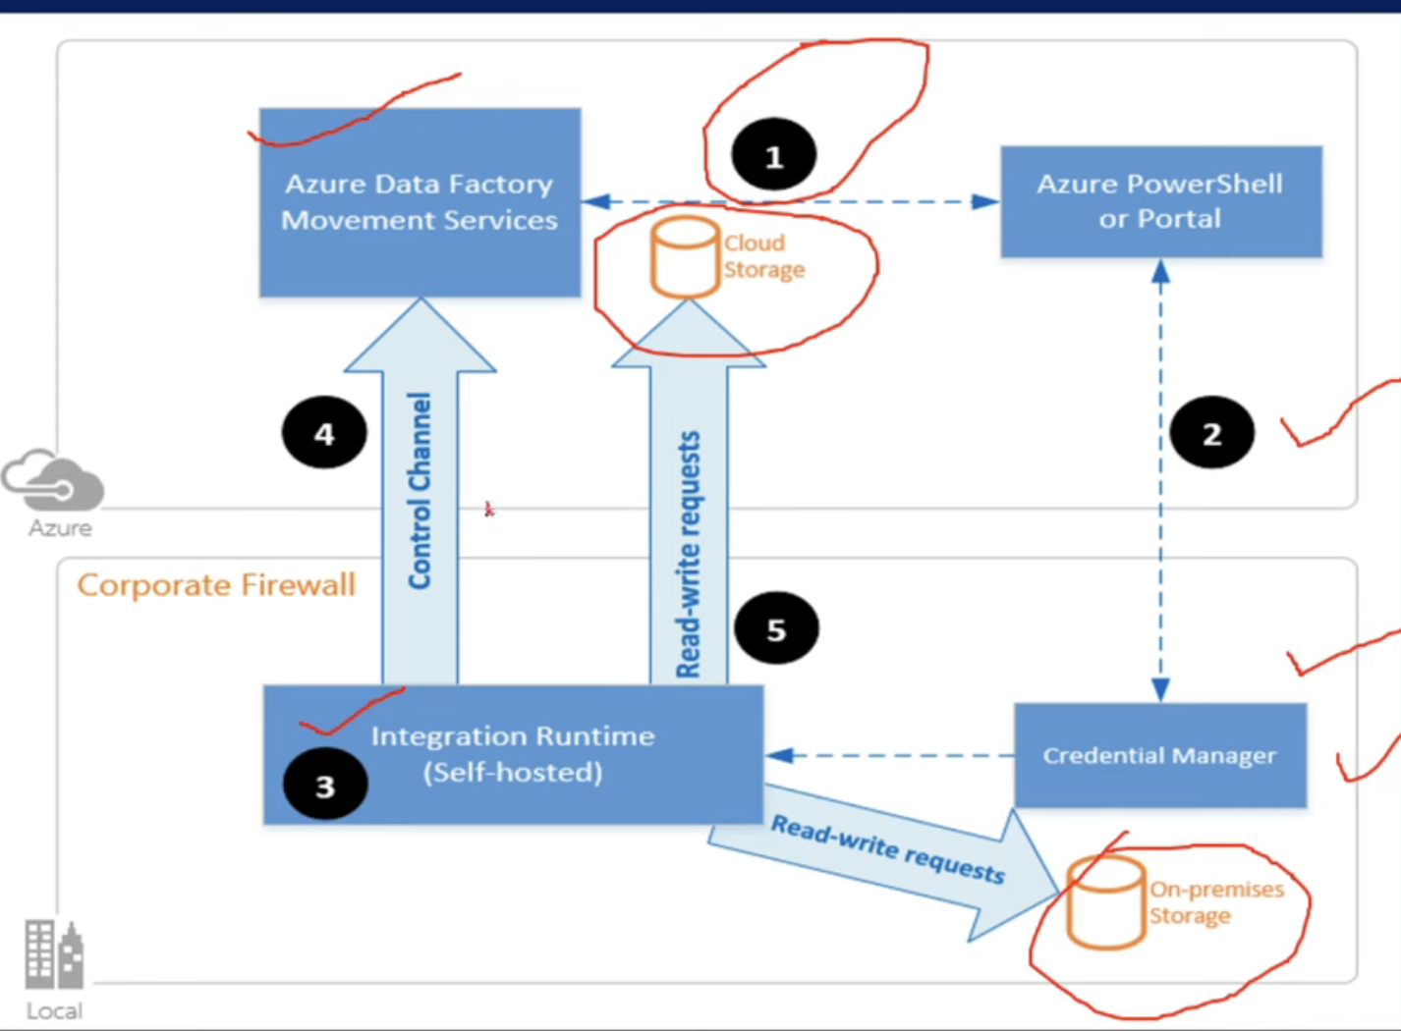

Shared Self Hosted Integration runtime in ADF:

Earlier for every ADF we need to setup IR, but now we have shared option where can I create one self hosted IR and share it across all ADF

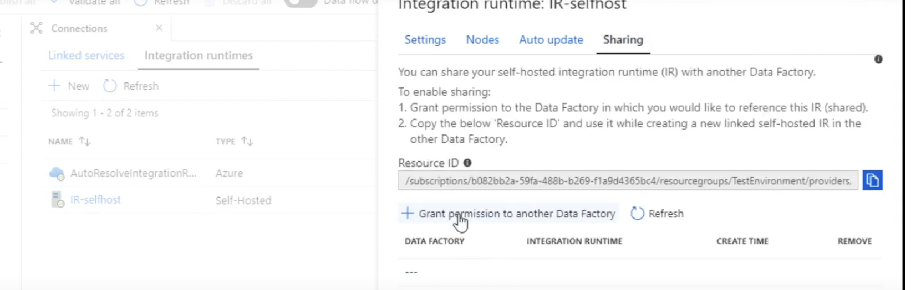

Parametrize Linked Service:

Suppose I have 10 DB then I might end up doing 10 Linked service, to avoid we can use parametrize it

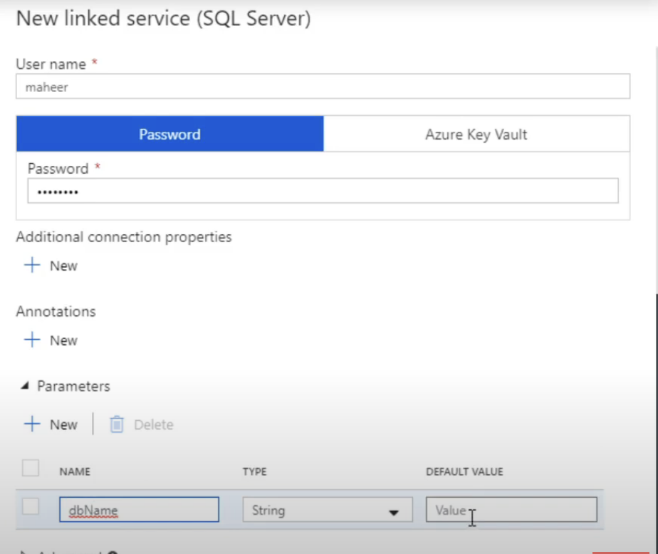 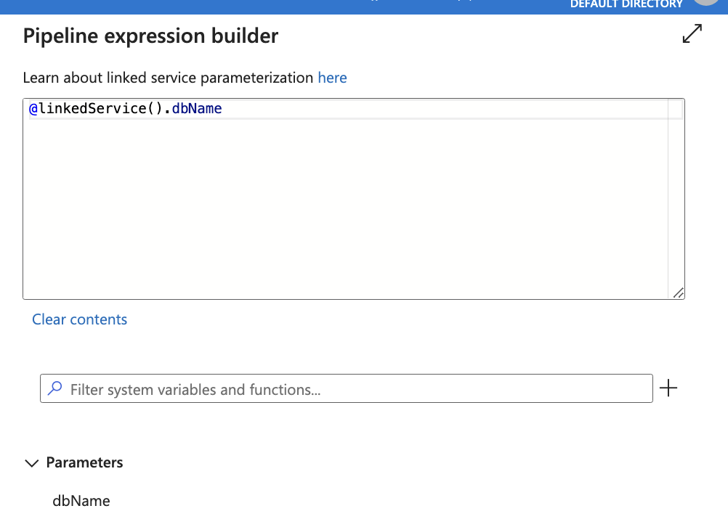

Parametrize Dataset in ADF:

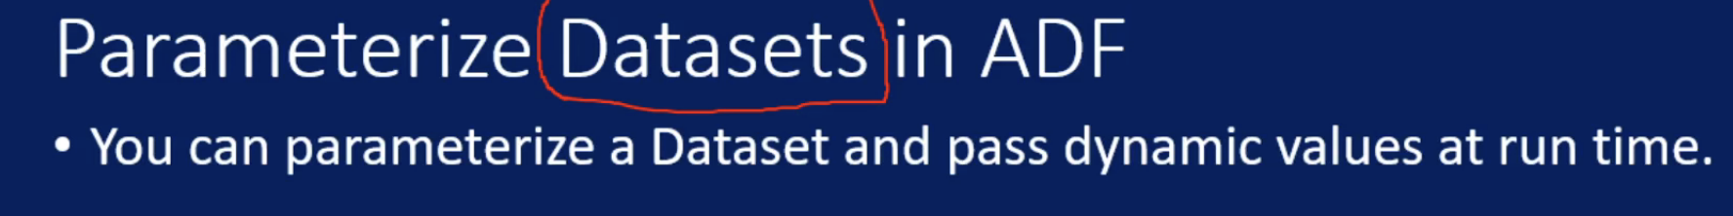

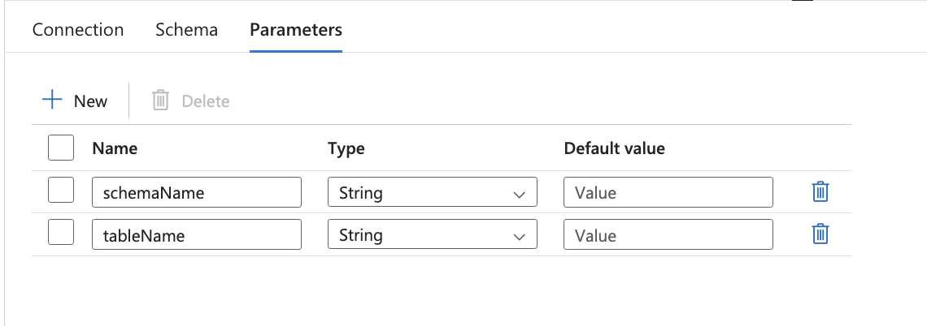



Parametrize Pipelines in ADF:

Let us take a scenario where we want to copy data from one table to another using ADF

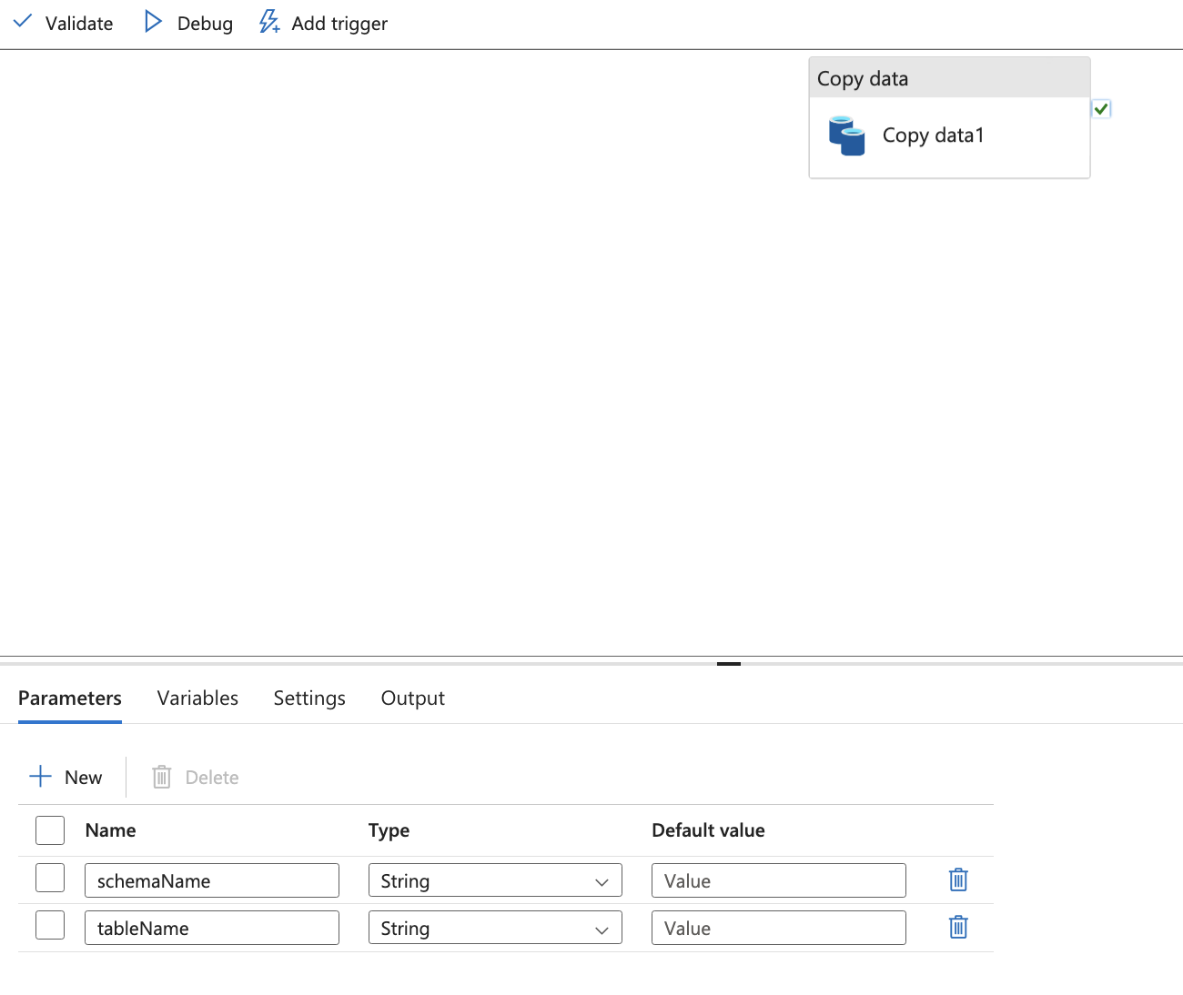

Click outside activity and add paramters

Trigger -> Pipeline -> dataset -> linked_service

System Variables:

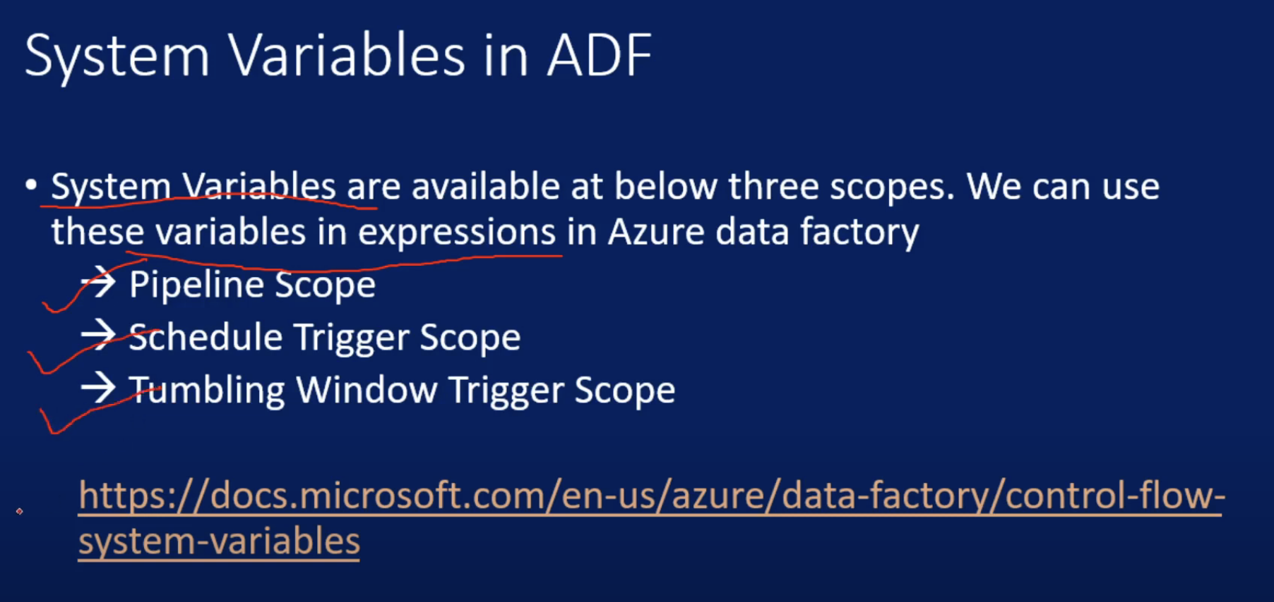

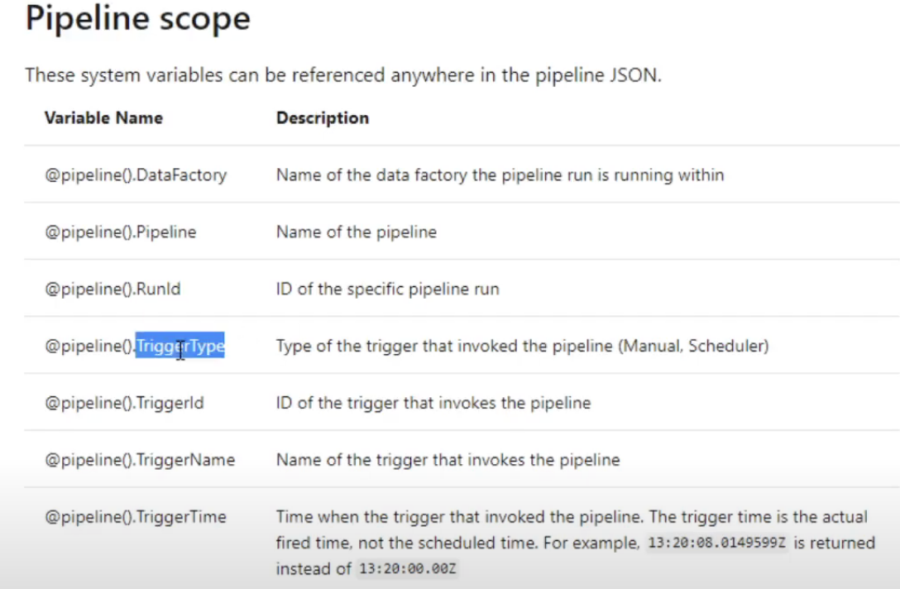

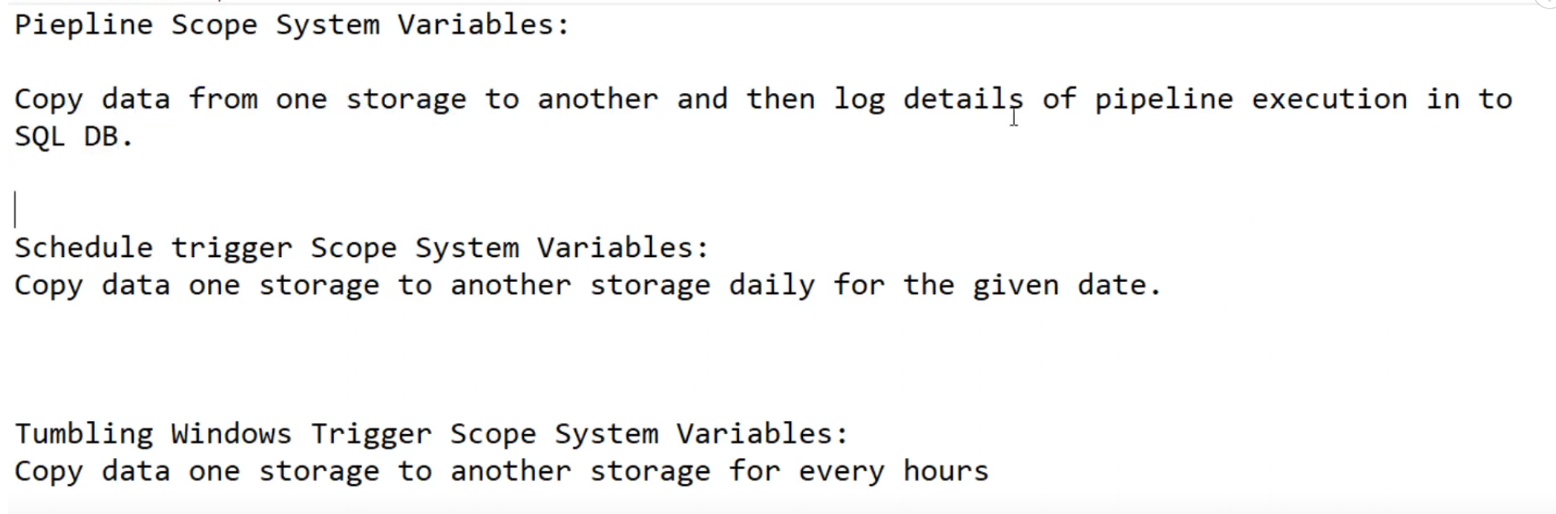

Connecttors:

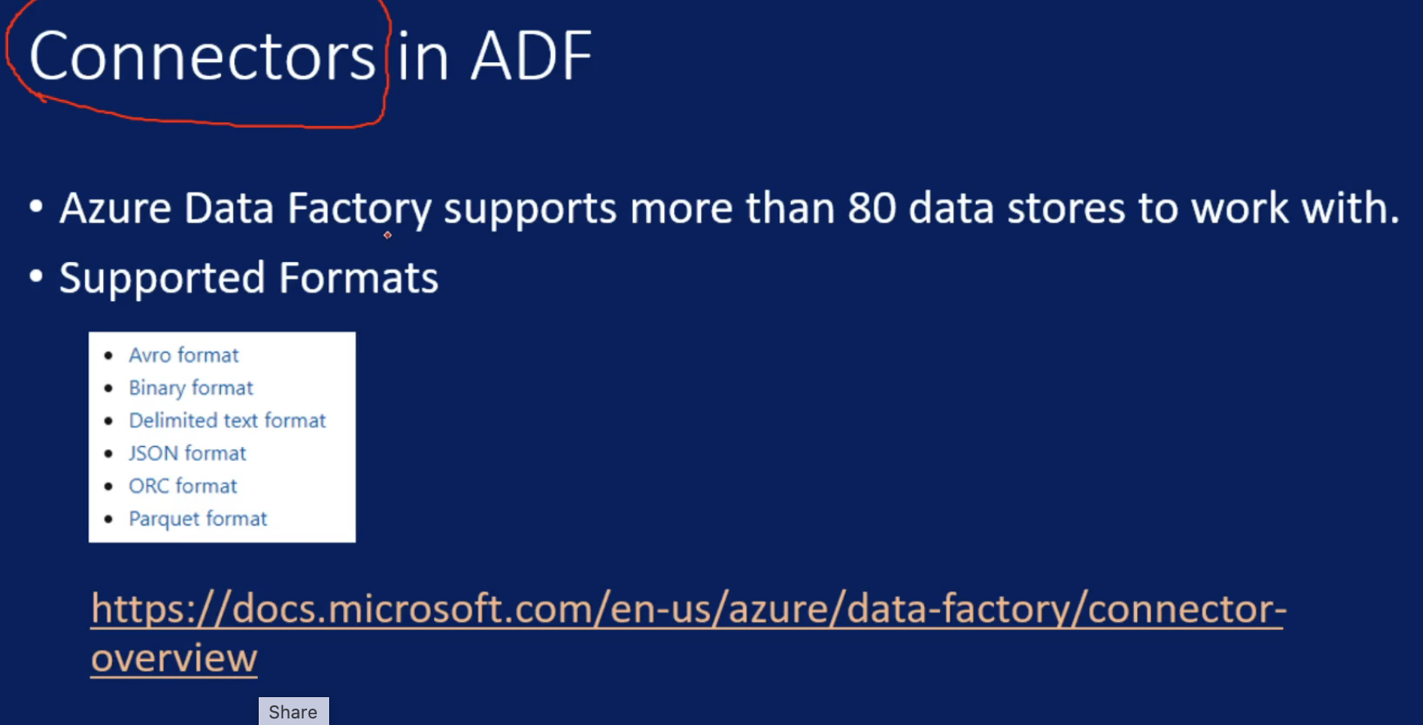

Supported File Format:

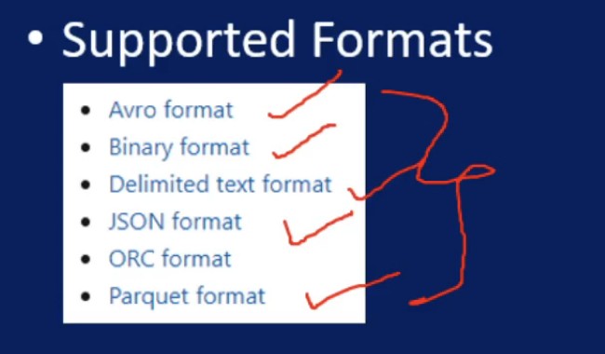

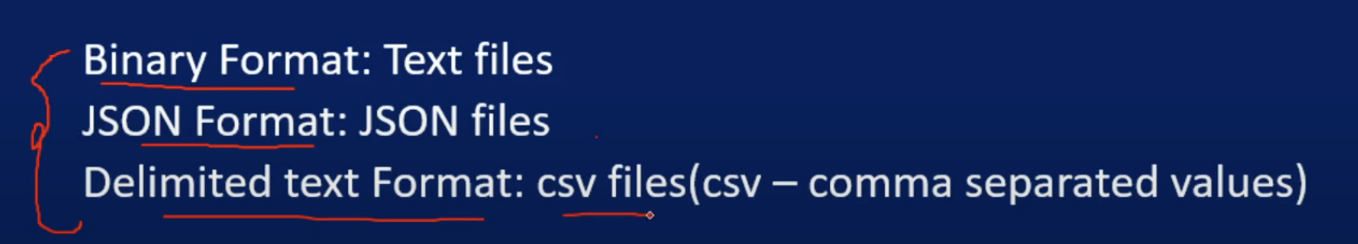

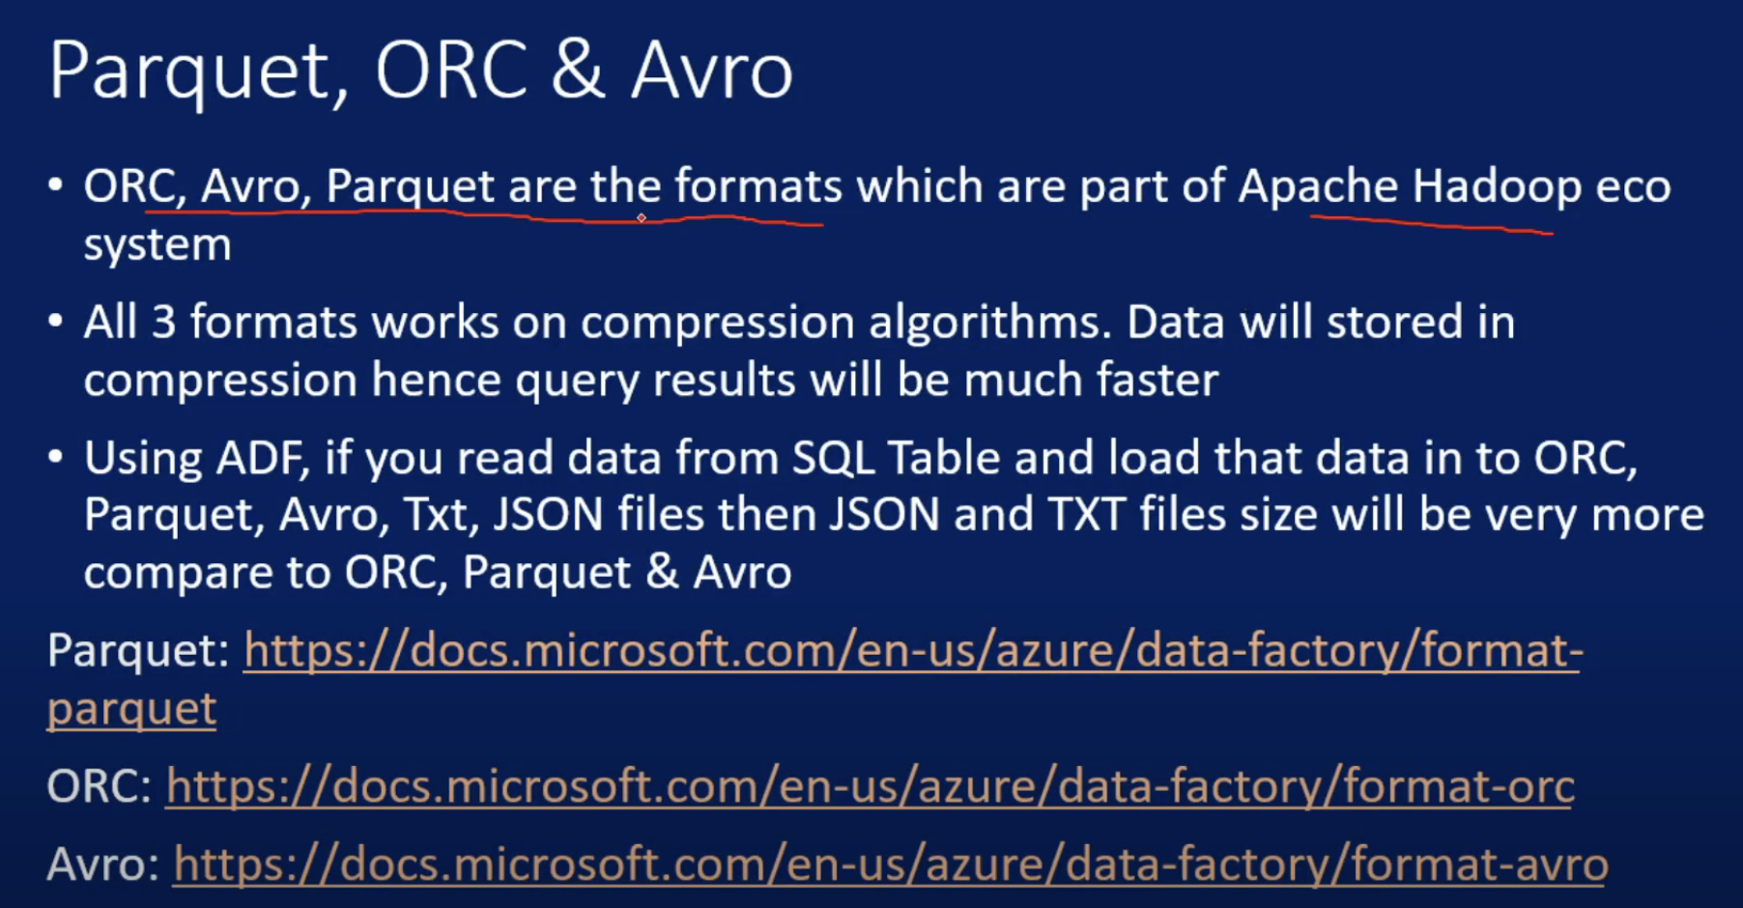

Copy Activity:

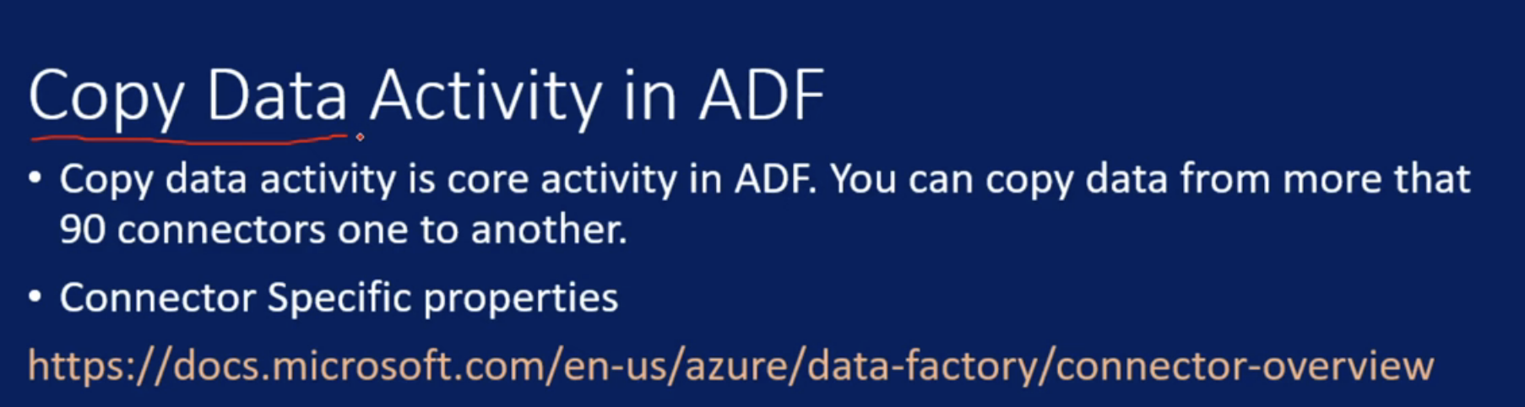

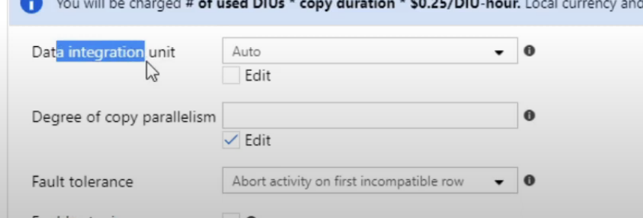

DI Units is nothing but resource configuration to run data activity

Parallelsim is more like a parallel threads

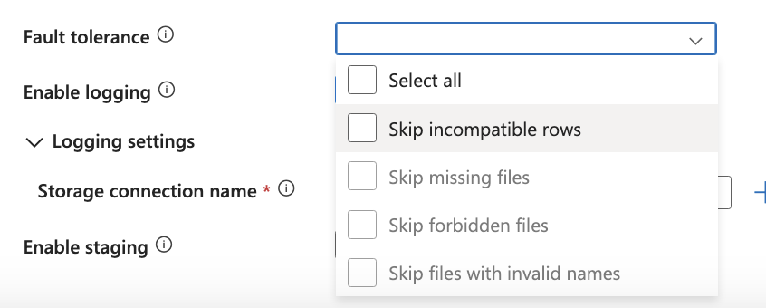

User Property: we can add some metadata info for the job

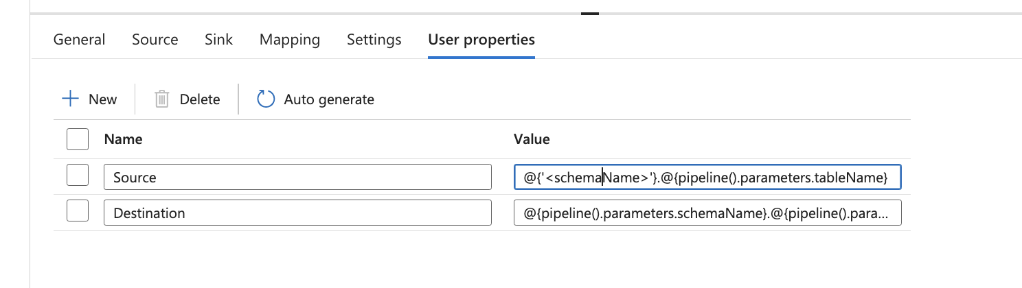

Monitor Copy data Activity:

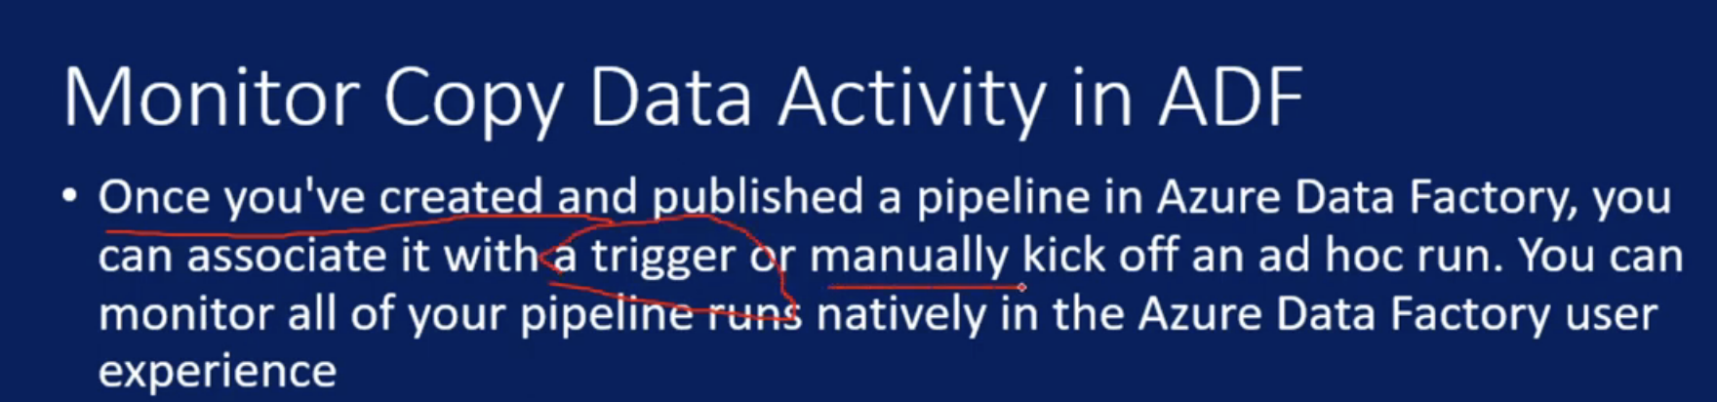

Delete Activity:

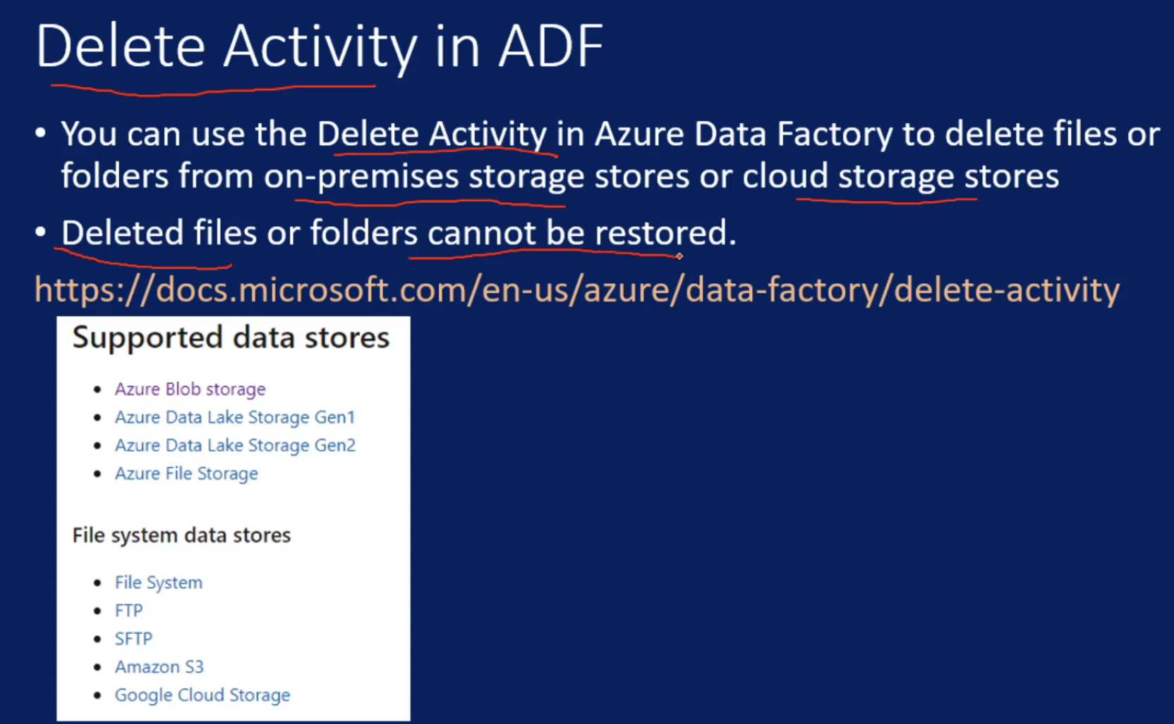

Variables in ADF:

Paramter values are provided while triggering the pipelines, where as variables are internal to pipelines

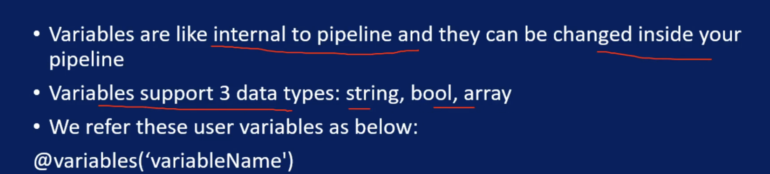

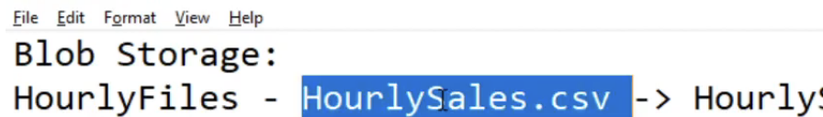



Suppose I want to create pipeline which reads Hourlysales.csv and adds data to hourly table and dailysales.csv to daily table, so for this we can use variables

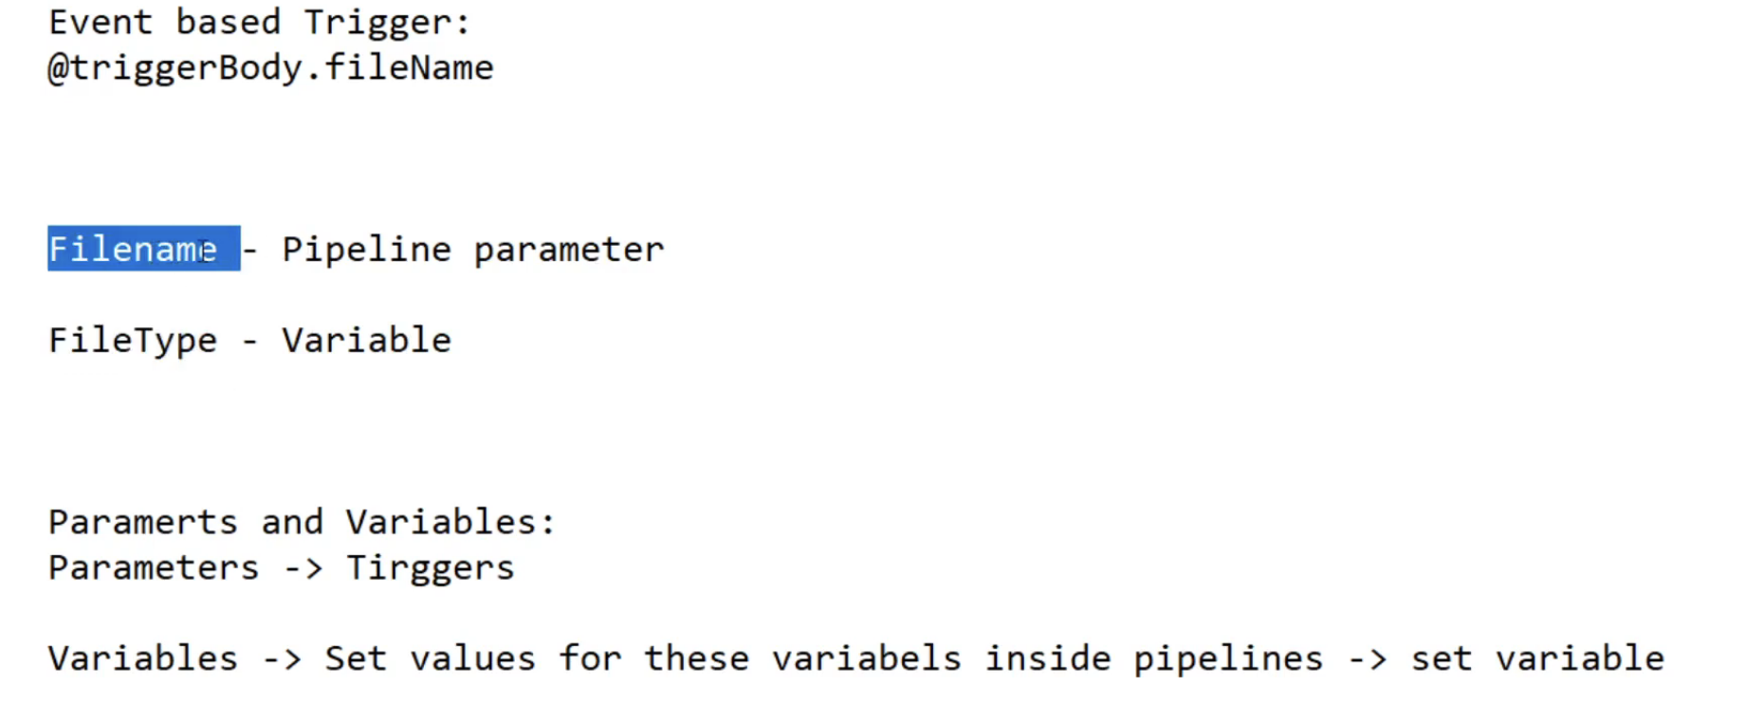

So first set filename parameter from that parameter I get value and remove sales.csv from the parameter name and set as variable

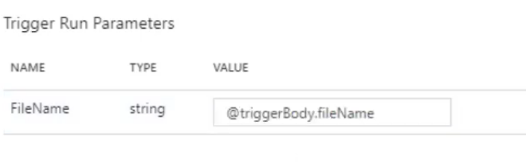

Set Variable Activity:

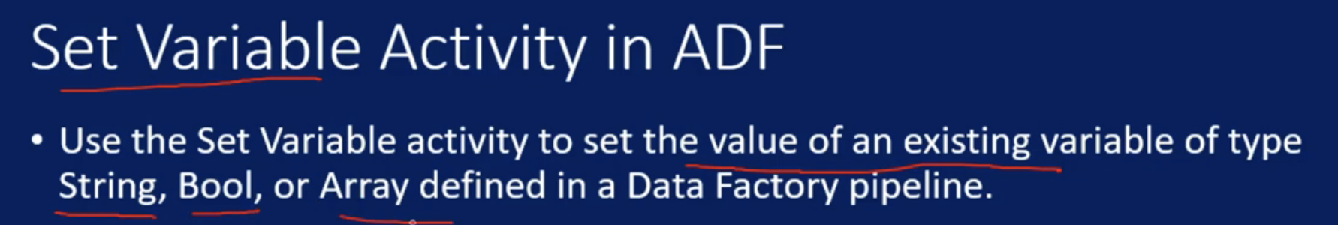

Append Variable:

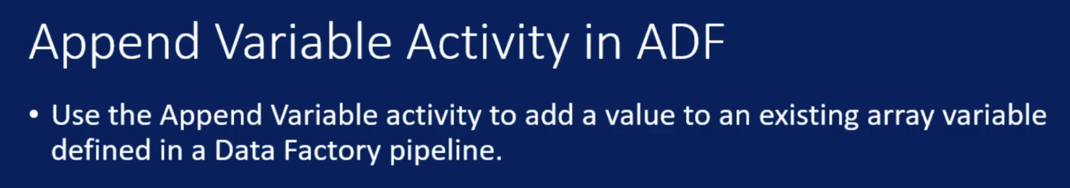

User Property:

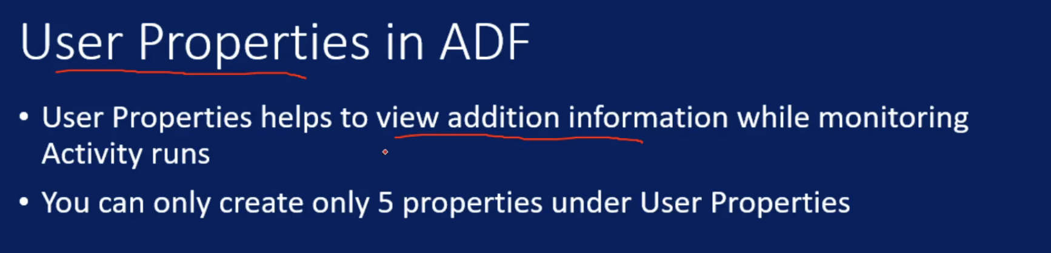

Execute Pipeline:

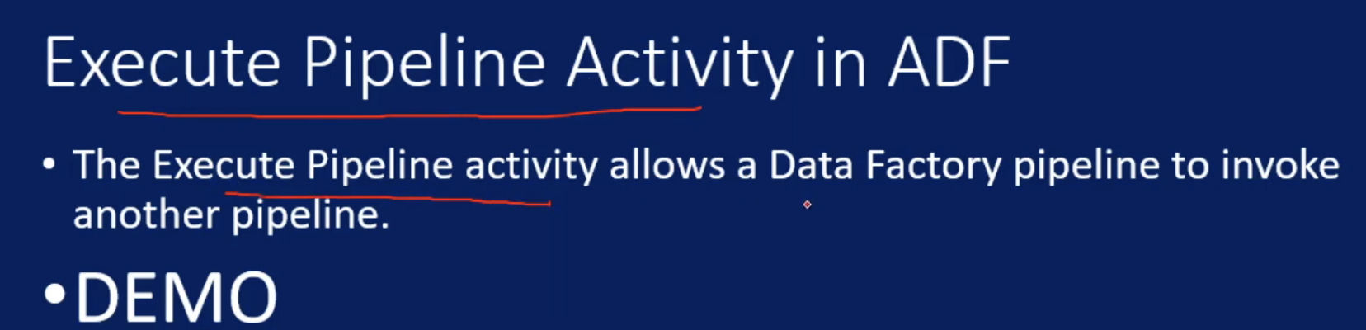

Filter Activity:

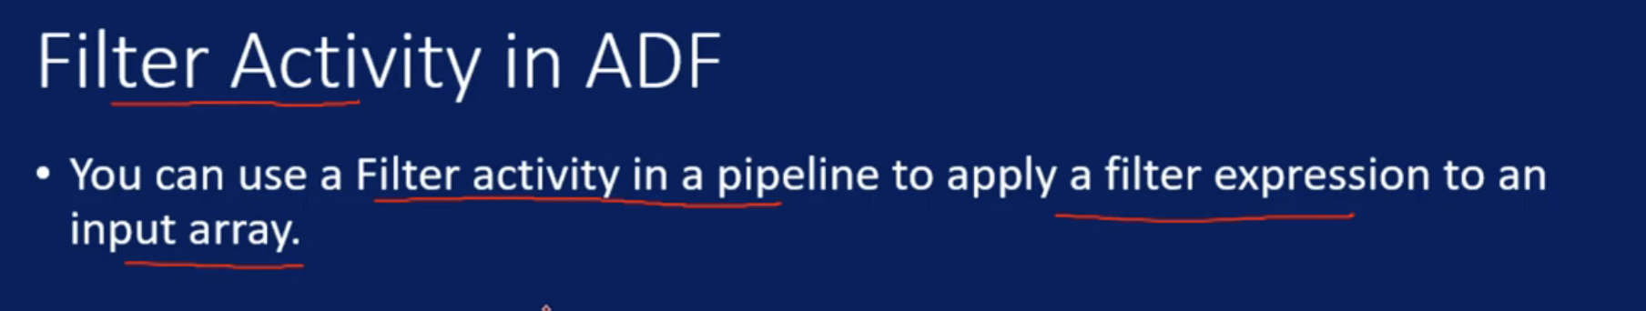

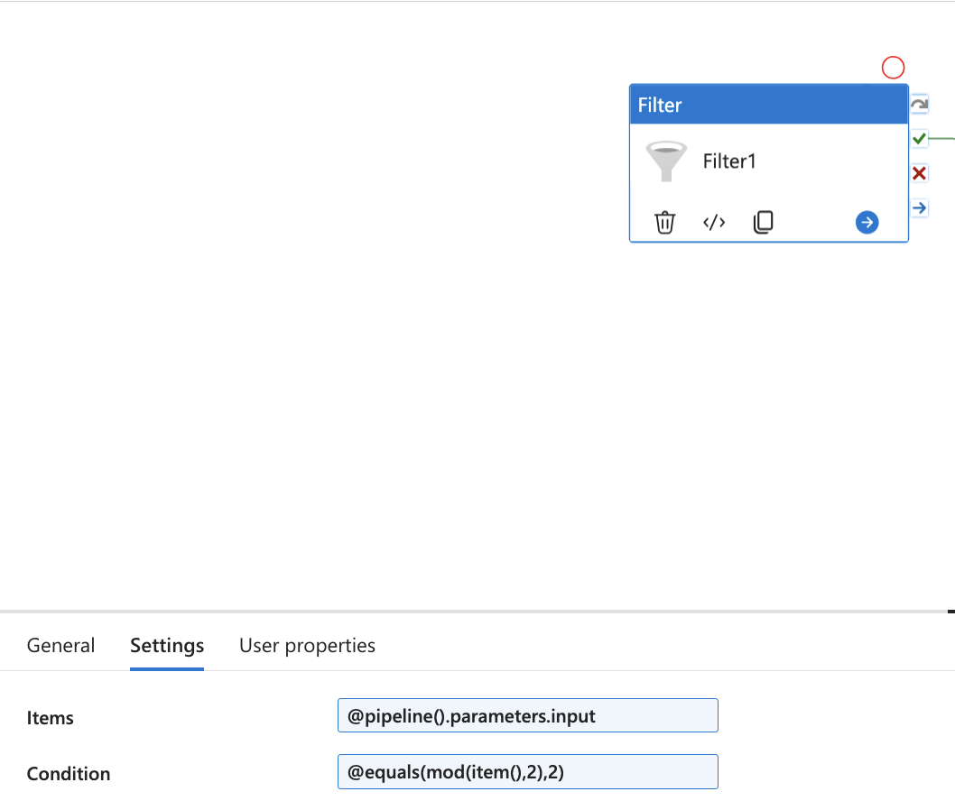

Foreach Activity:

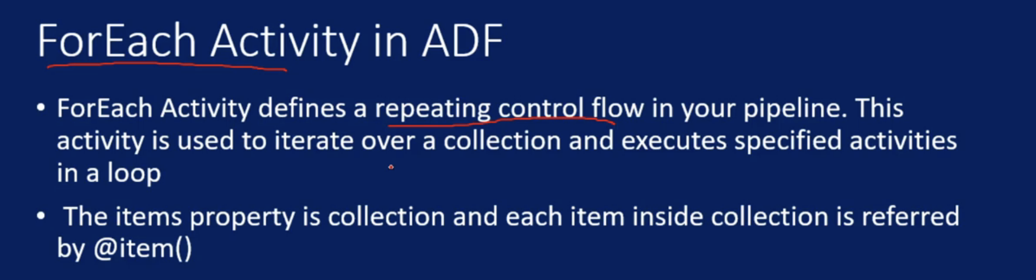



**If we are reading parameter to dataset, firsr we need to create a parameter in dataset and then link pipeline parameter to dataset parameter**

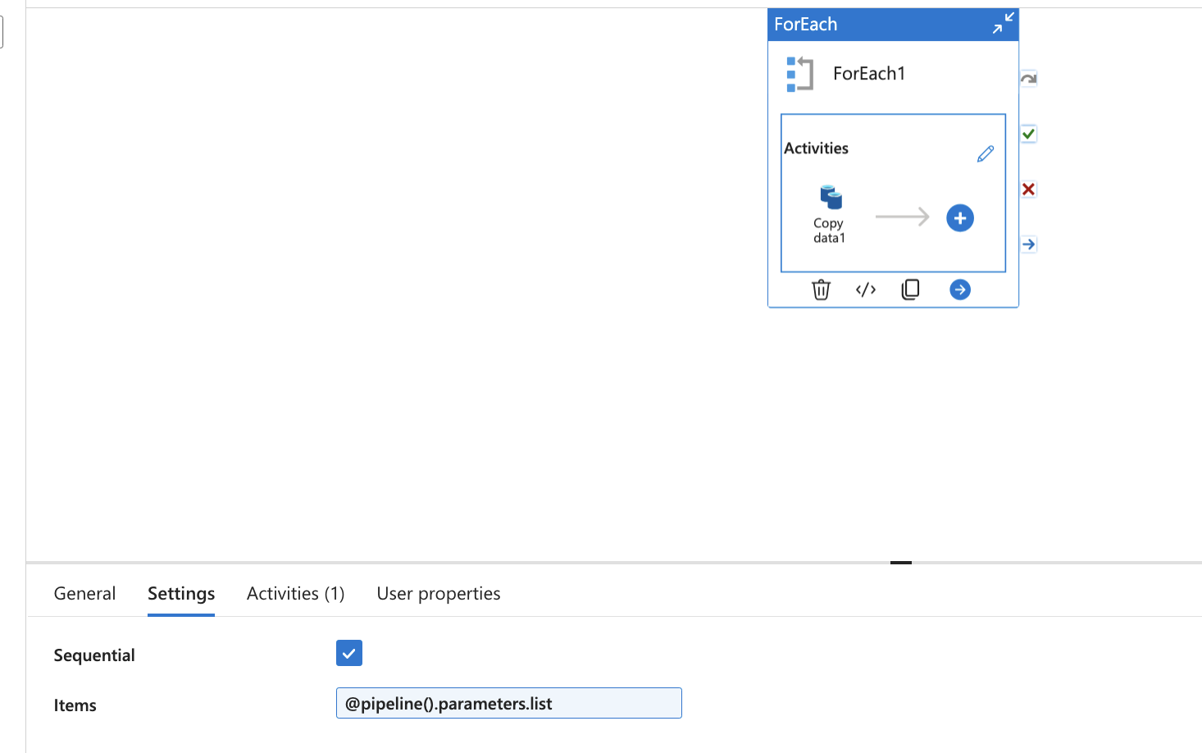

Get Metadata Activity:

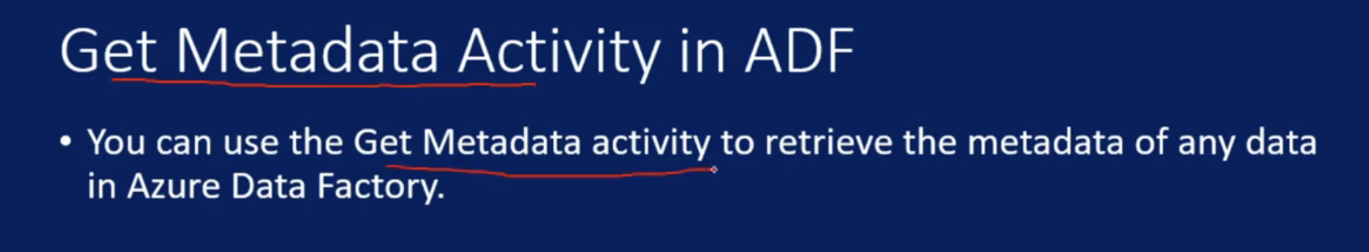

Mainly to get metadata about dataset

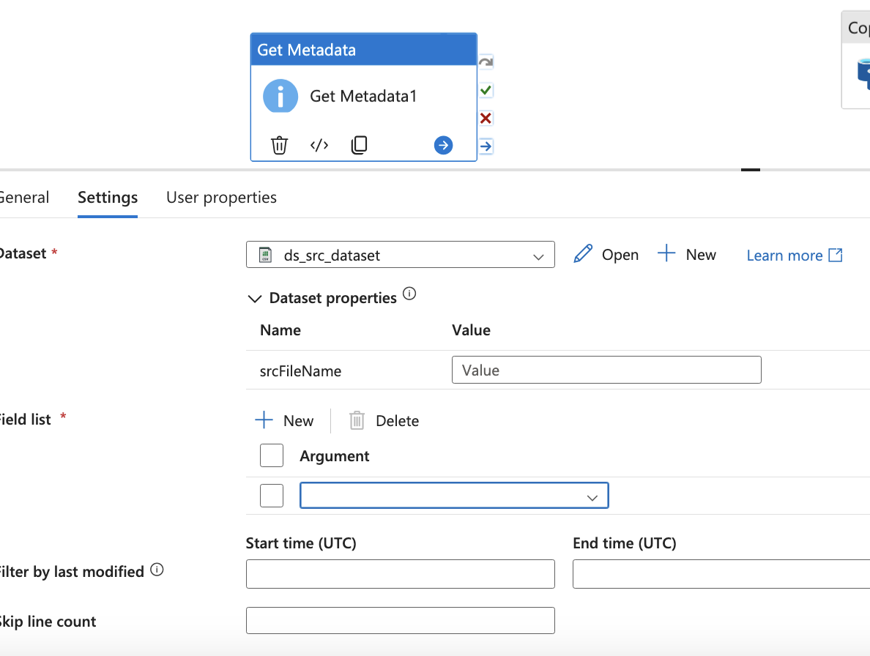

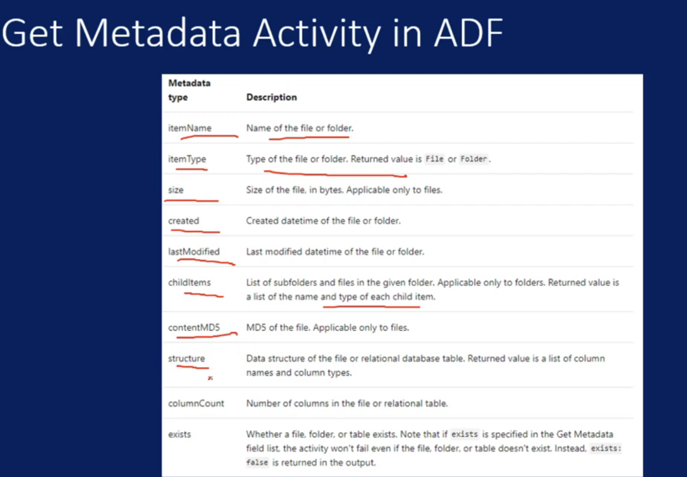

If Condition:

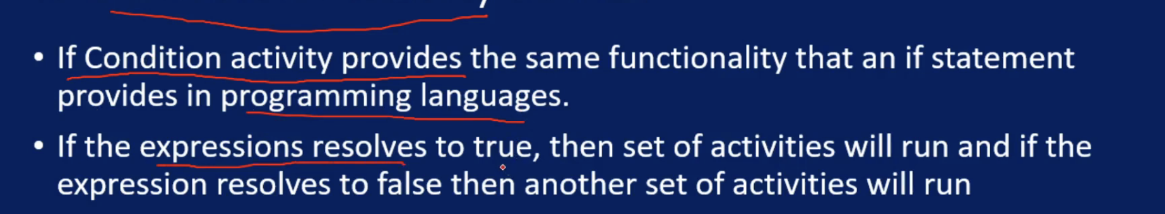



Wait Activity:

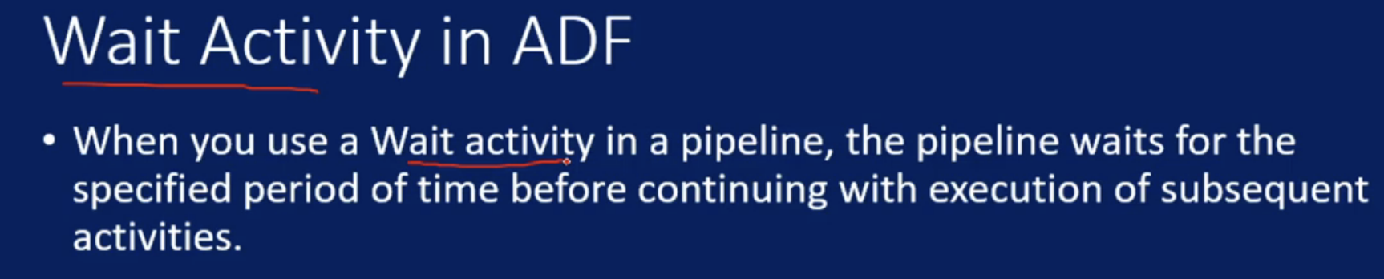

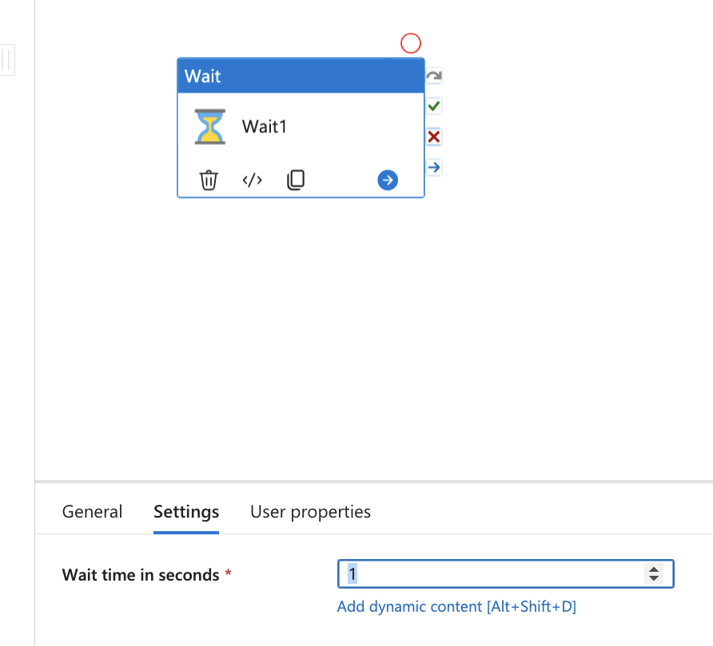

Until Activity:

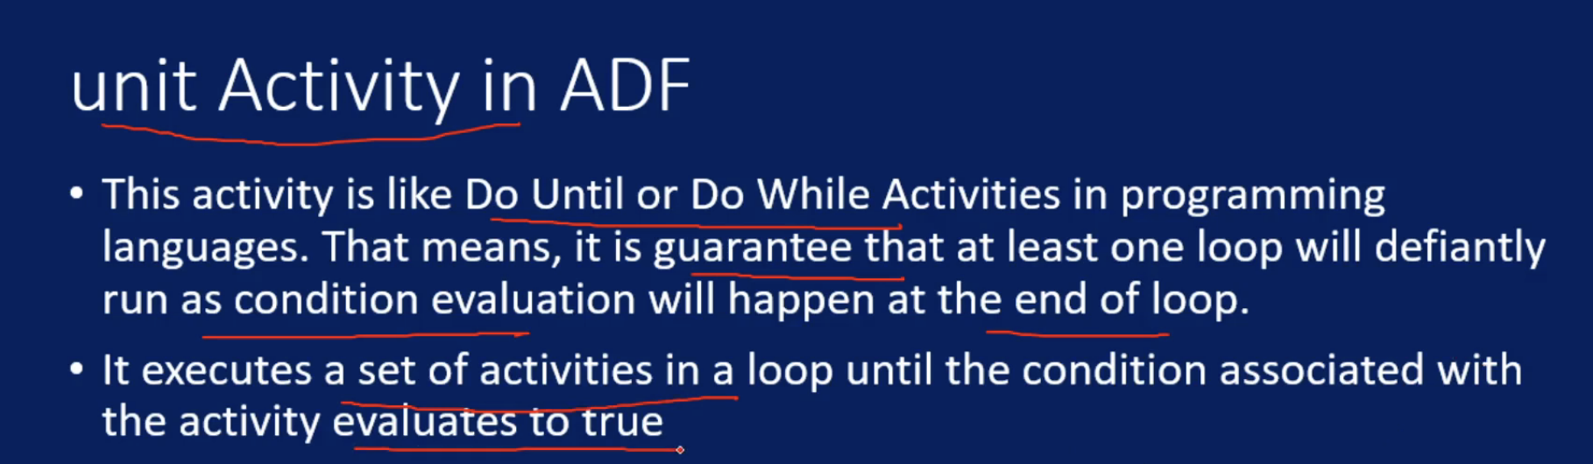

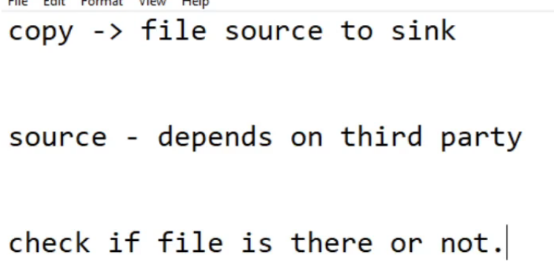

It keeps running until value is True, once value becomes true it will stop

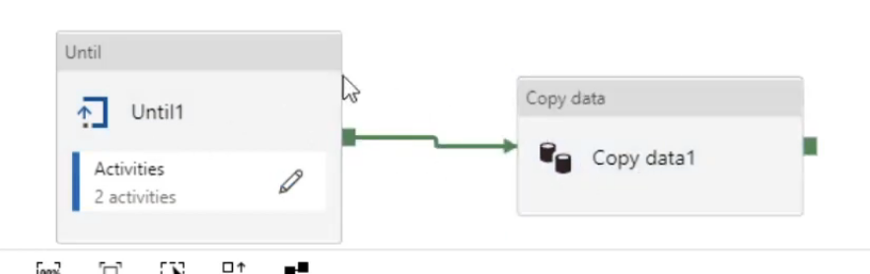

Web Activity:

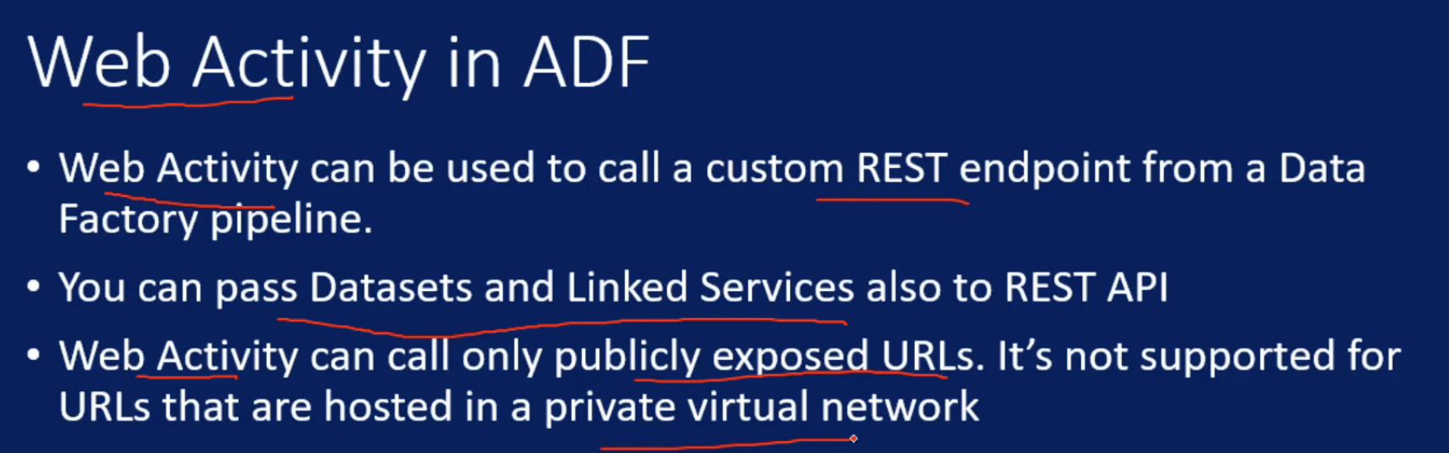

Each dataset and linked service will have it’s own json, so we can tag those json as part of web request

Webhook:

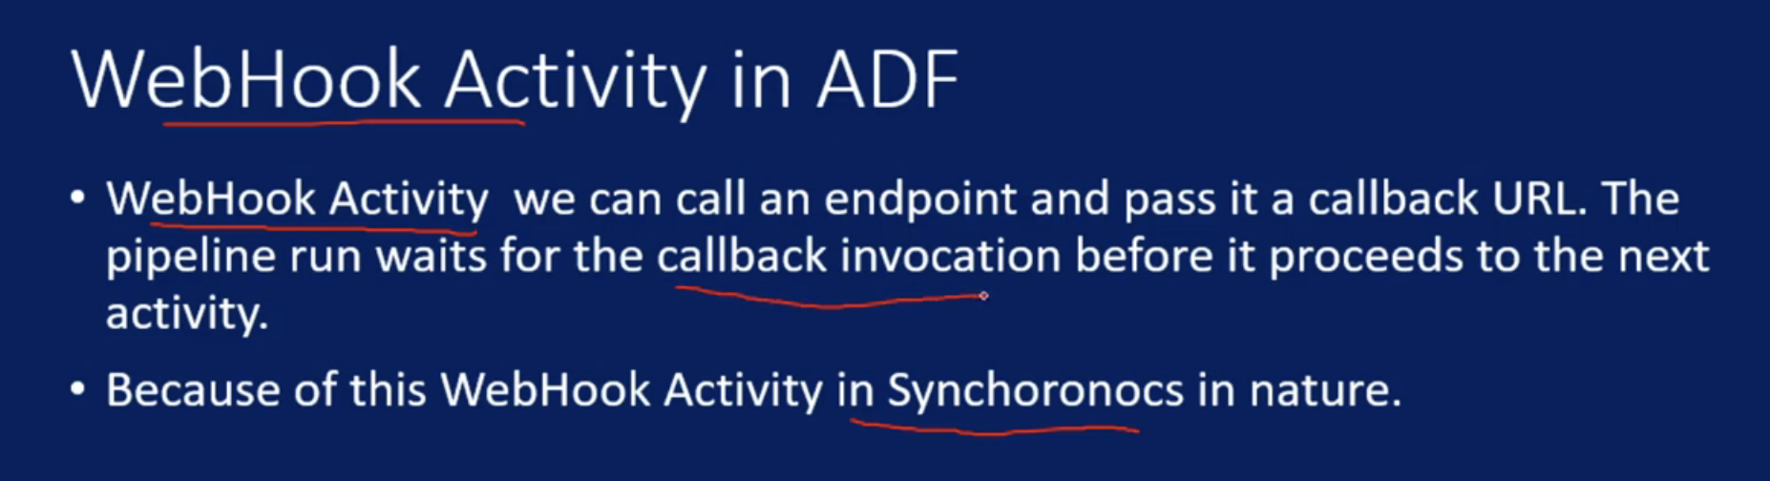

It will be always POST request

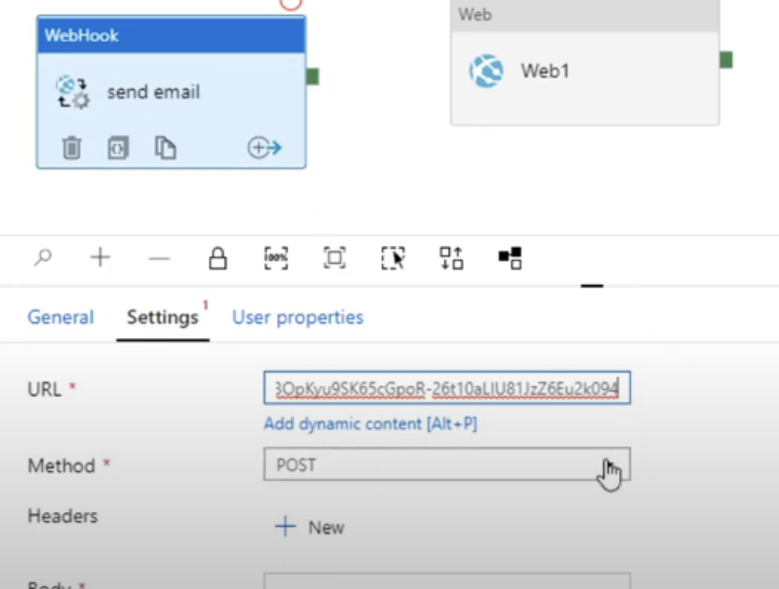

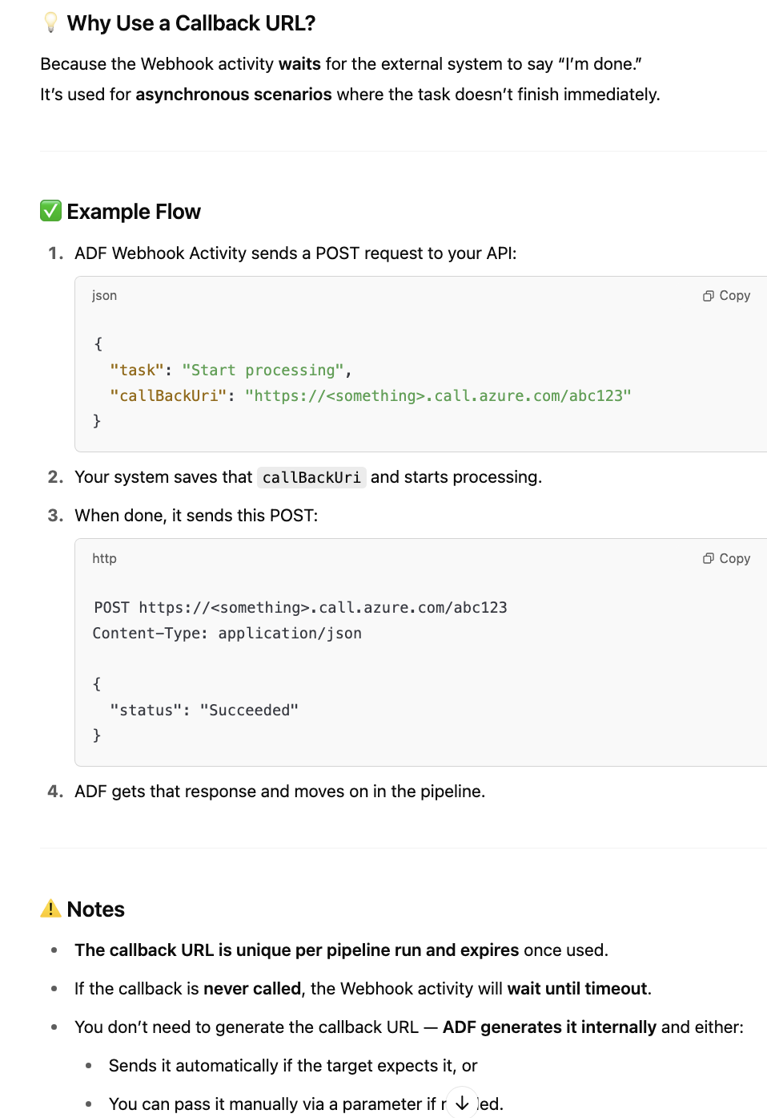

Switch Activity:

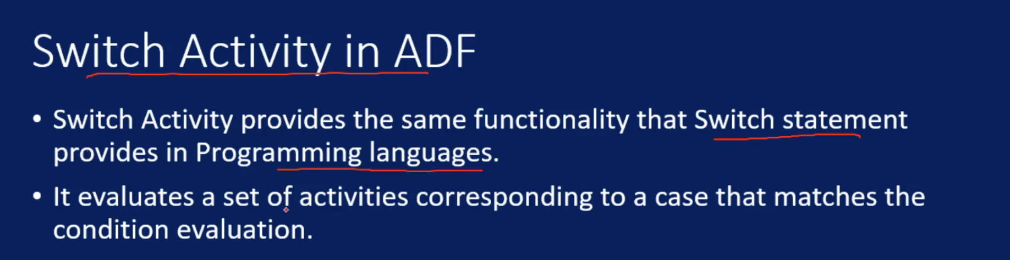



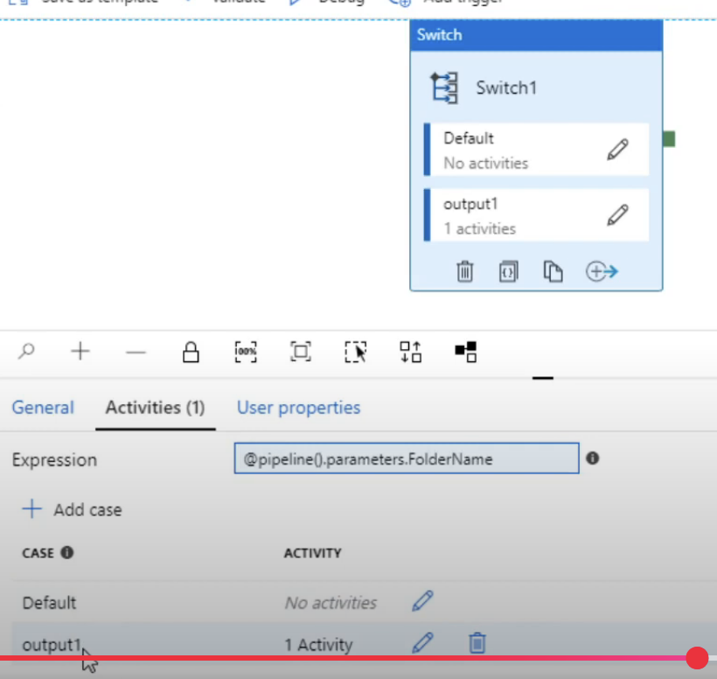

We can create many cases and add corresponding activities inside that

Validation Activity:

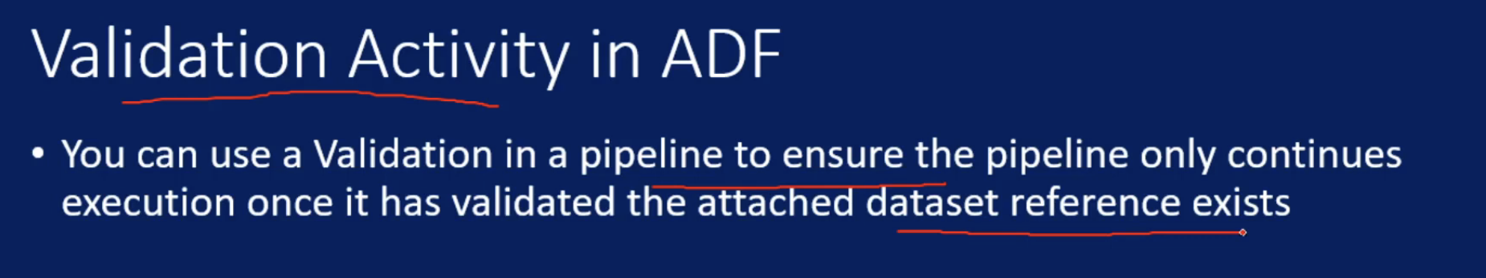

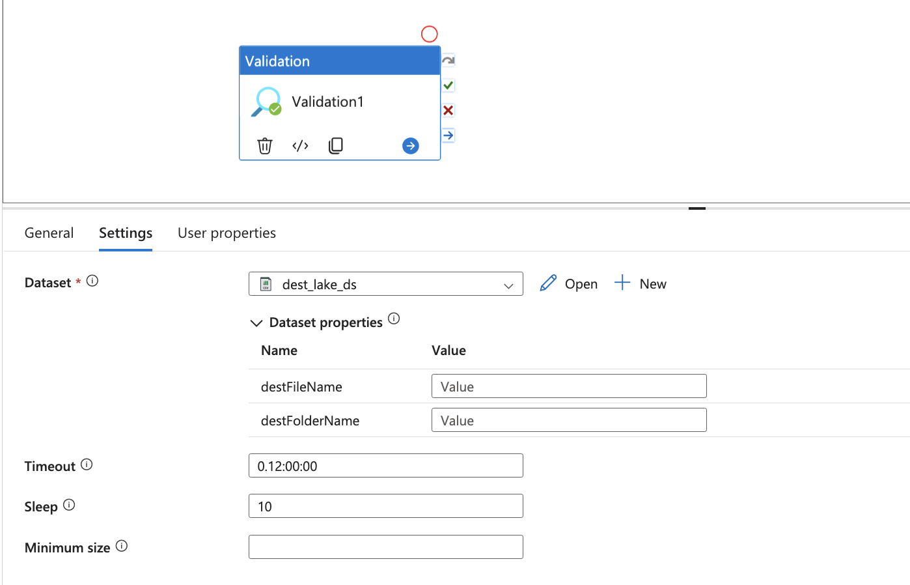

Lookup Activity:

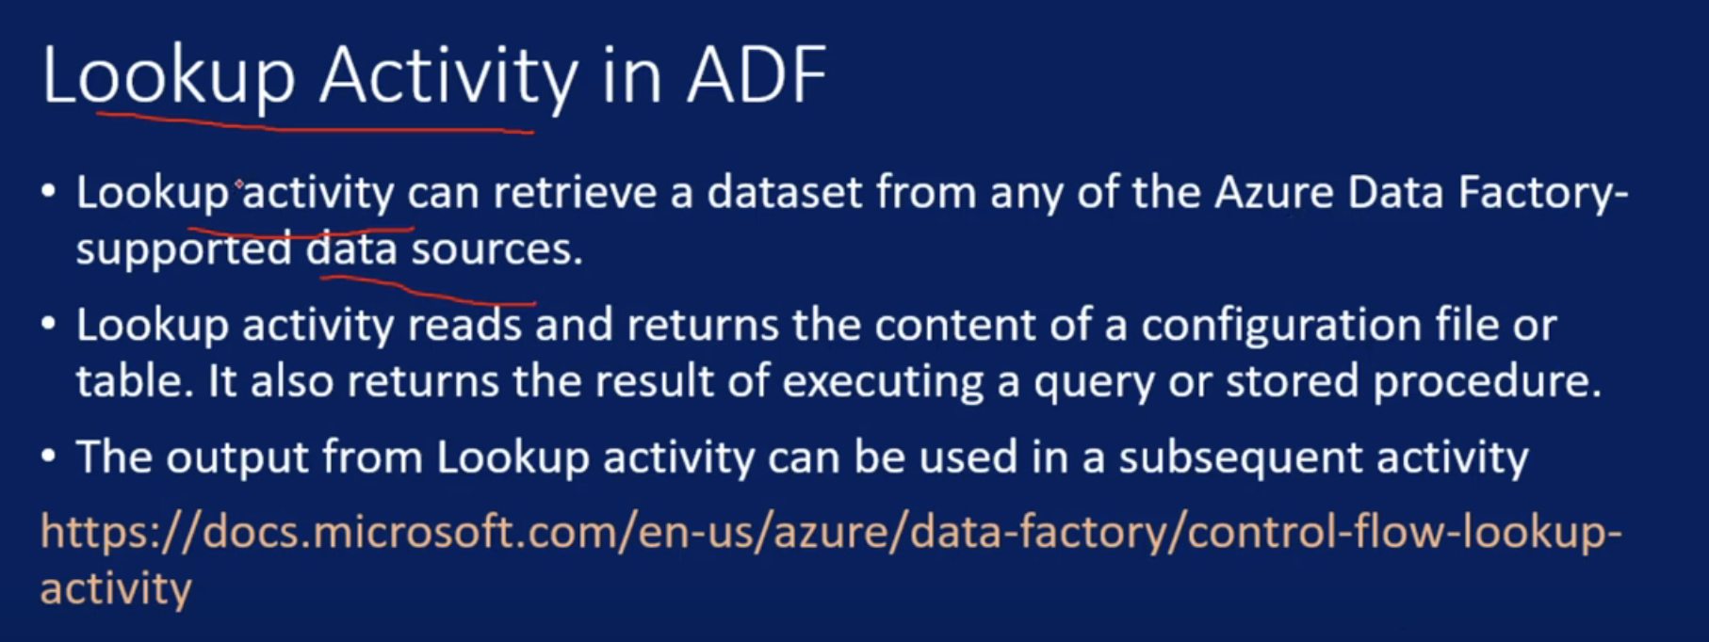

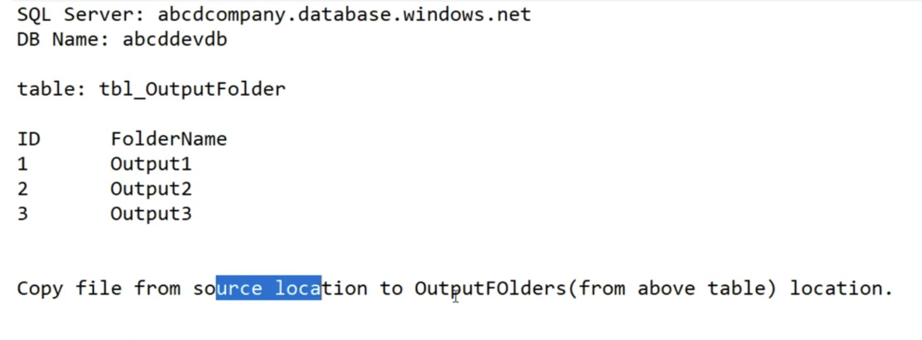

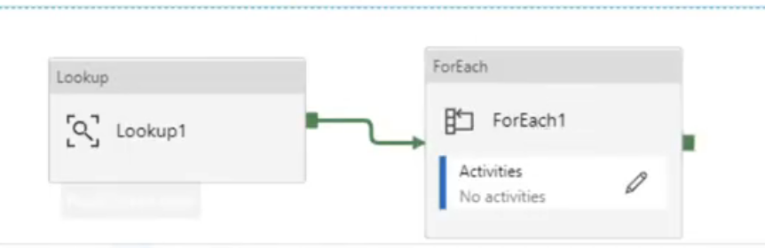

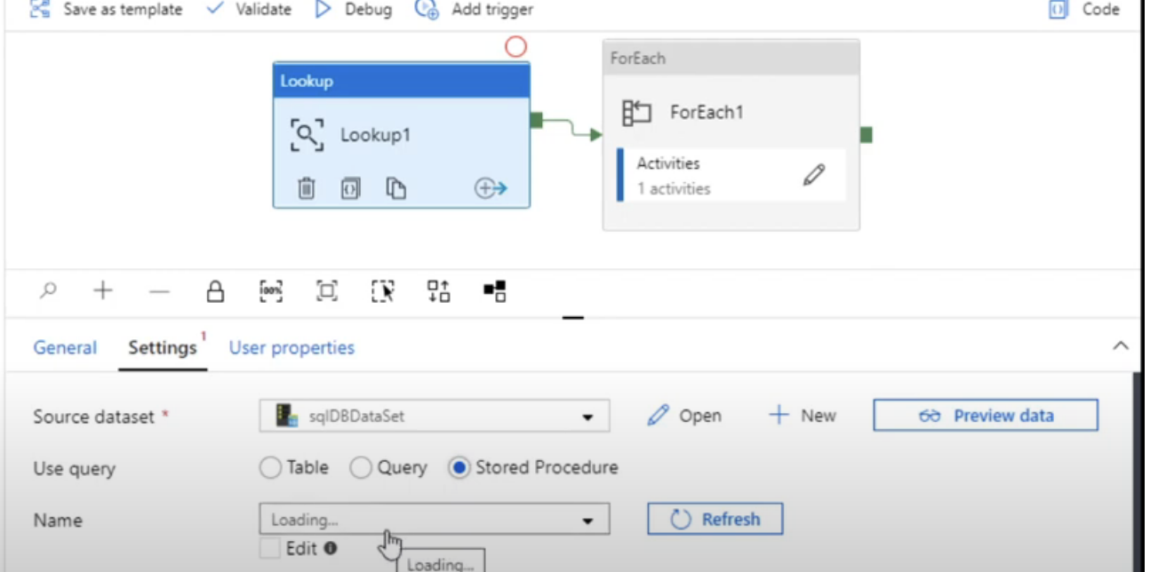

Lookup activity return all values in an array and we can use foreach activity

Transform Data Activity:

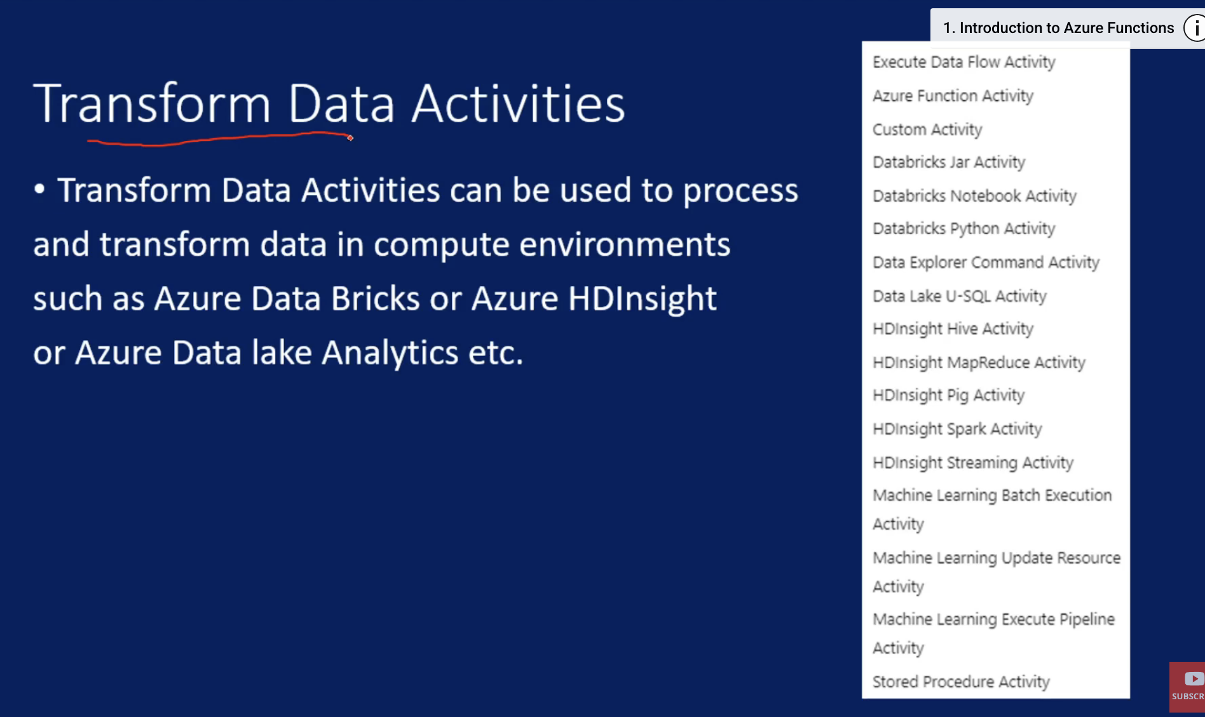

Stored Procedure Activity:

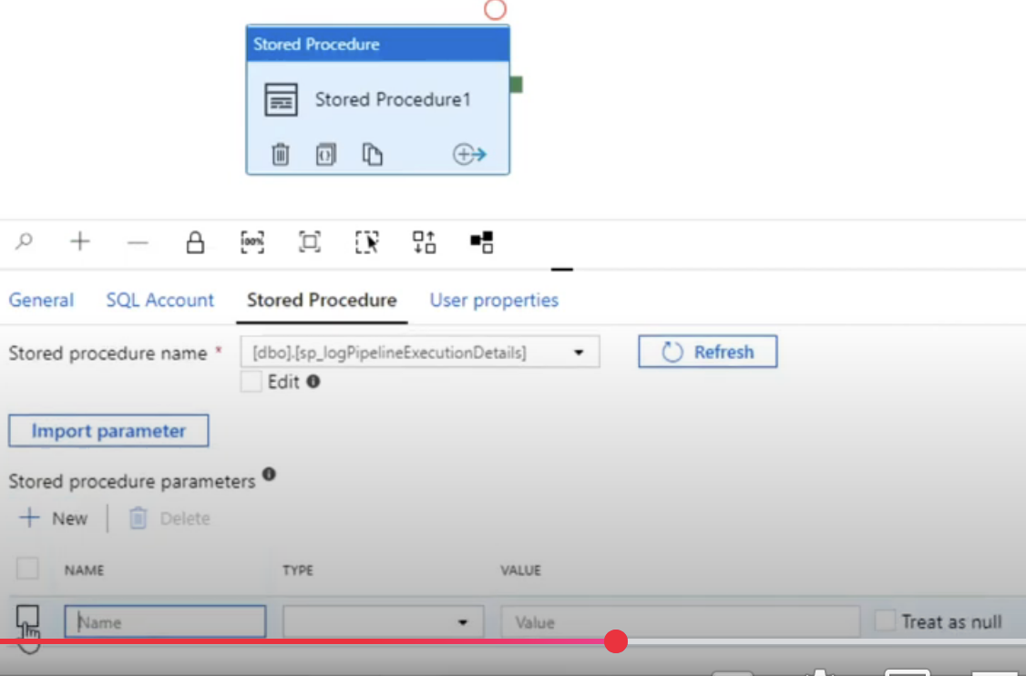

DataFlows:

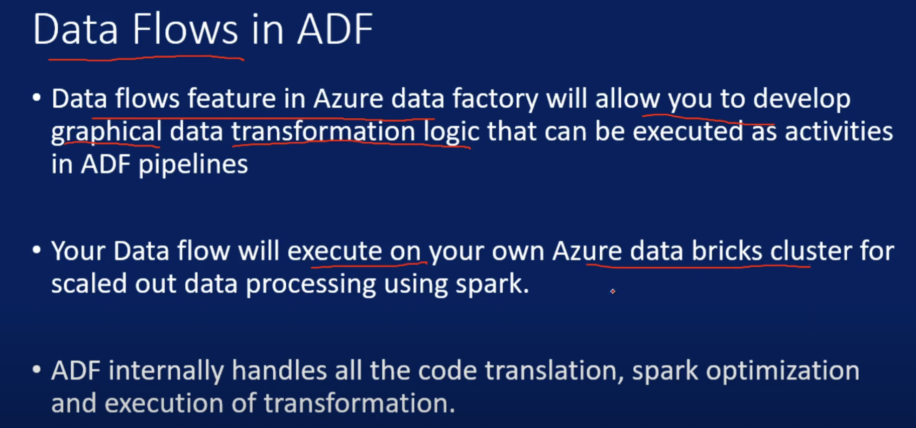

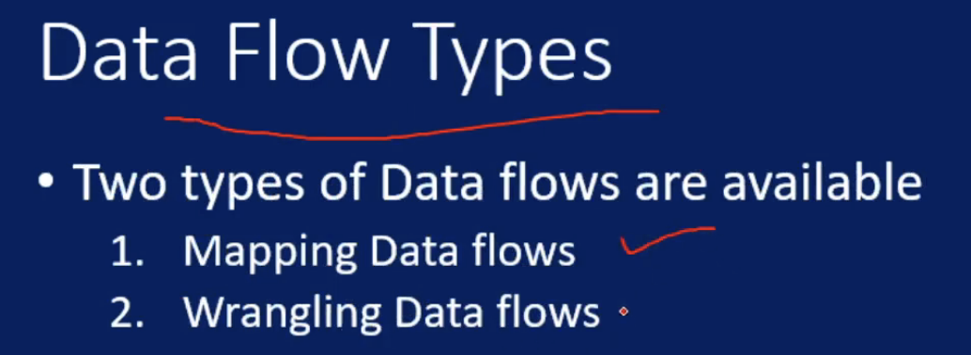

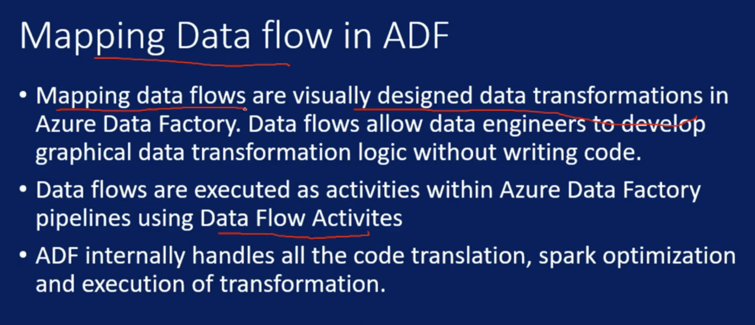

Data Flow Activity:

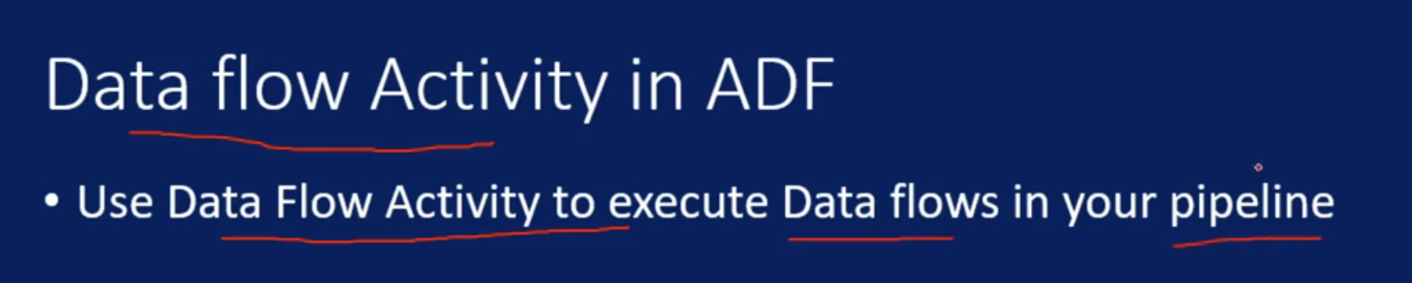

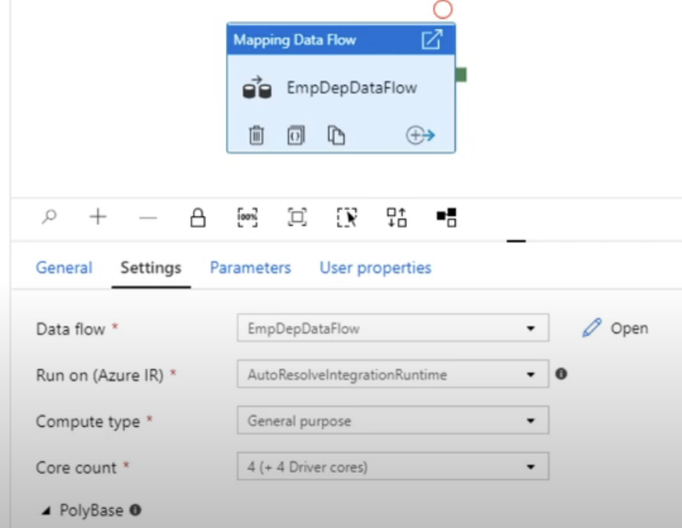

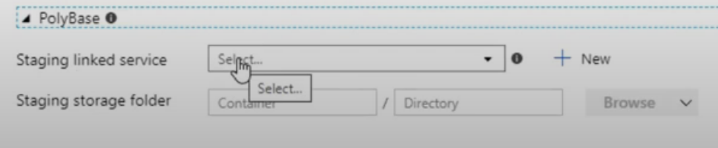

In polybase data will be loaded in staging first and then from staging to sink

Mapping Data Flow Debug Mode:

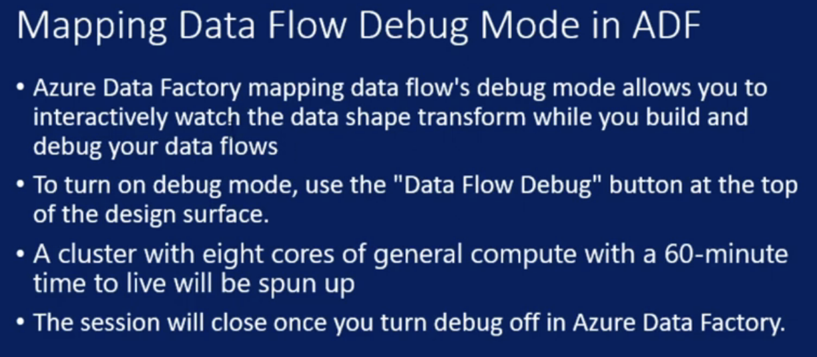

Filter Transformations:

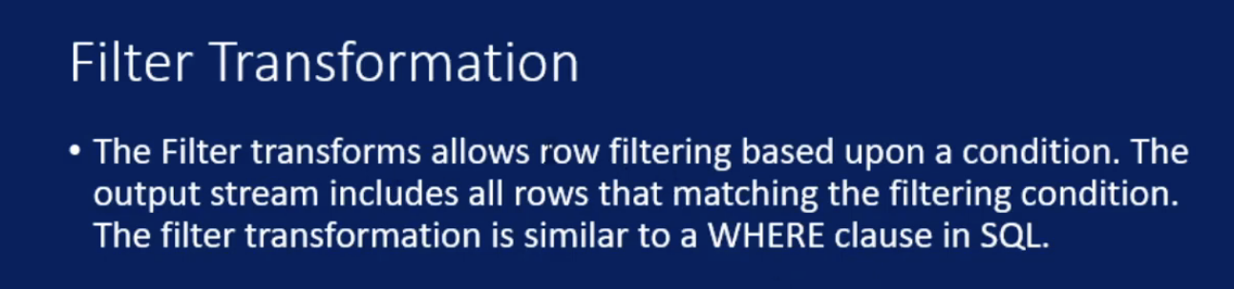

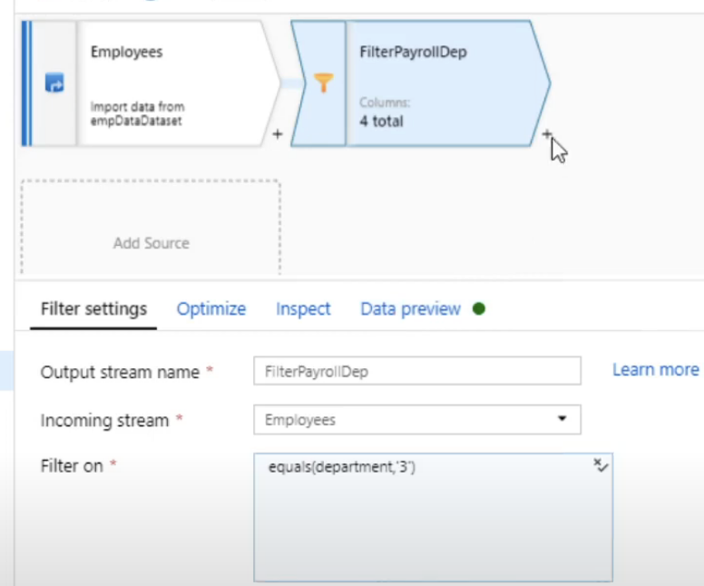

Aggregate Transformations:

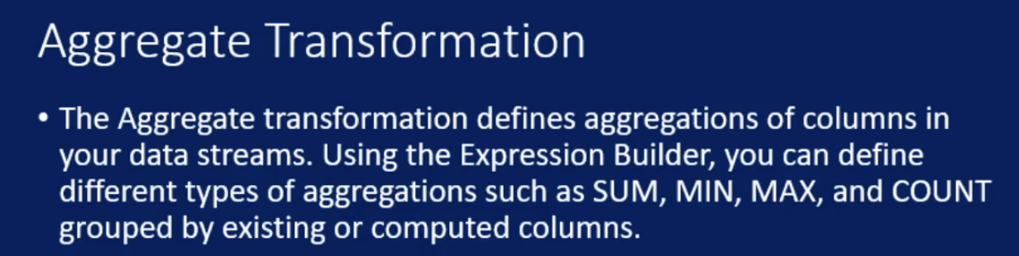

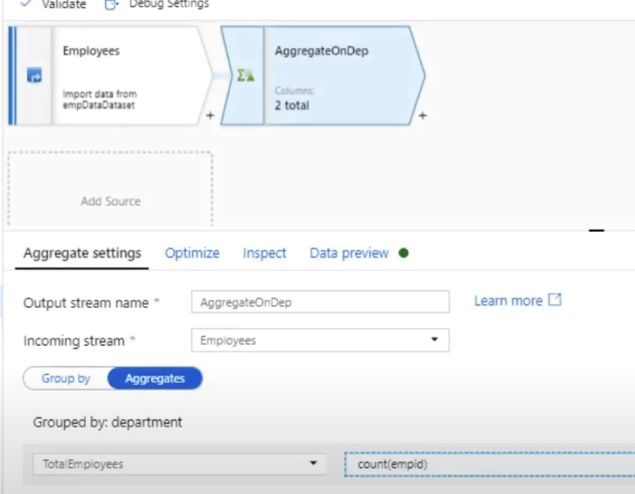

Join Transformations:

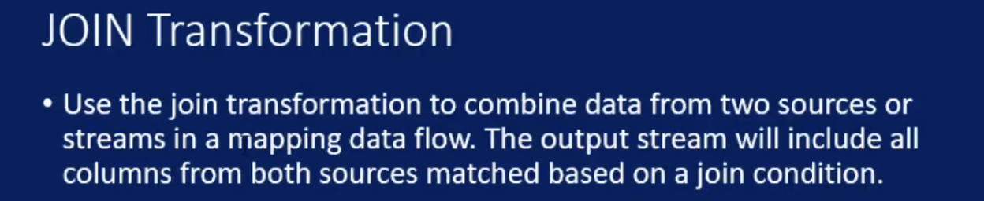

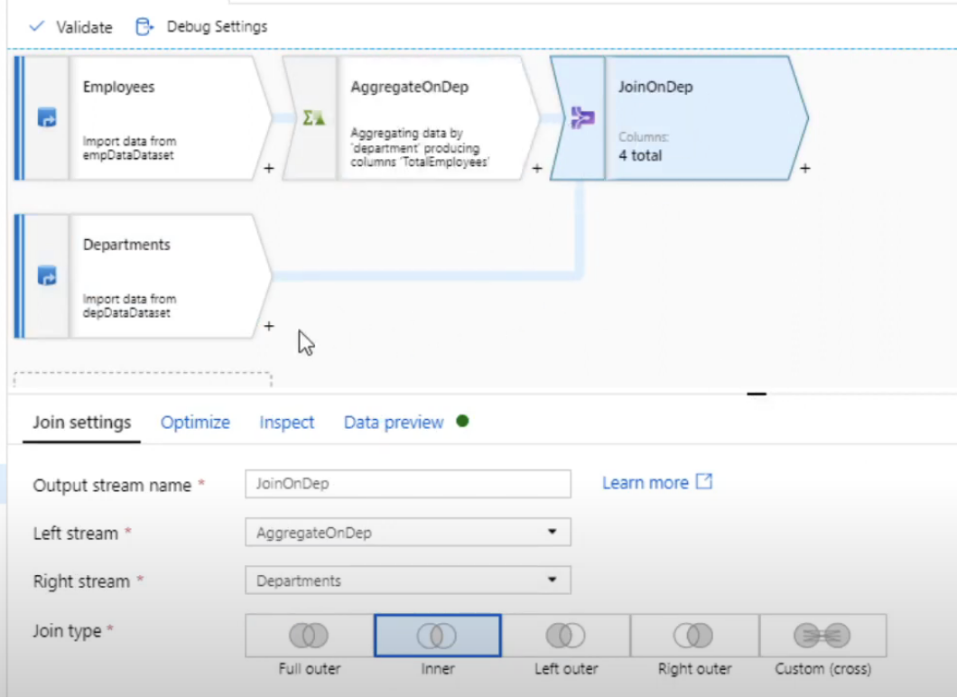

Conditional Split:

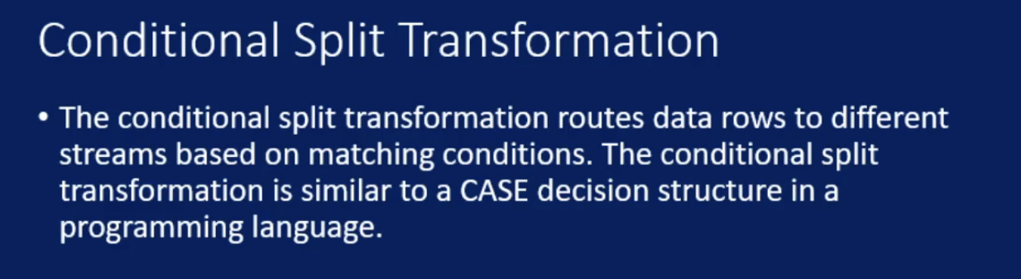

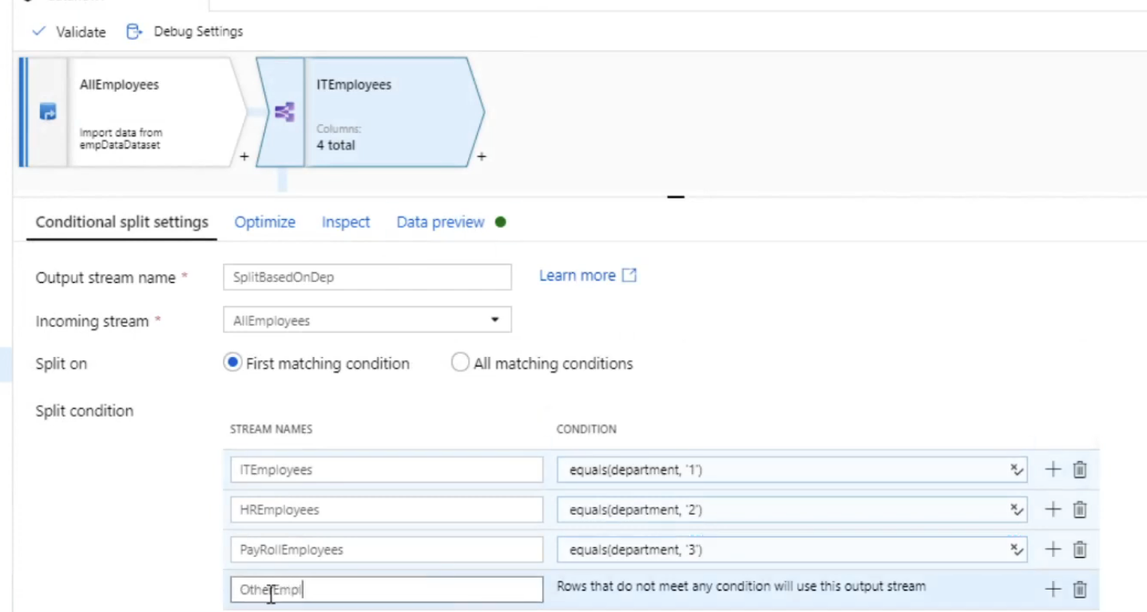

Derived Columns:

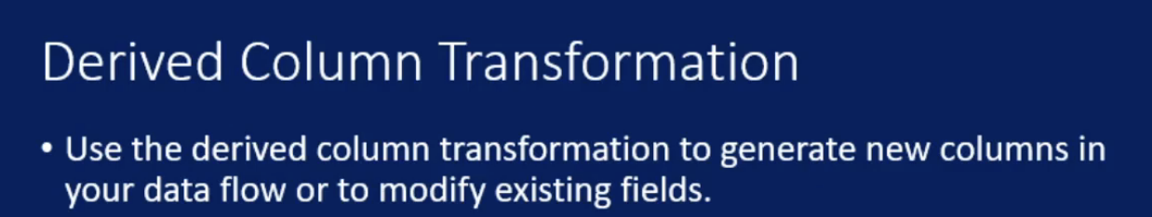

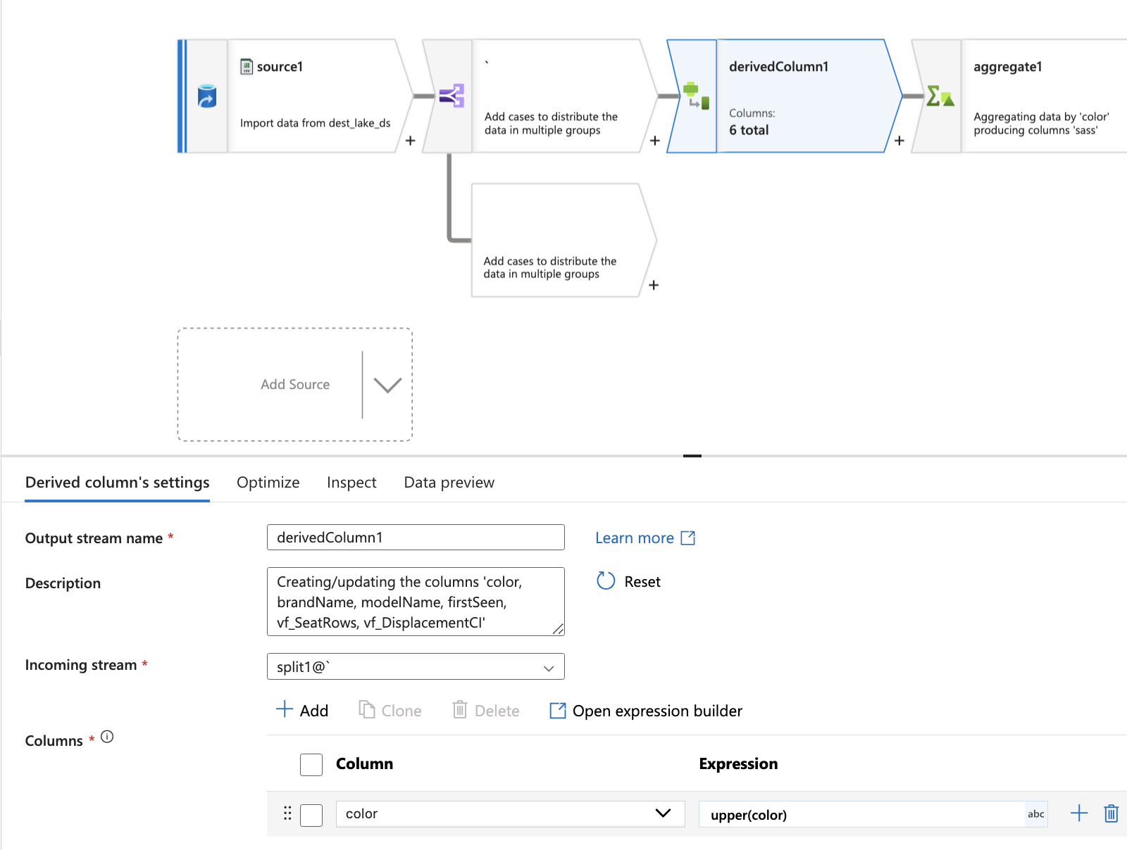

Replace null

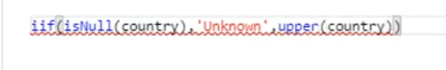

Exists Transformation:

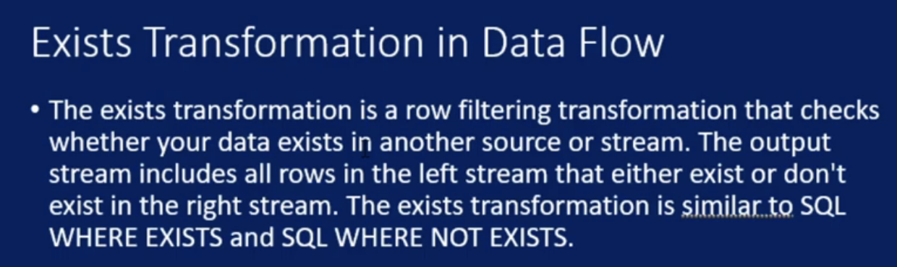

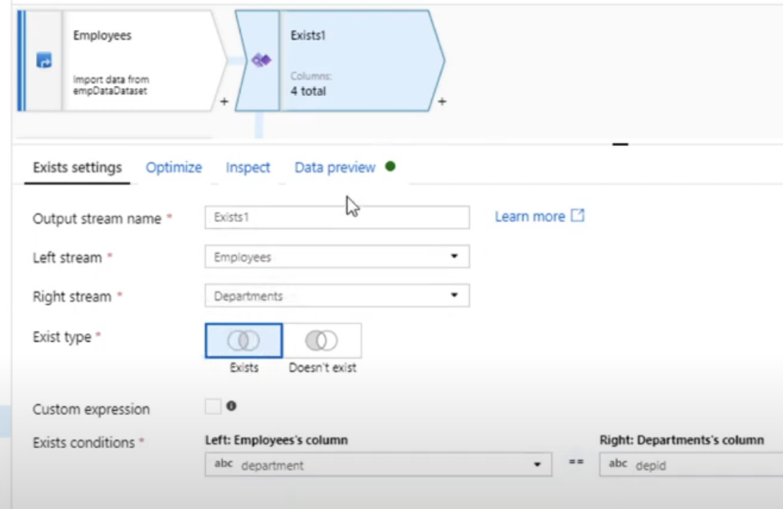

Union Transformation:

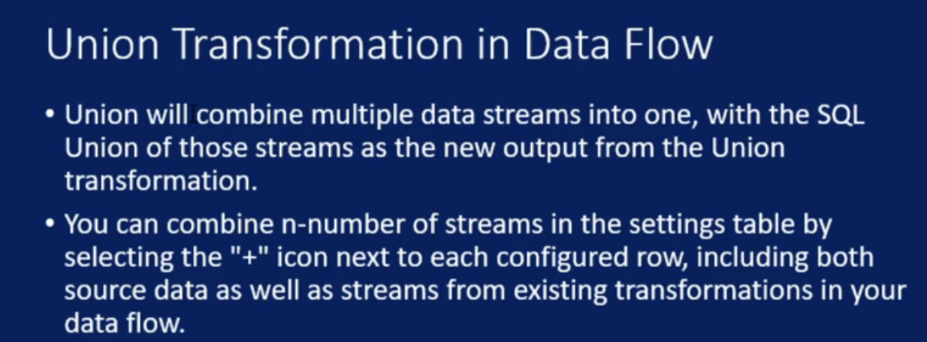

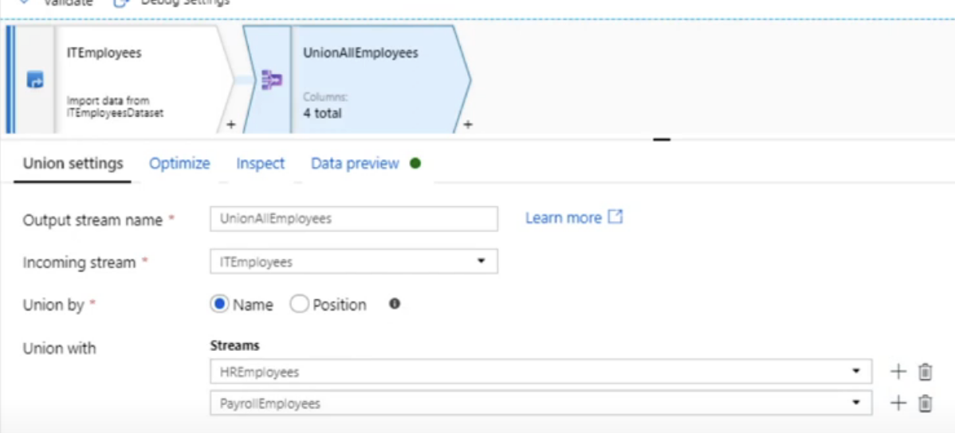

Lookup Transformations:

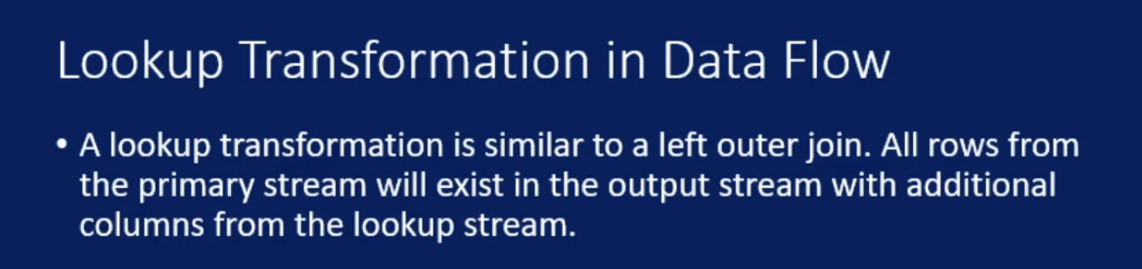

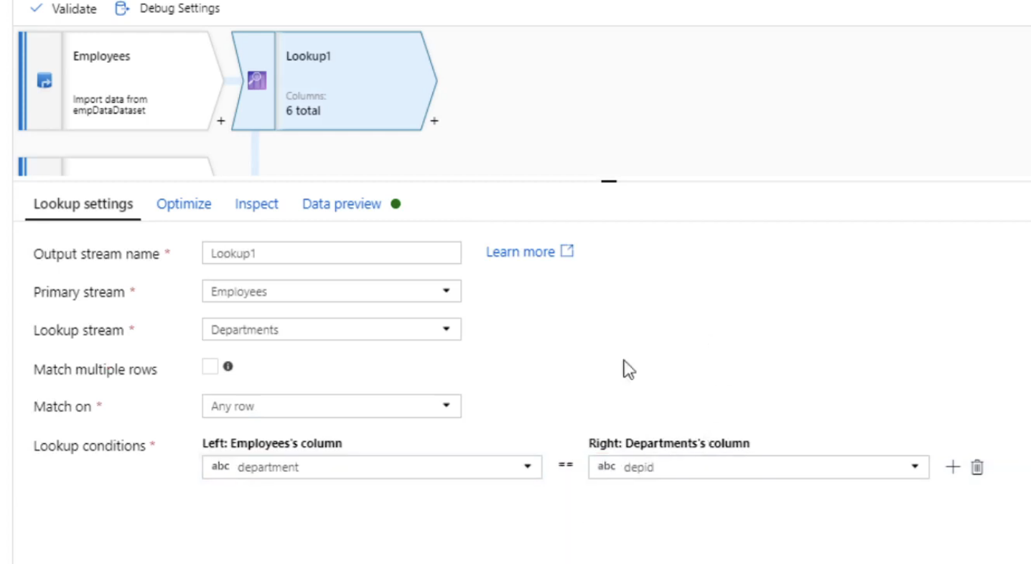

Sort Transformation

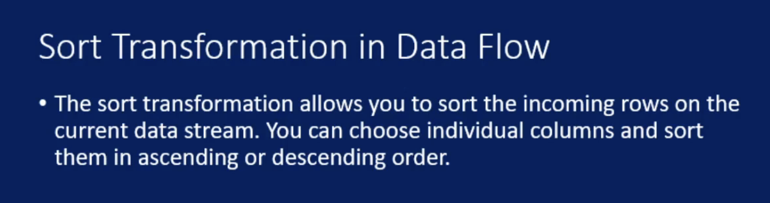

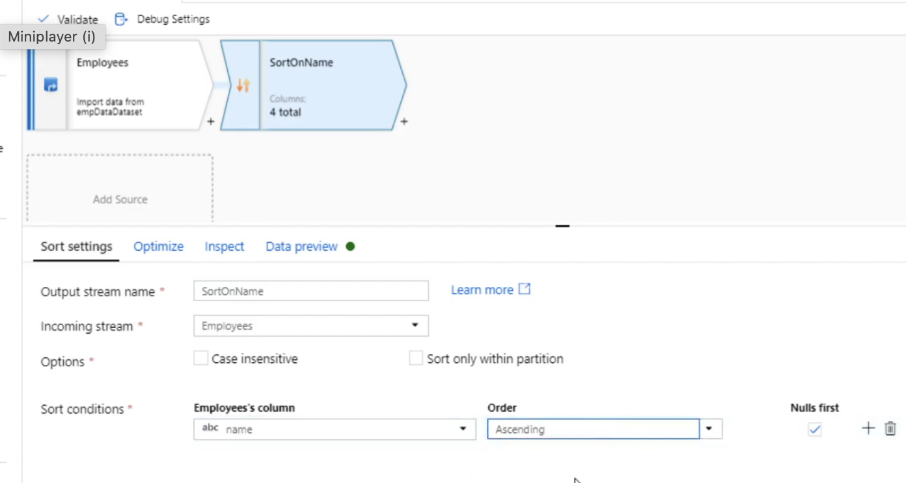

New Branch:

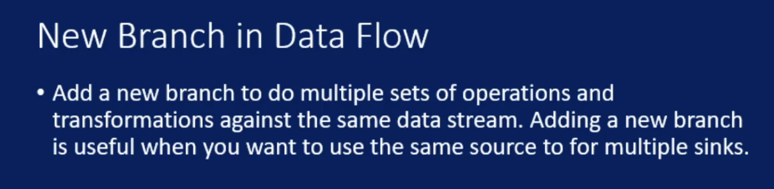

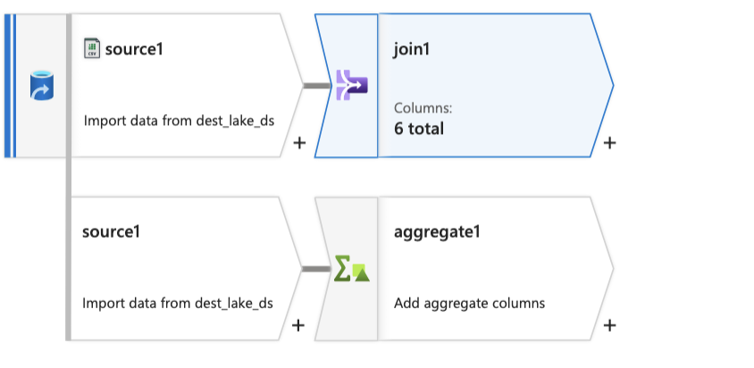

Select Transformation:

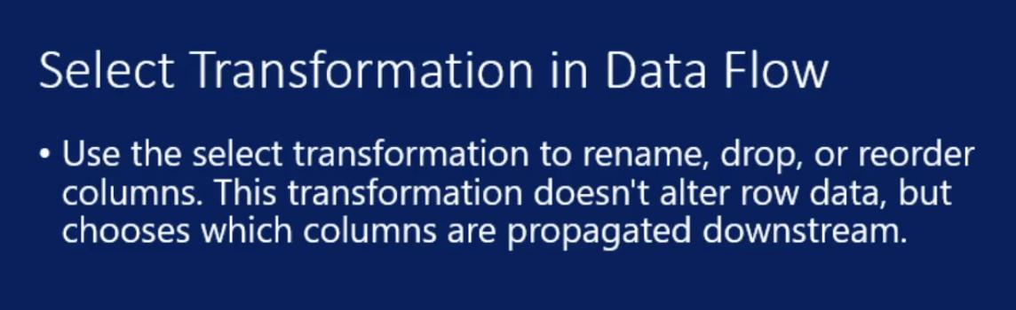

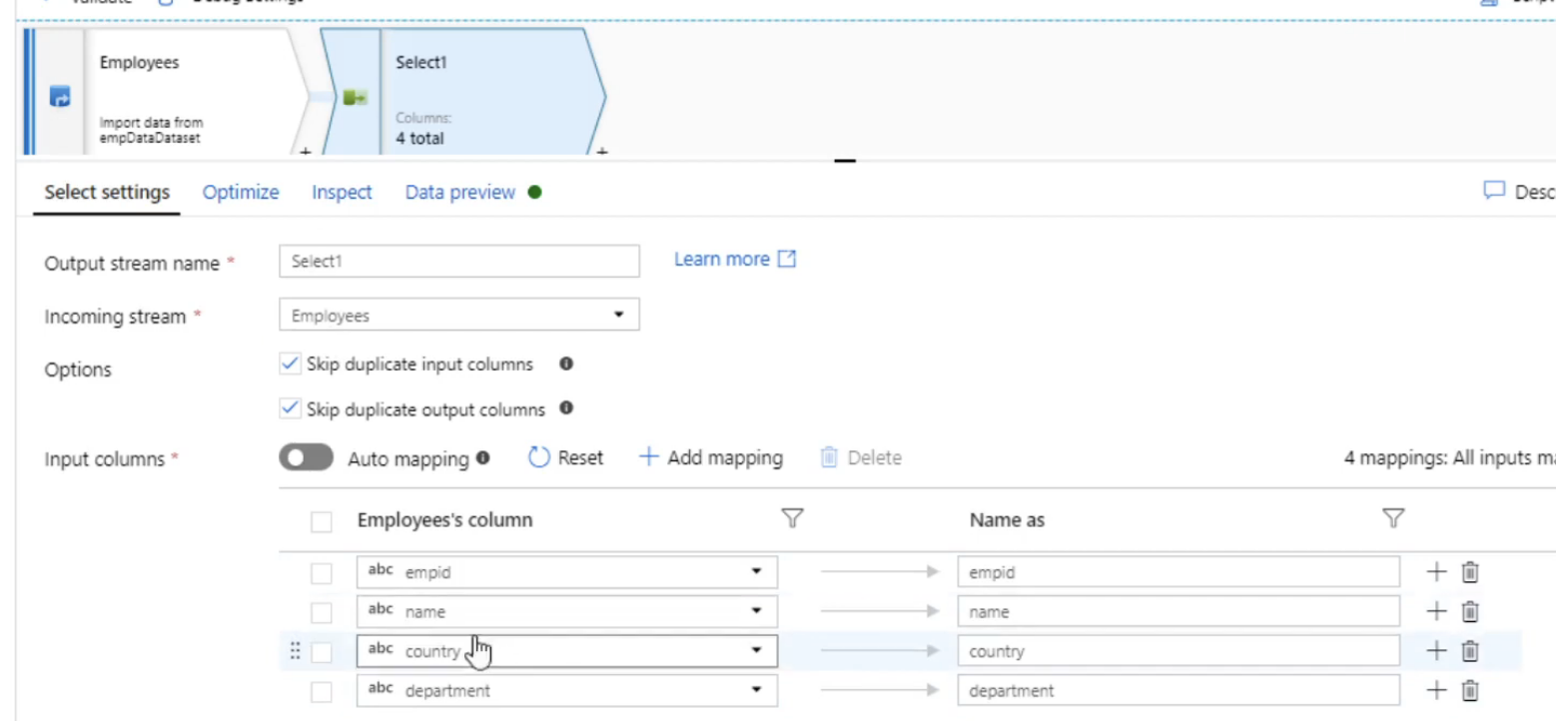

Pivot Transformation:

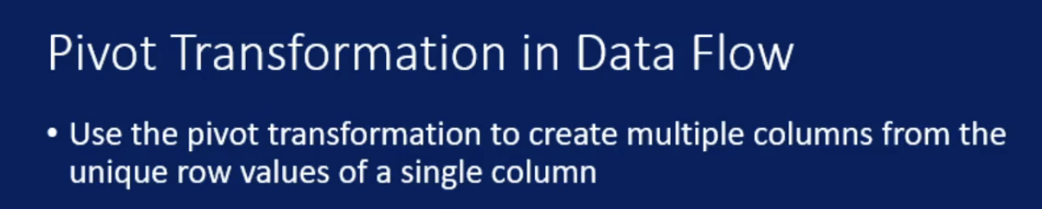

Pivot is nothing but converting column values as columns

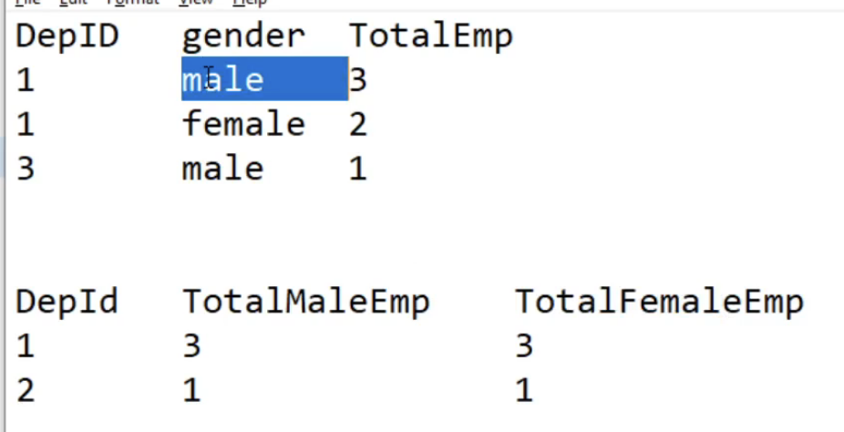

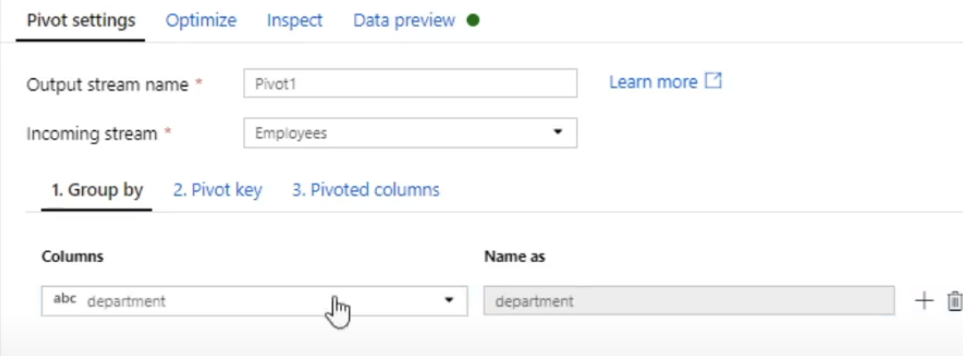

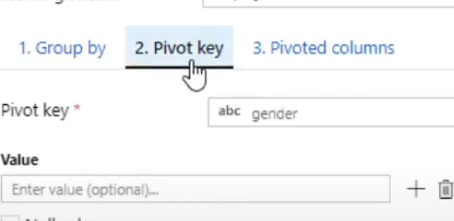

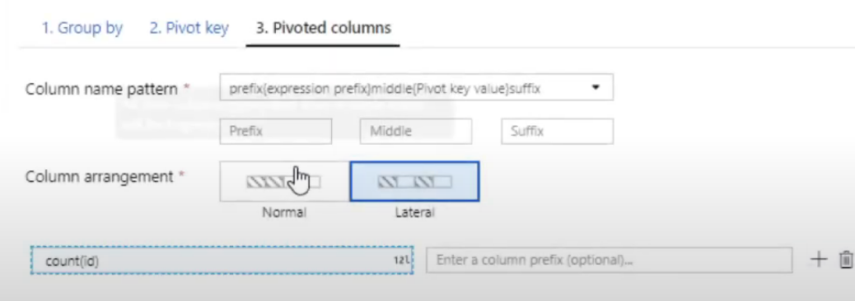

Unpivot:

Transforming column to column values

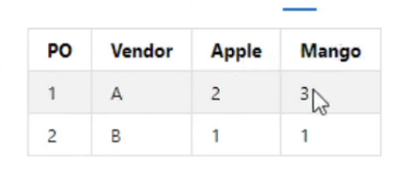

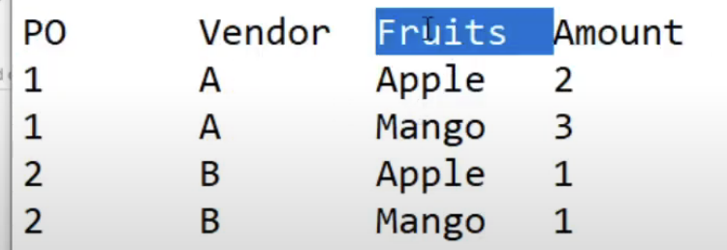

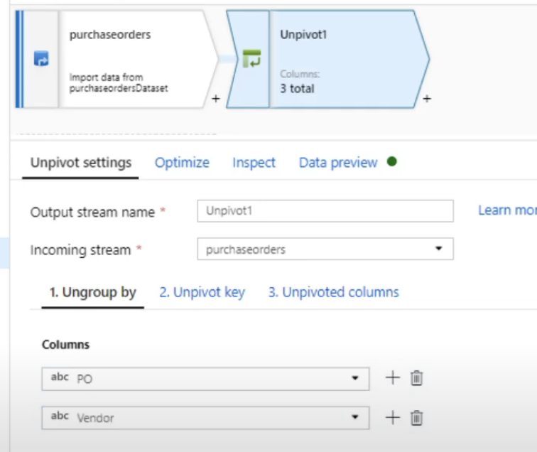

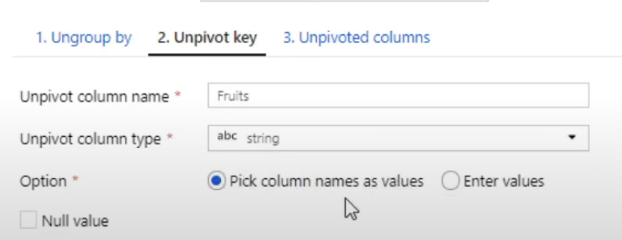

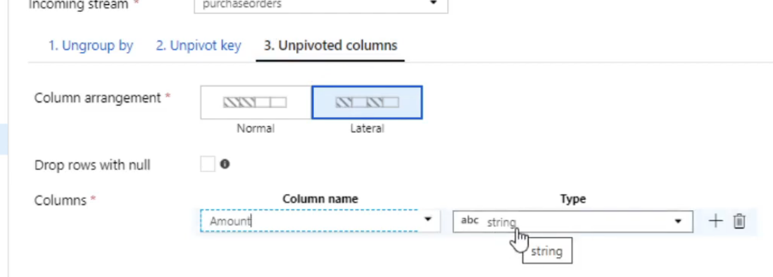

Surrogate Key:

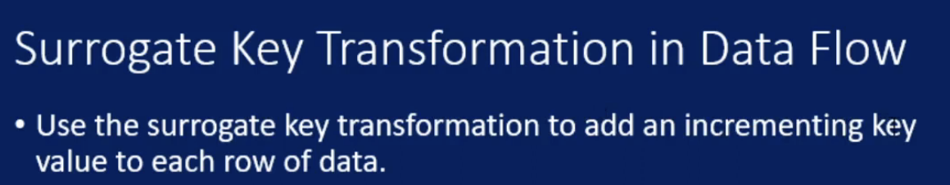

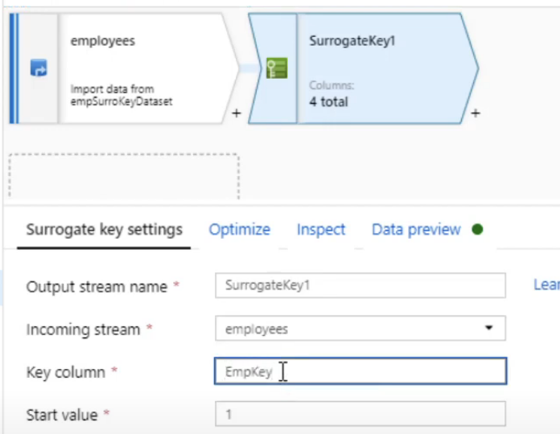

Window Transformation:

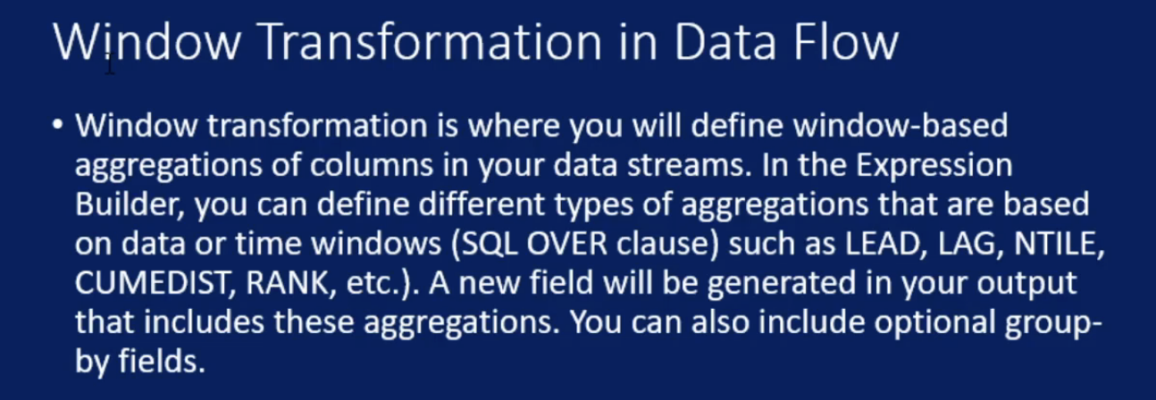

Same as sql window function

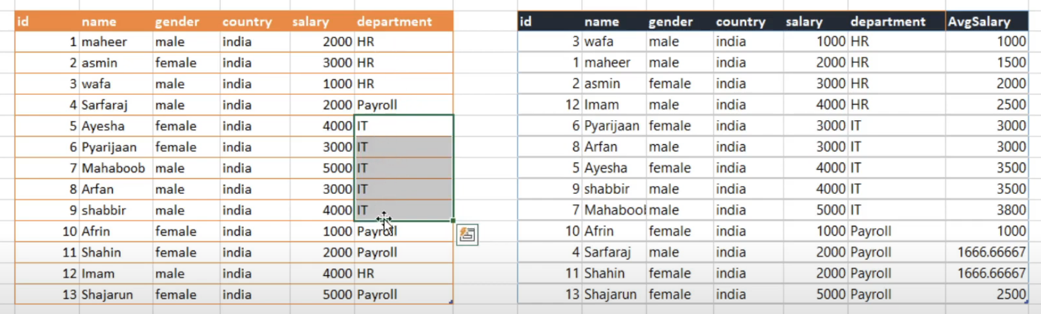

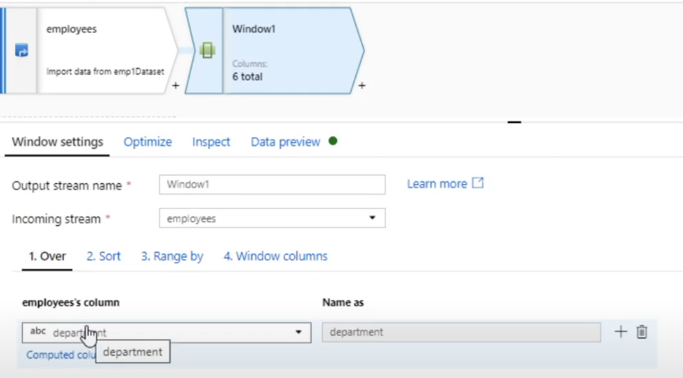

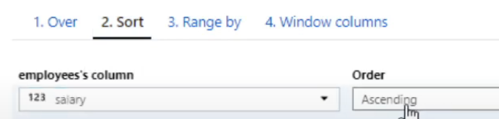

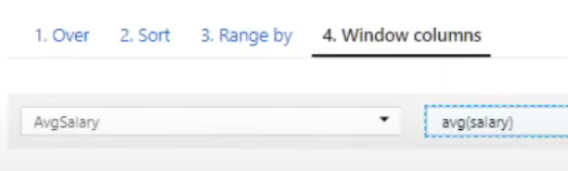

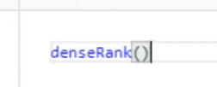

Alter Row:

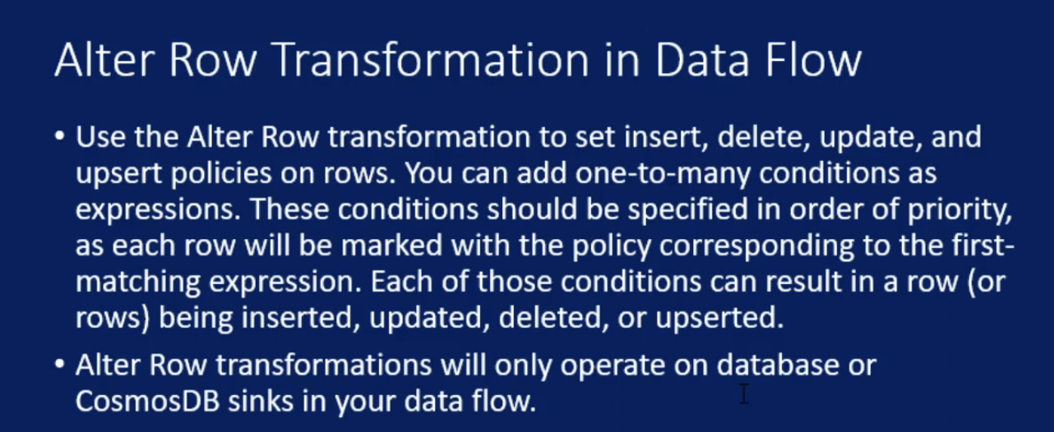

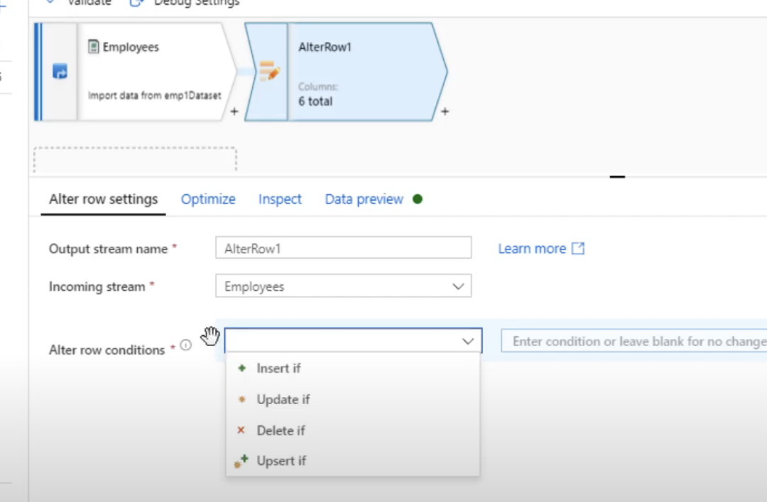

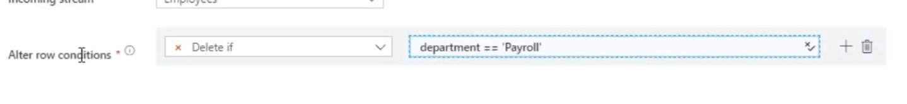

Rows with department as payroll will not be inserted

During update it will map with sink

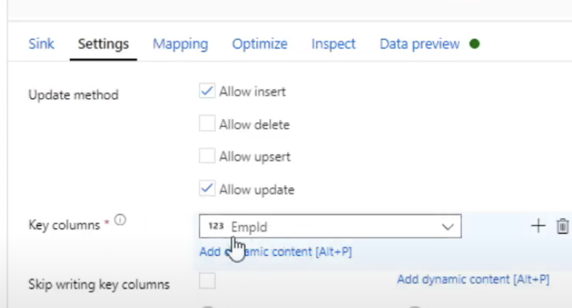

For update if Empid value is present in sink & source, then only that value will be updated

Flatten:

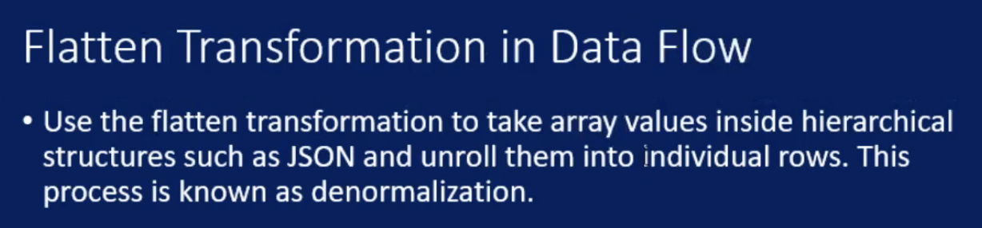

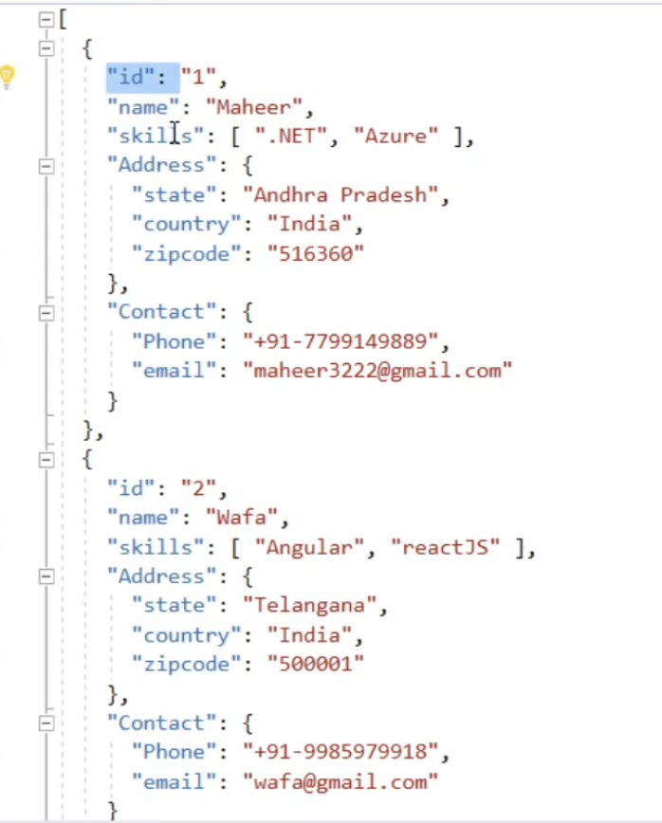

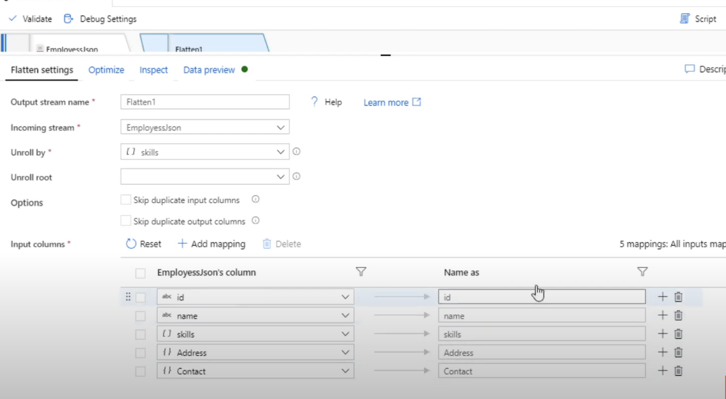

Paramterize Data Flow:

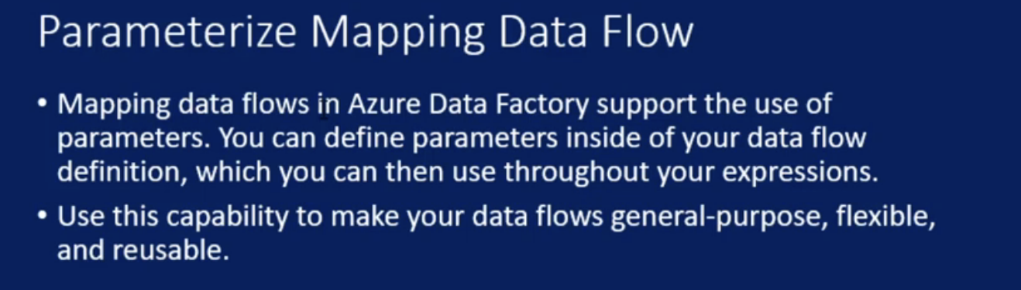

We can create parameter in dataflow and same parameter will be reflected in dataflow activity and we can create pipeline parameter and map pipeline parameter to dataflow parameter

Validate Schema:

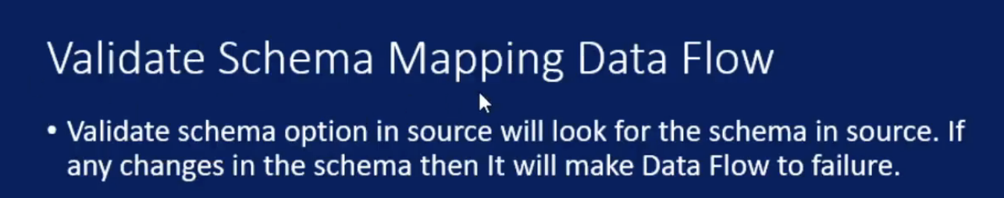

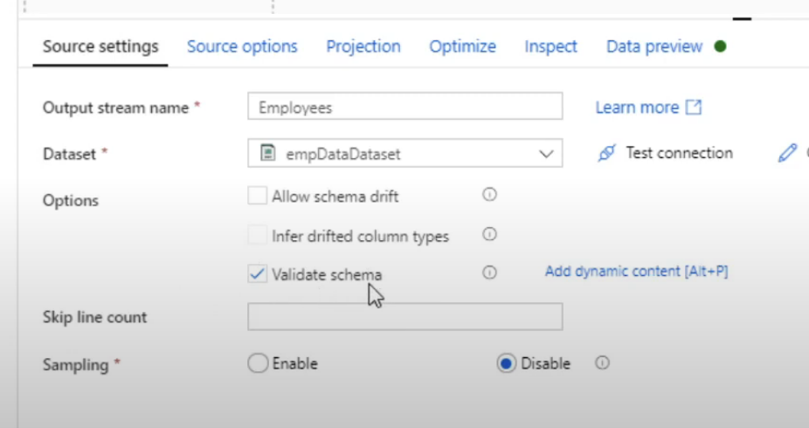

Schema Drift:

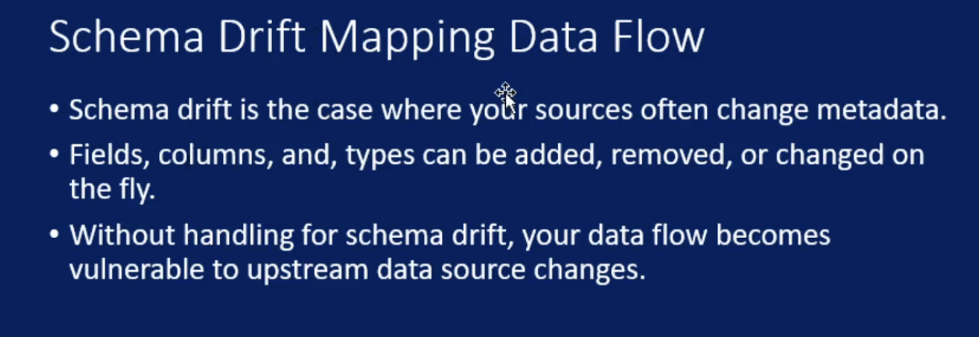

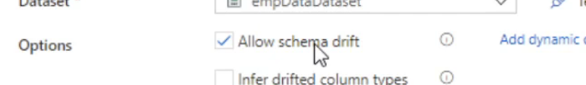

Wrangling Data Flow renamed as Power Query

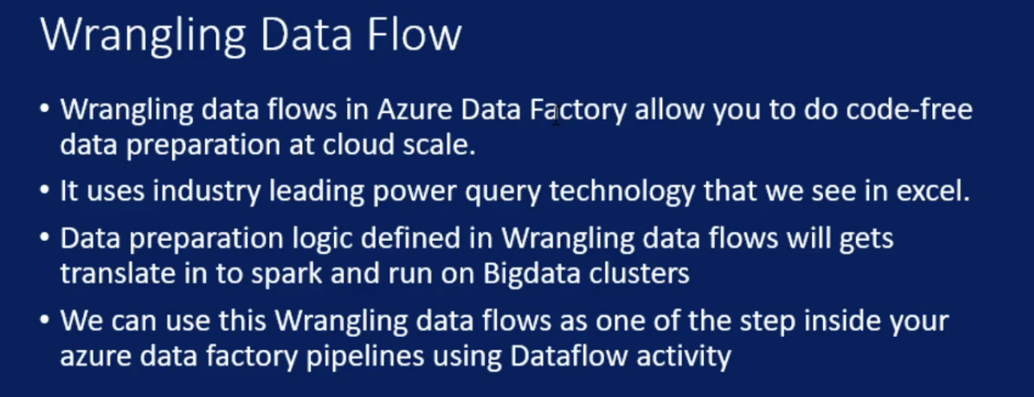

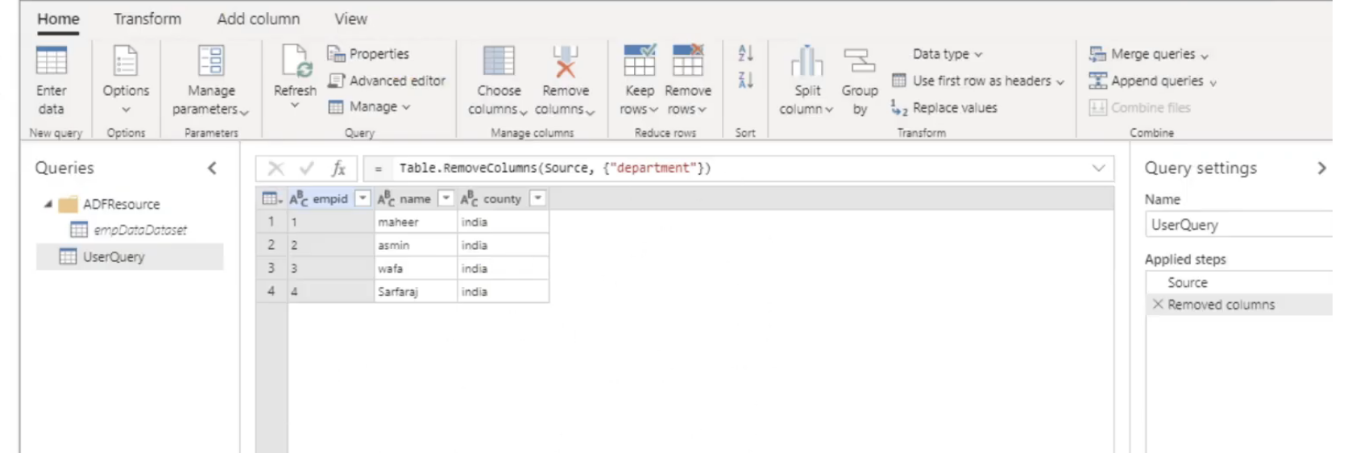

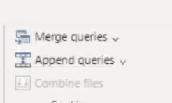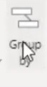

Author Modes:

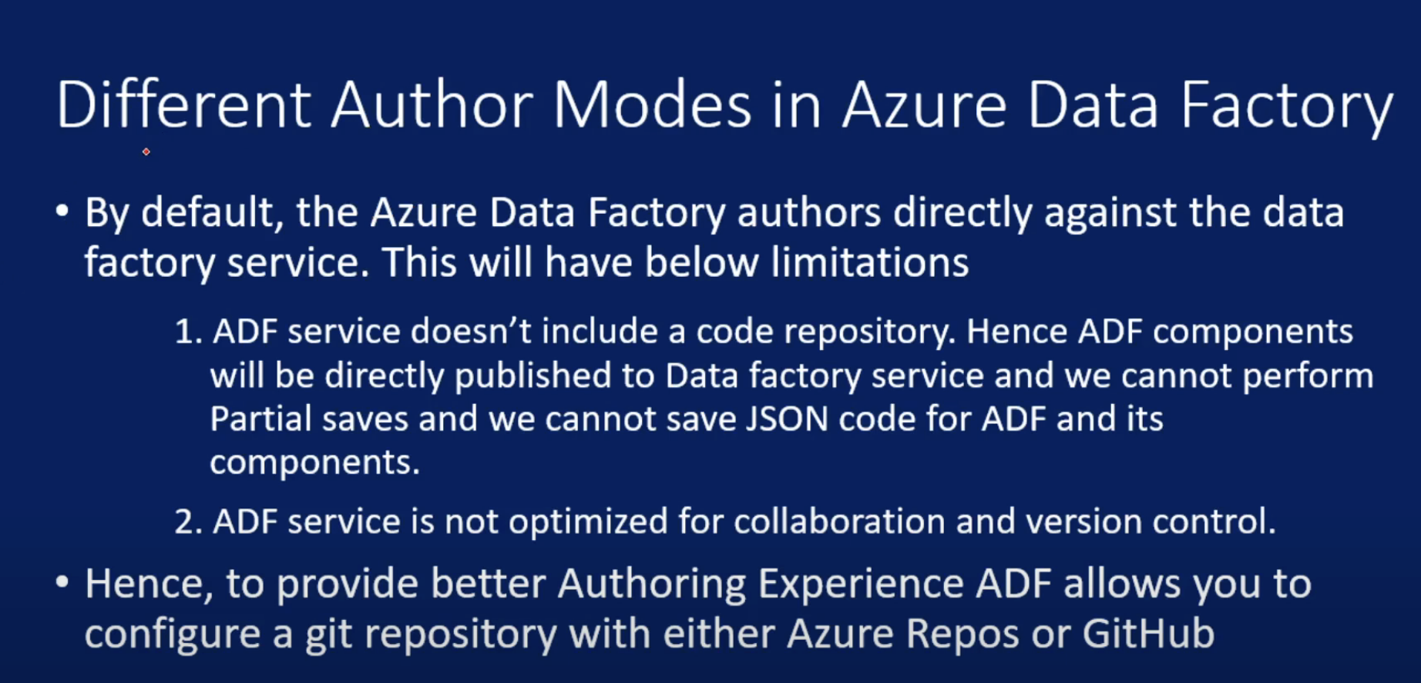

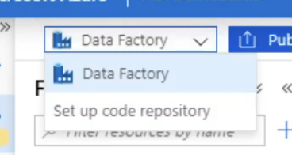

In default data factory mode u can’t save draft changes

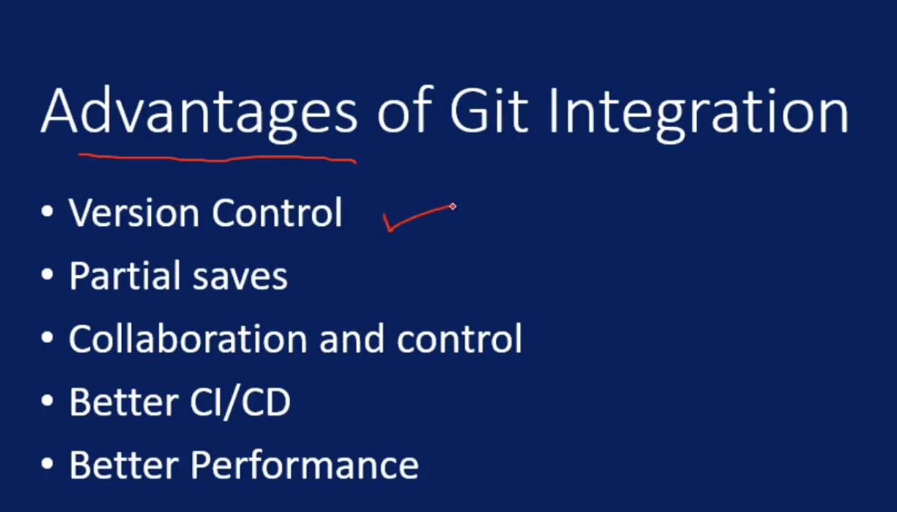

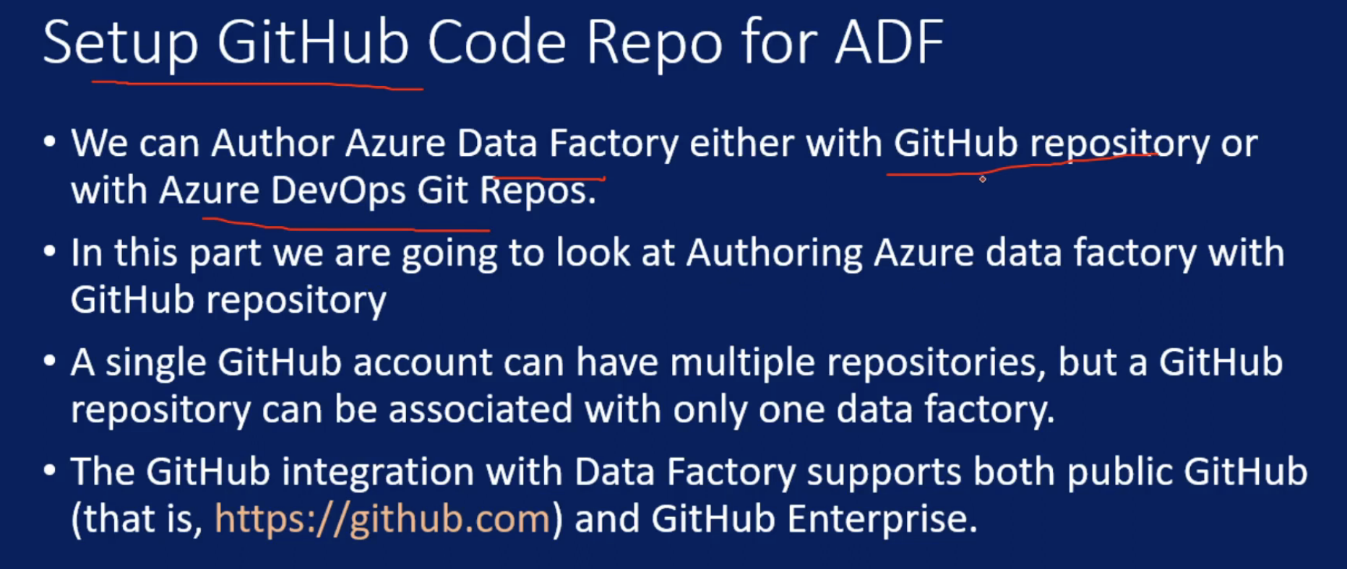

Key Vault Secret:

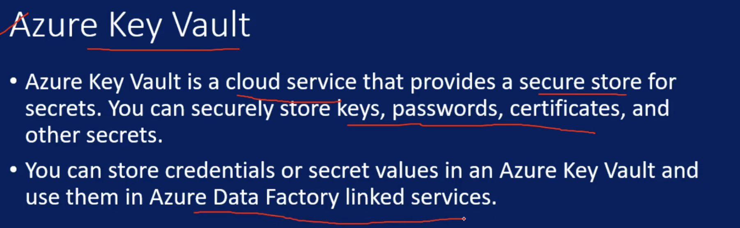

CI & CD in ADF:

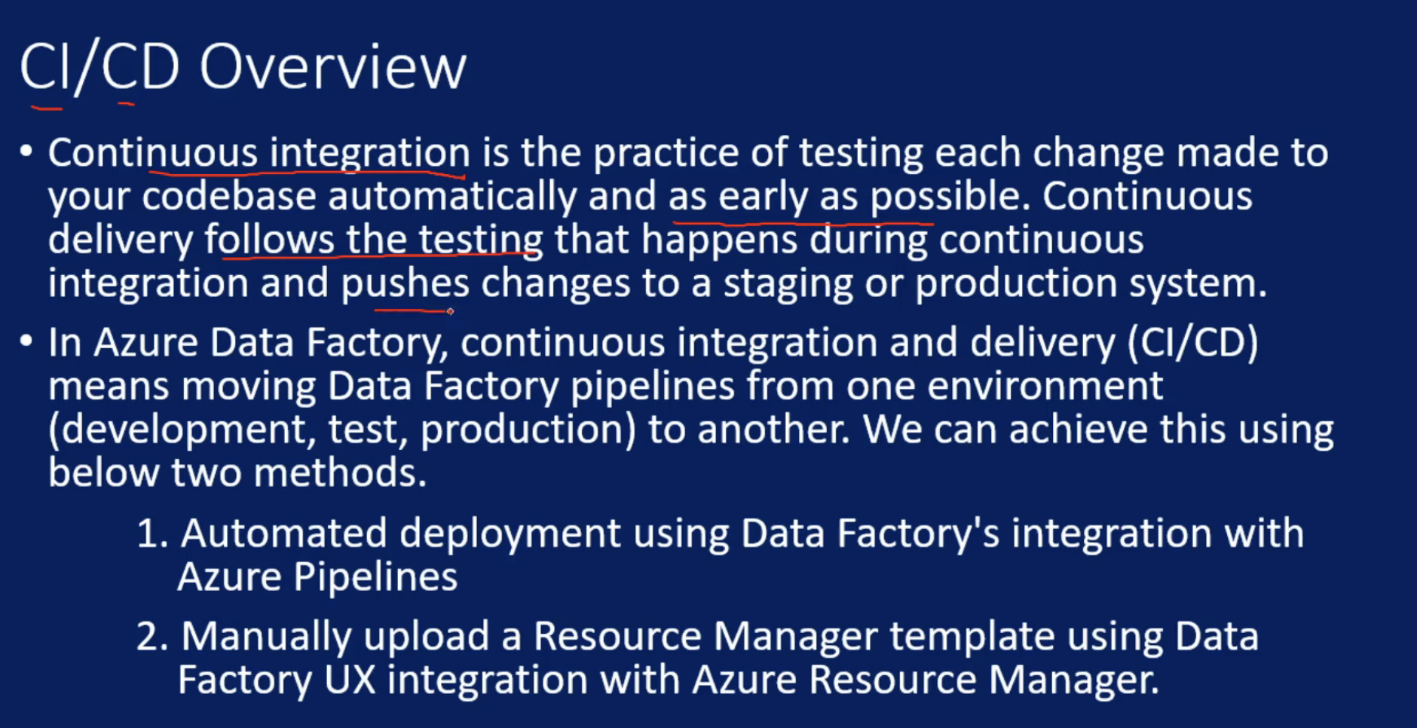

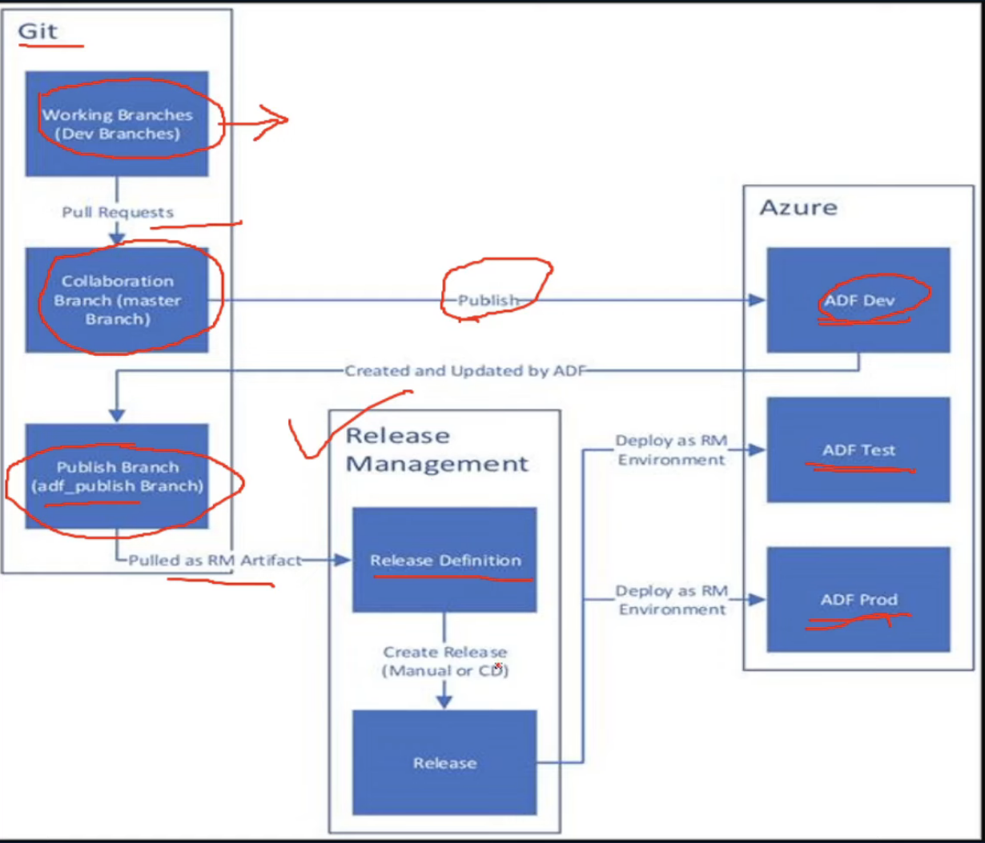

We can use parameters to deploy

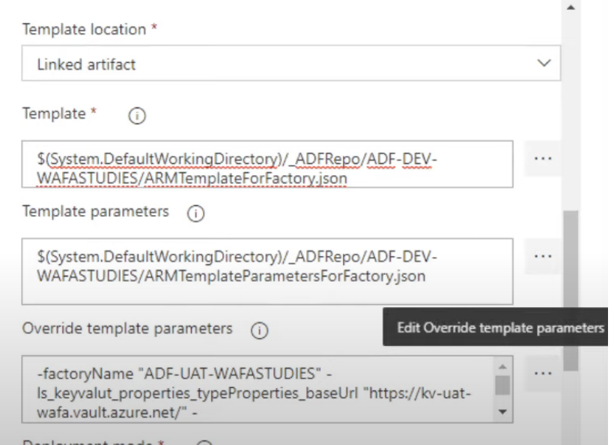

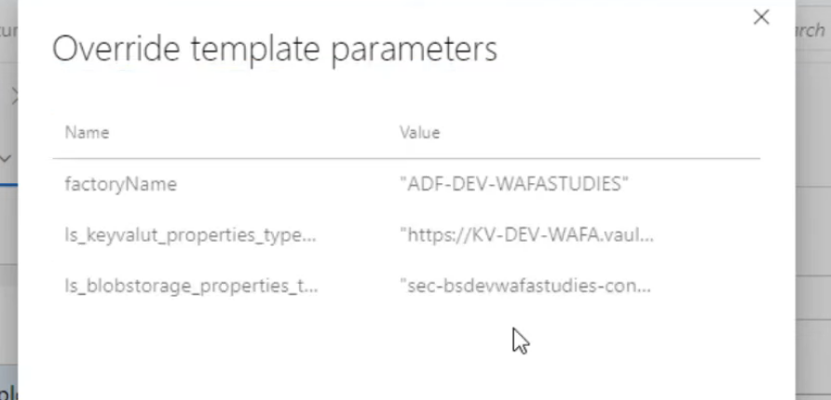

Read JSON of one Activity to Another:

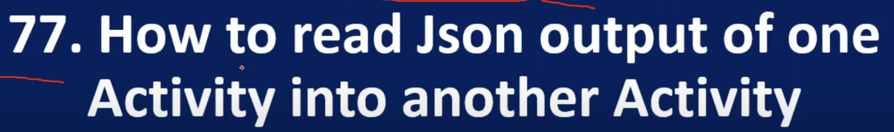

Use GetActivity and useforeach

Annotations:

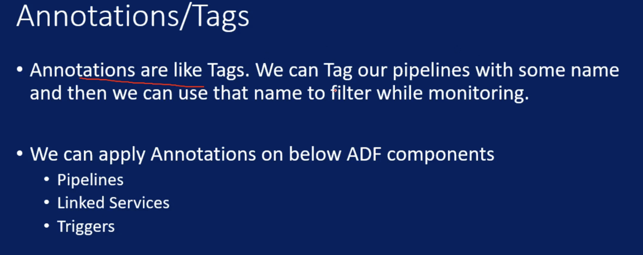

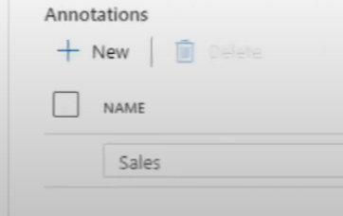

Templates:

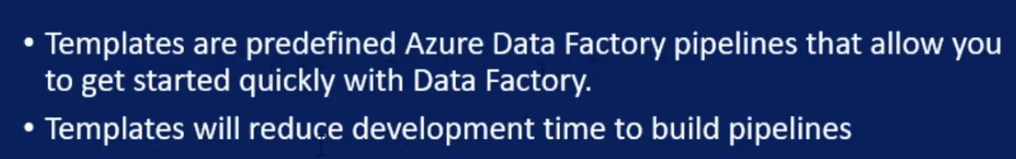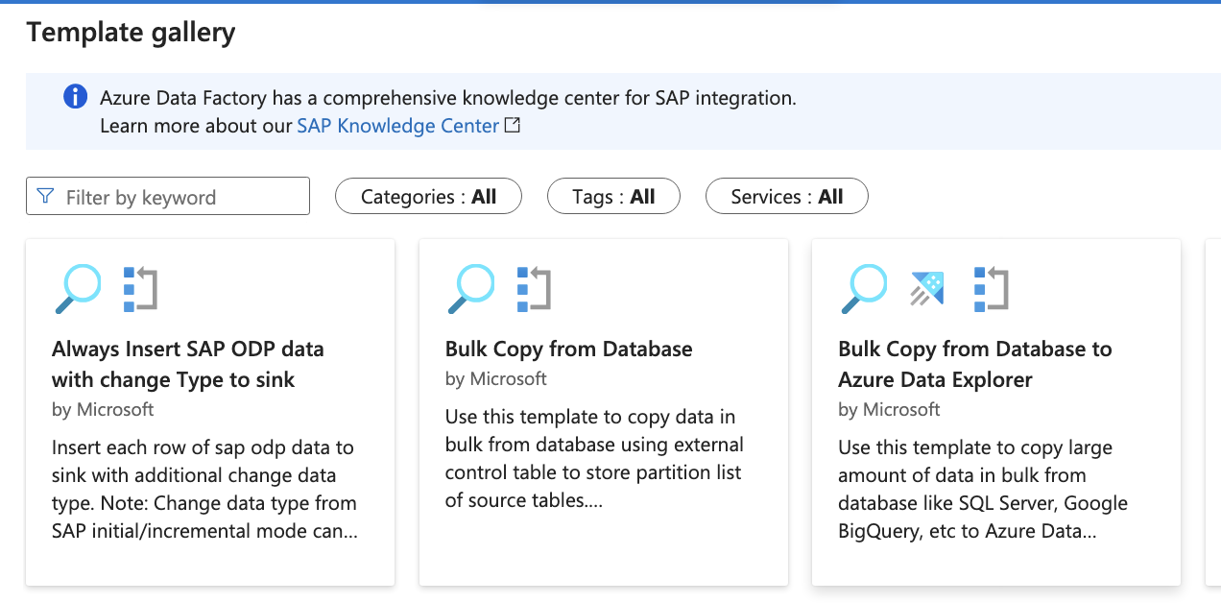

Global Paramters:

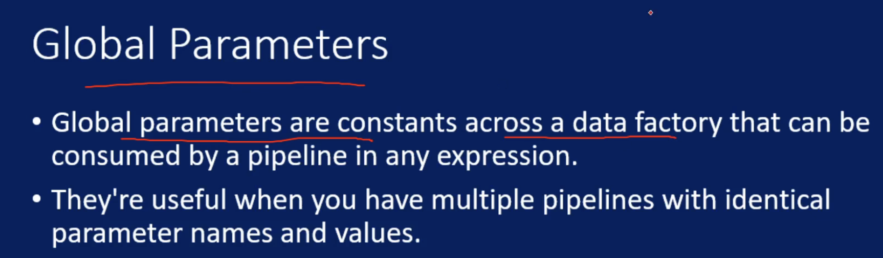

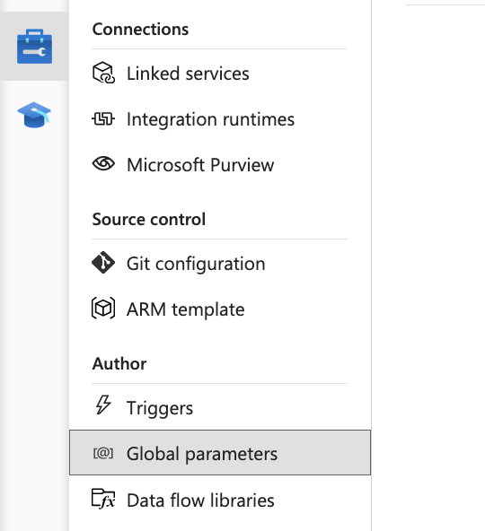

Rank

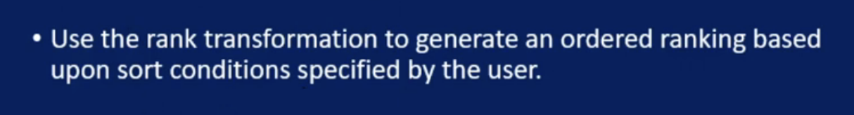

Same as sql

Cache Sink & Lookup:

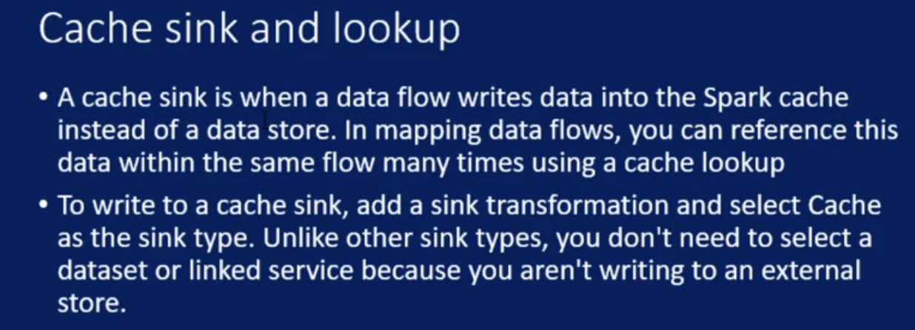

I have tbl_country table:

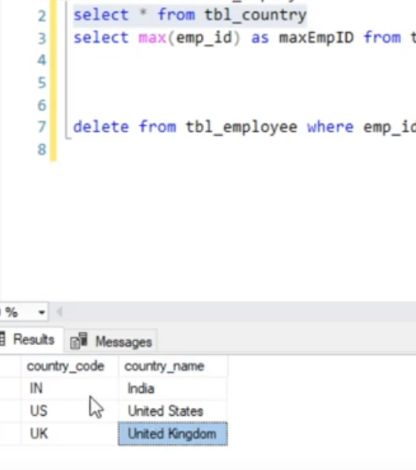

When I insert to tbl_employee we should replace IN with India

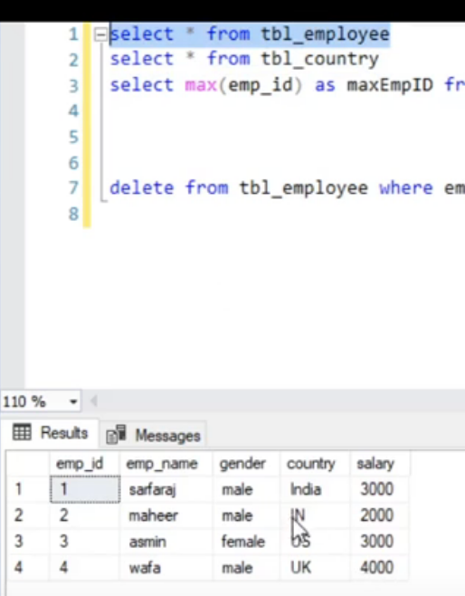

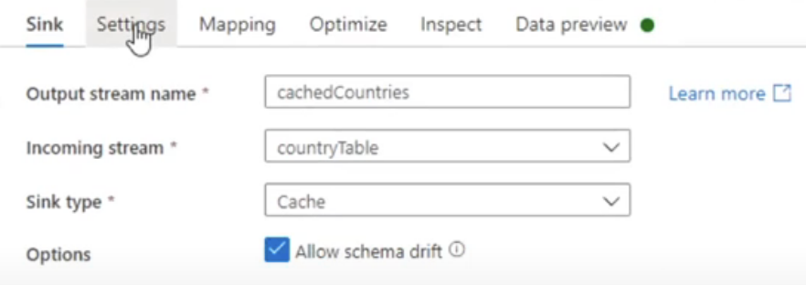

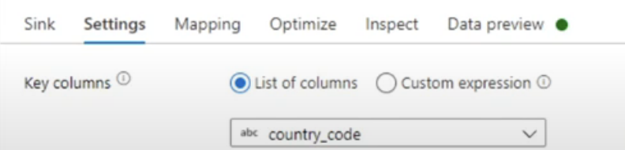

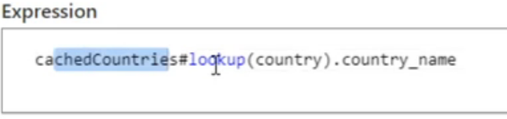

Session Log in Copy Activity;

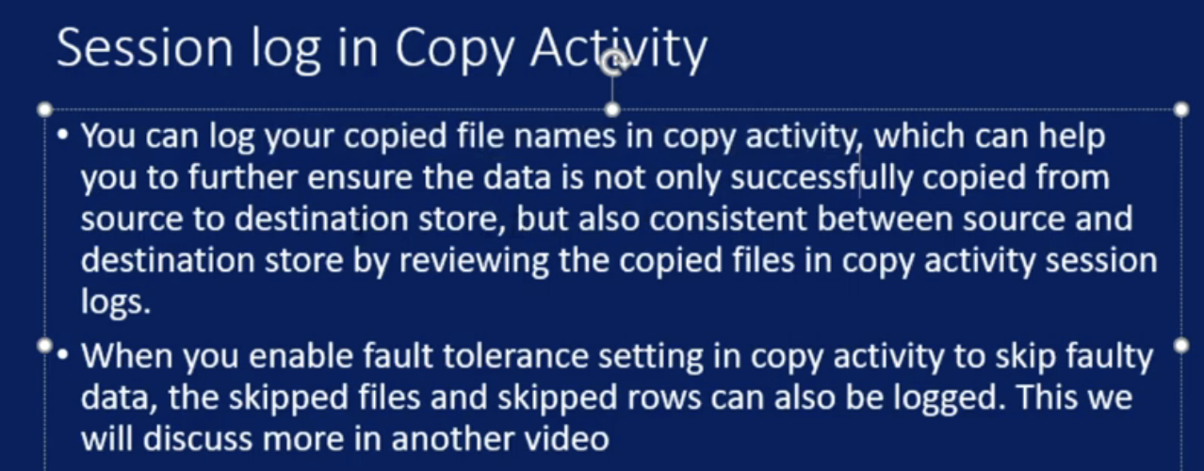

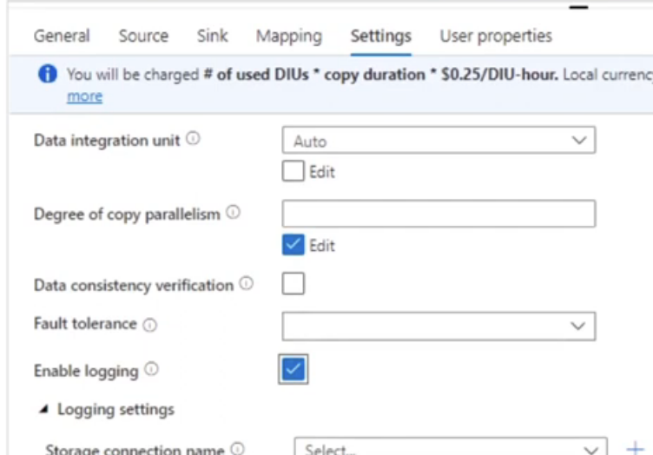

Create variable in pipeline

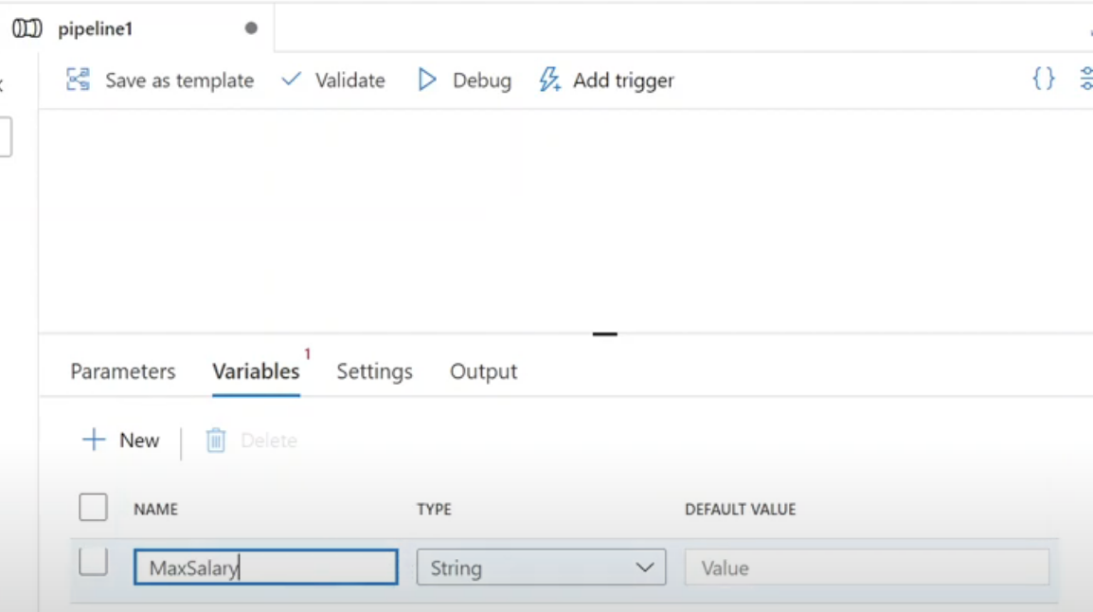

We can do cache sink and from cache sink we can get value

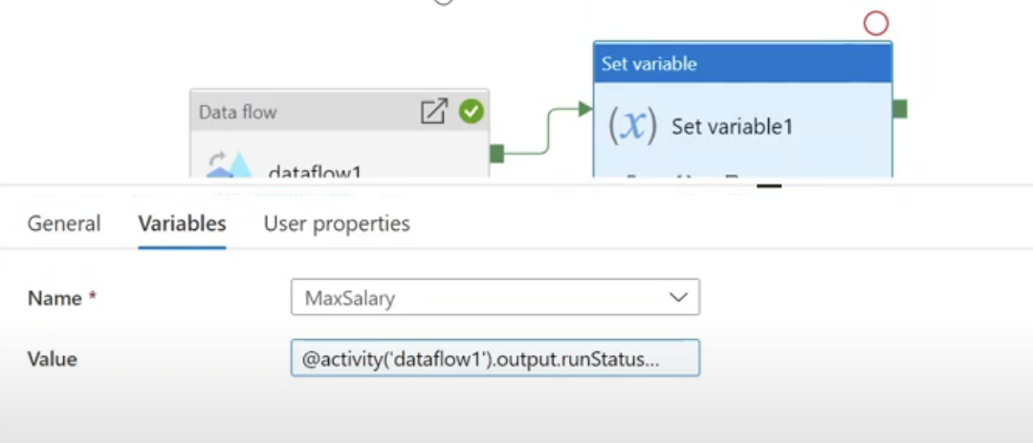

Parse Transformation:

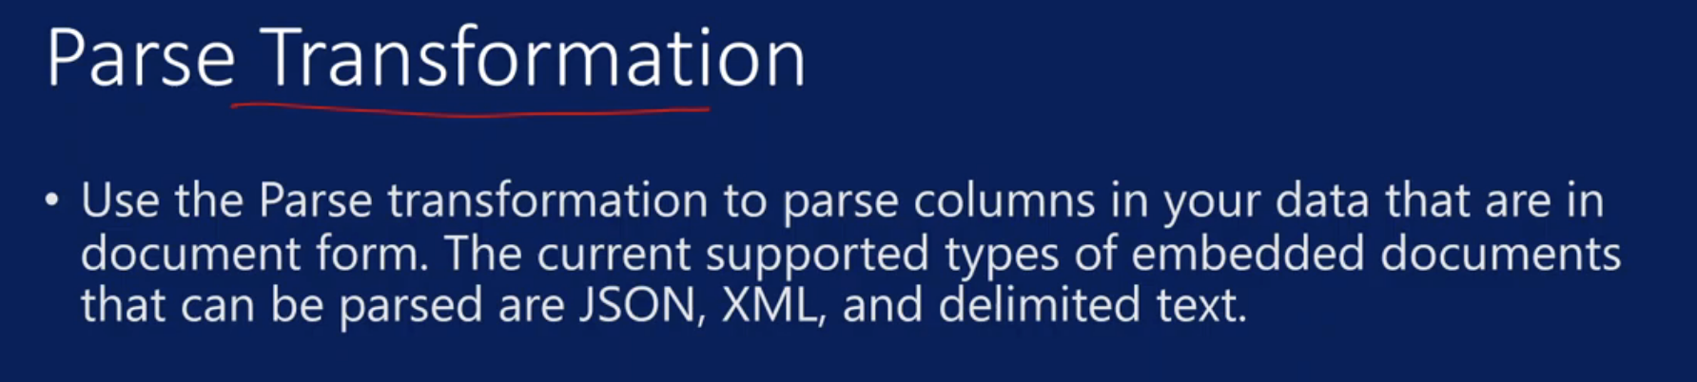

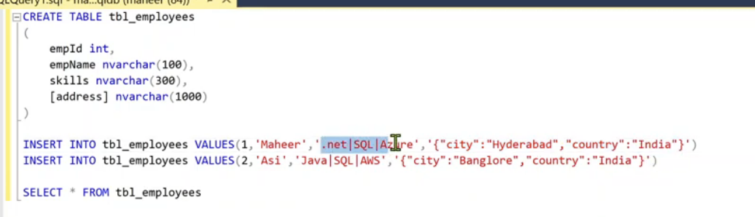

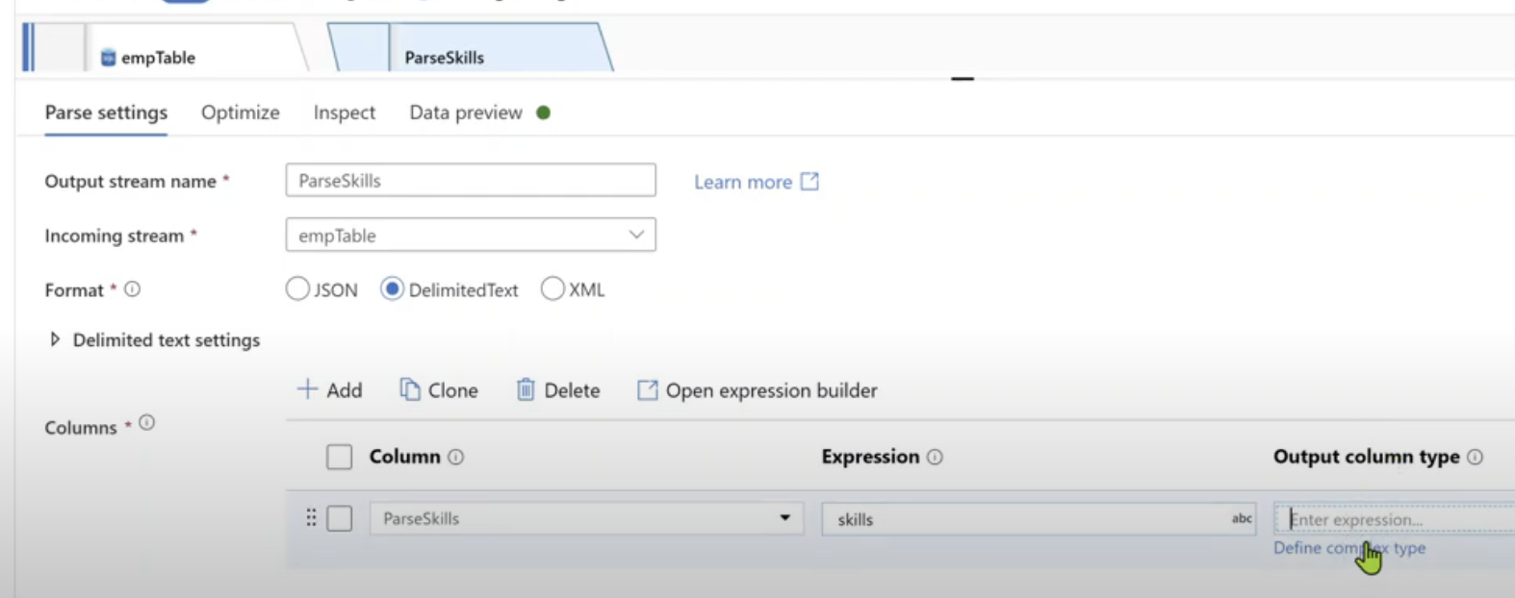

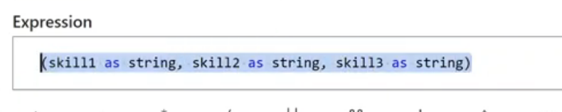

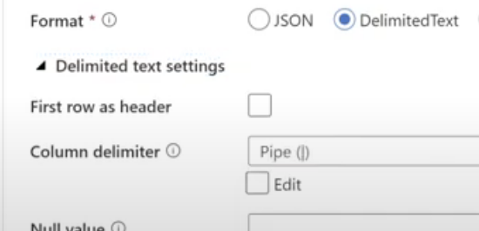

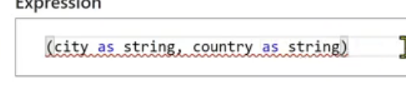

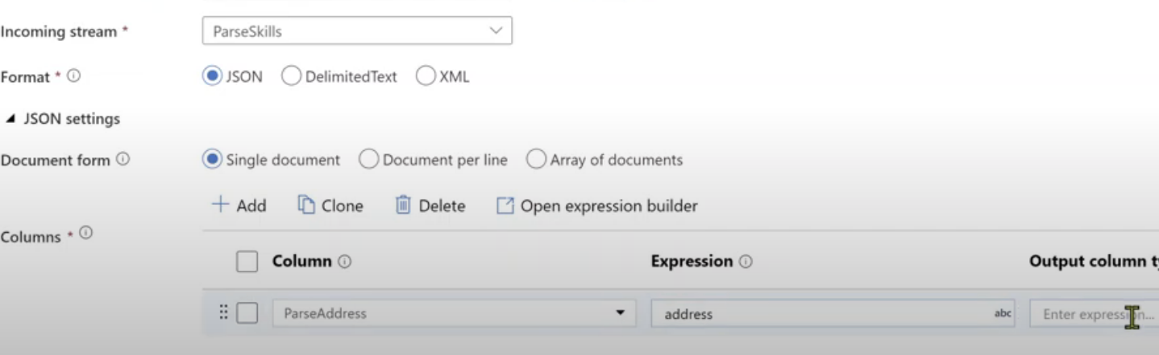

Fail Activity:

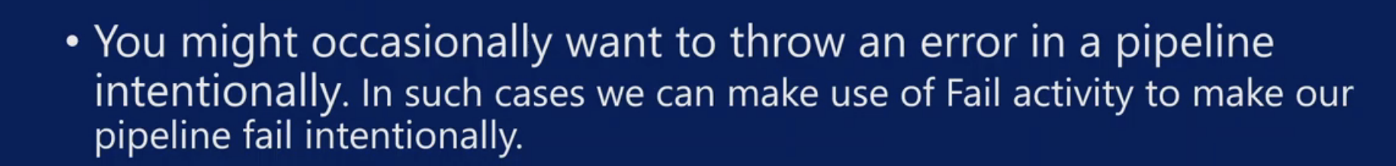

Inline Dataset:

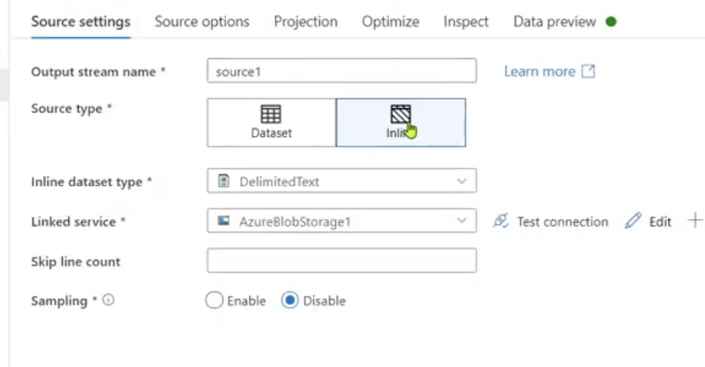

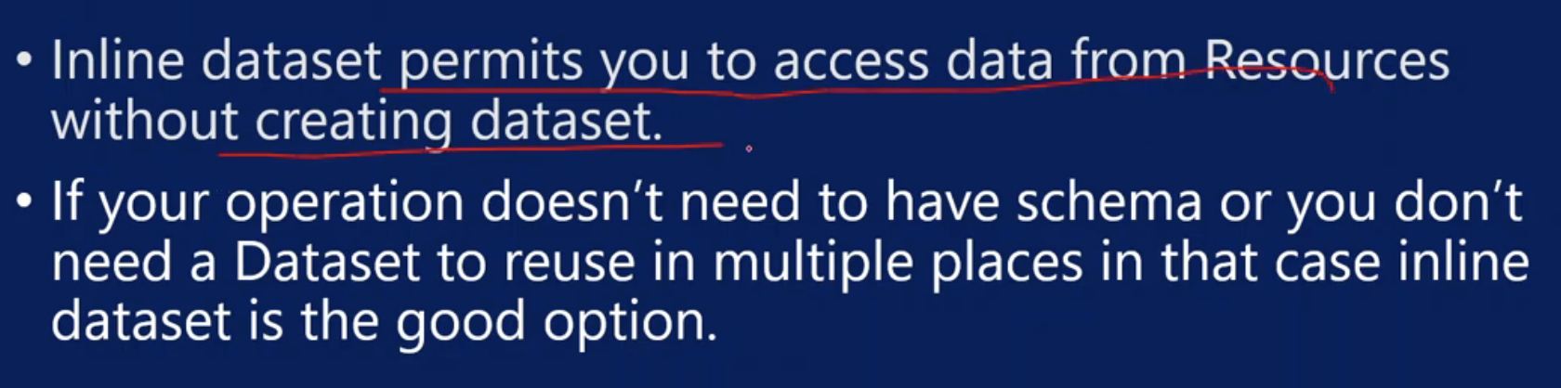

Stringify

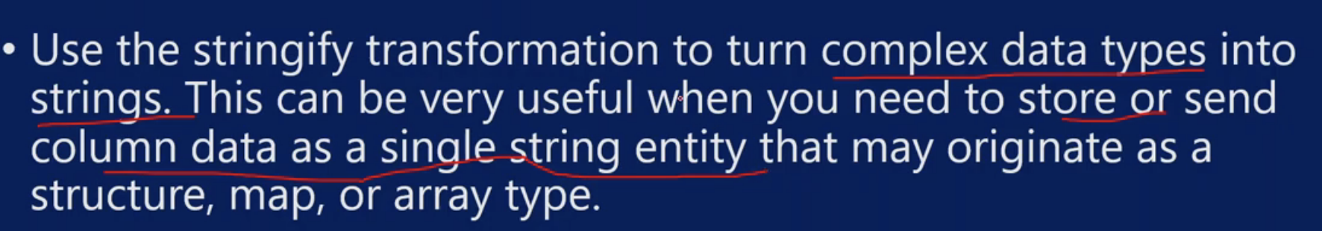

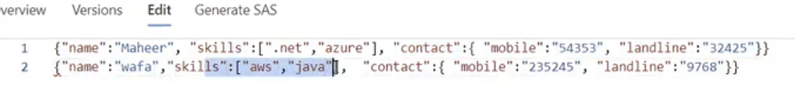

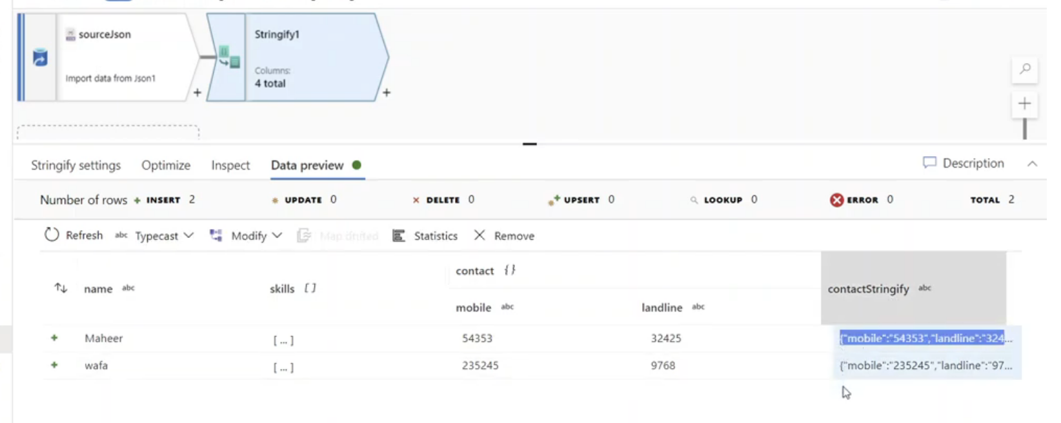

Assert Transformation:

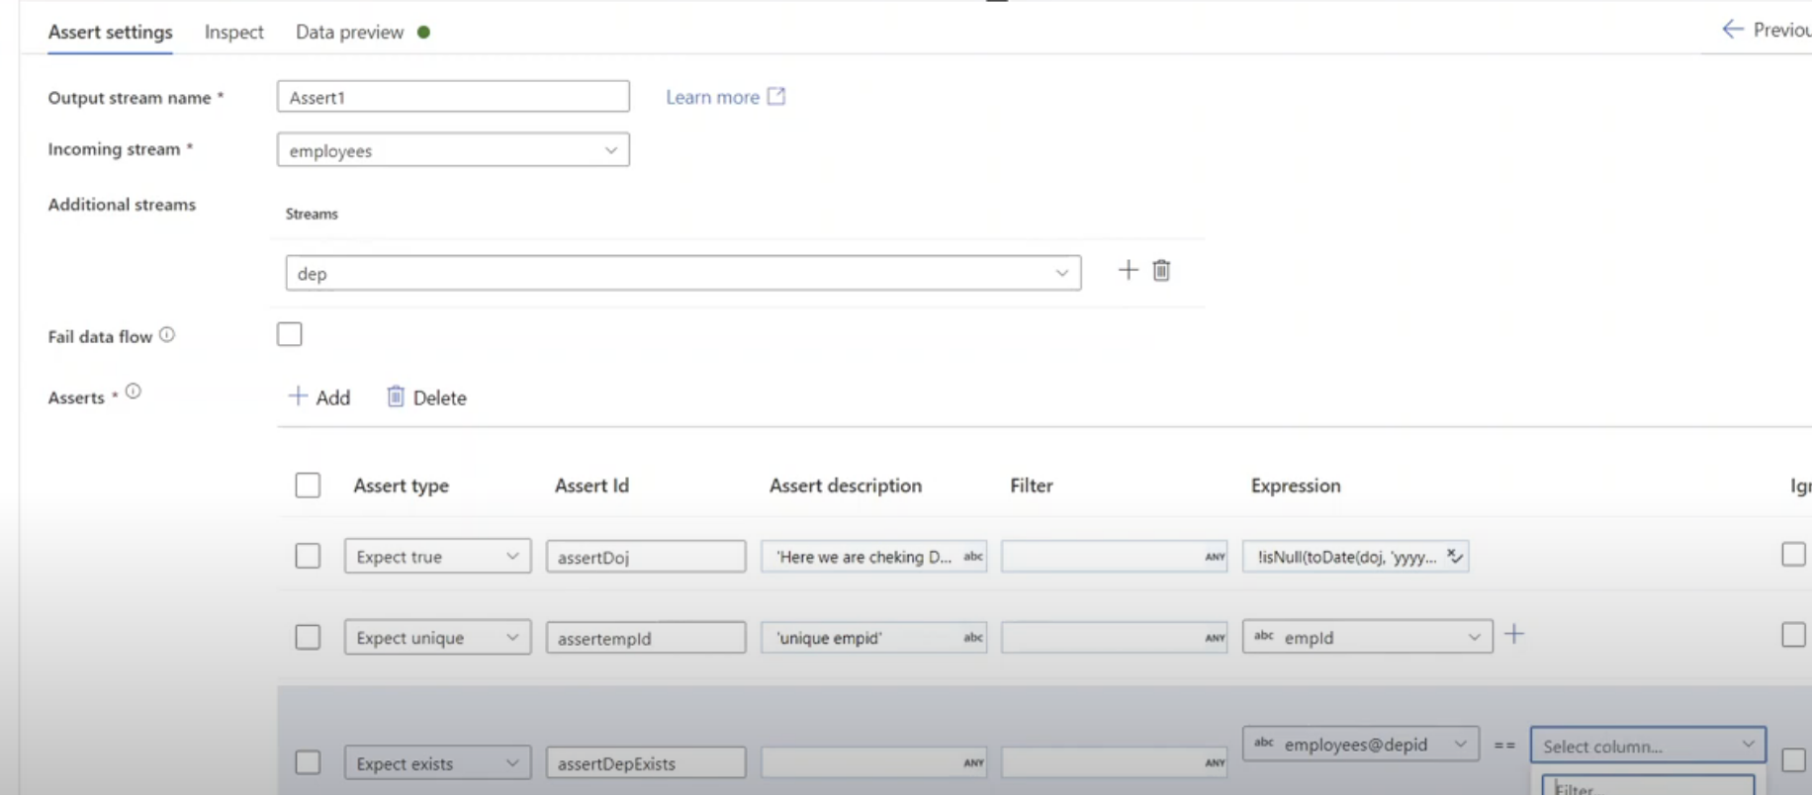

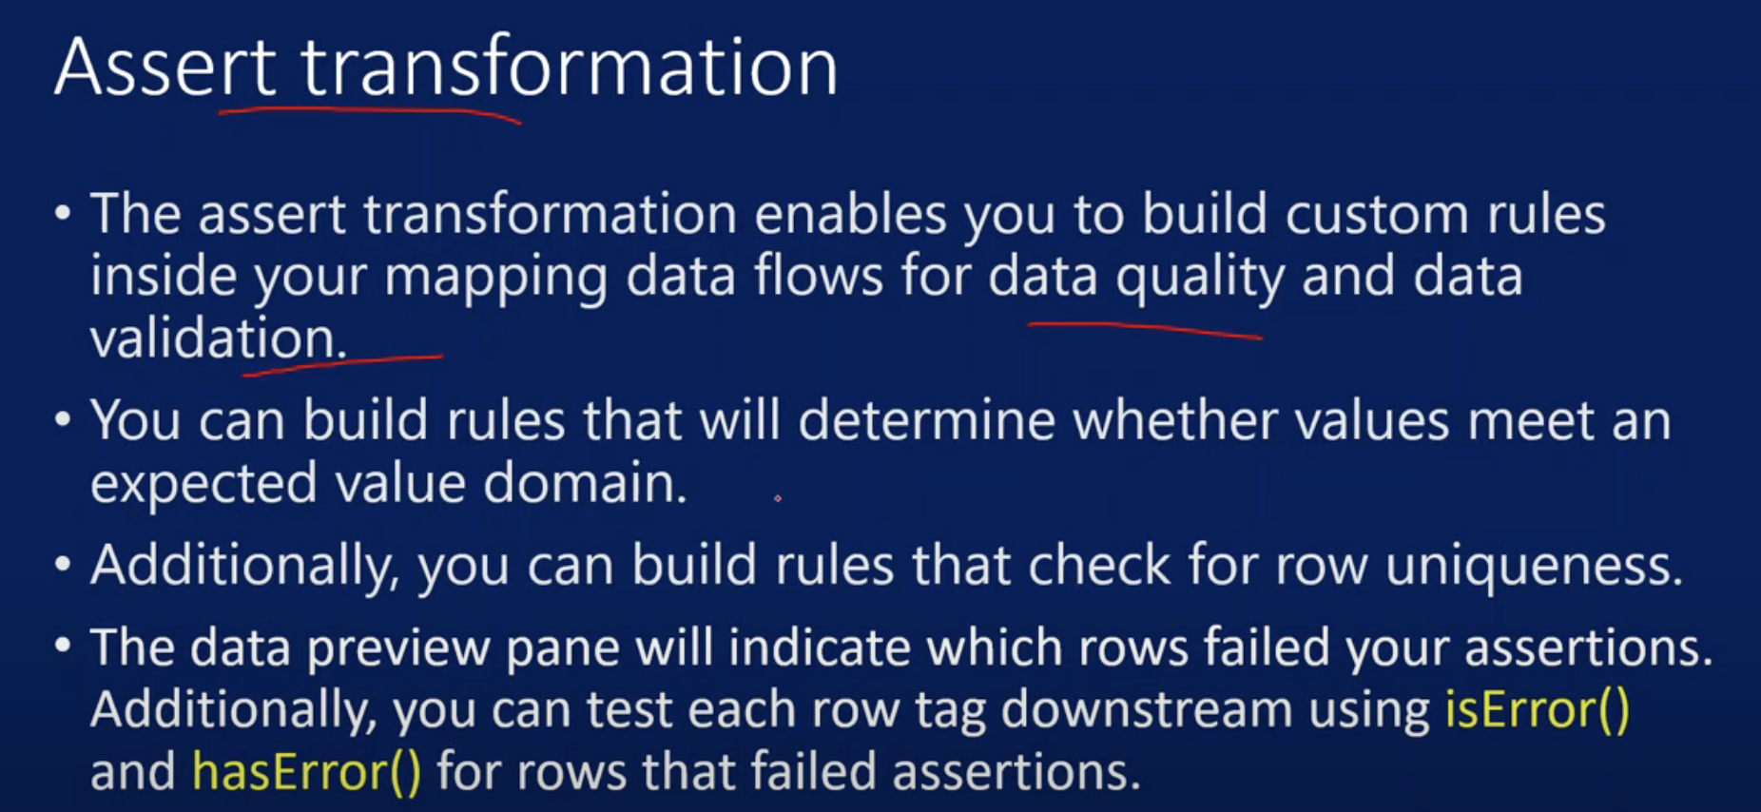

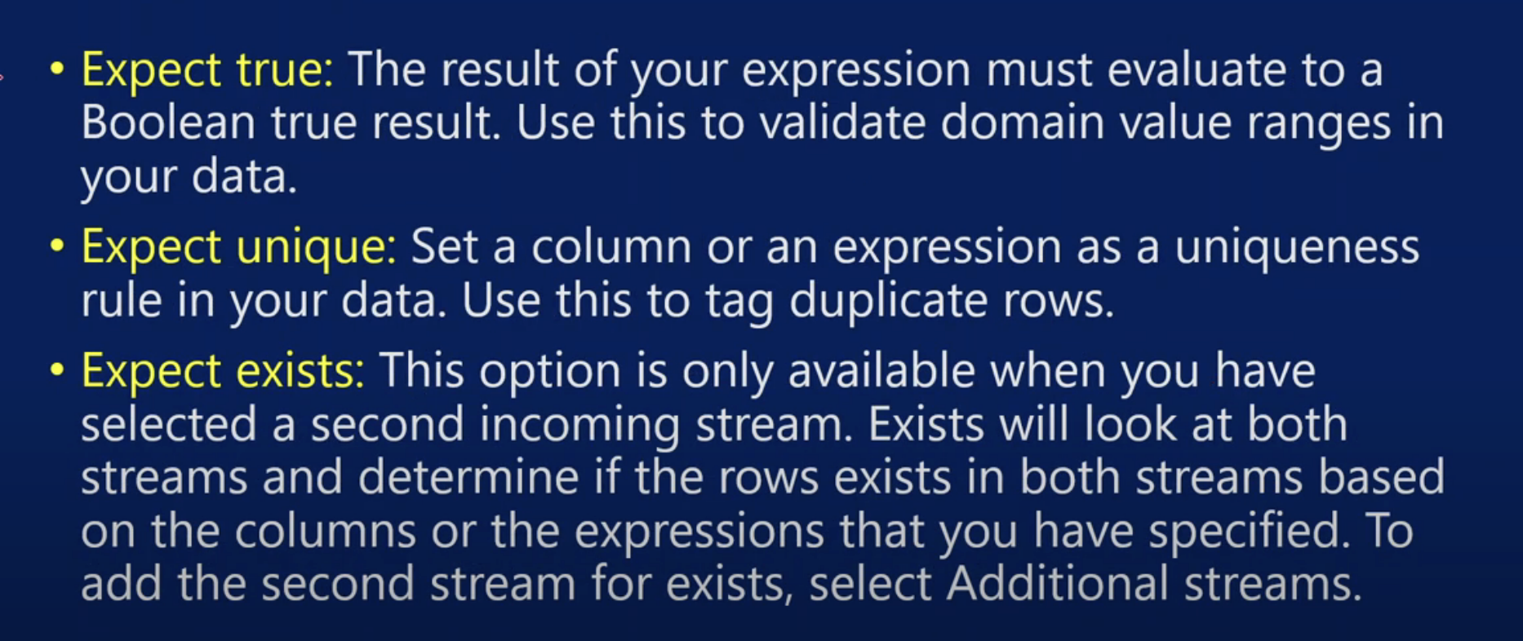

Flowlet:



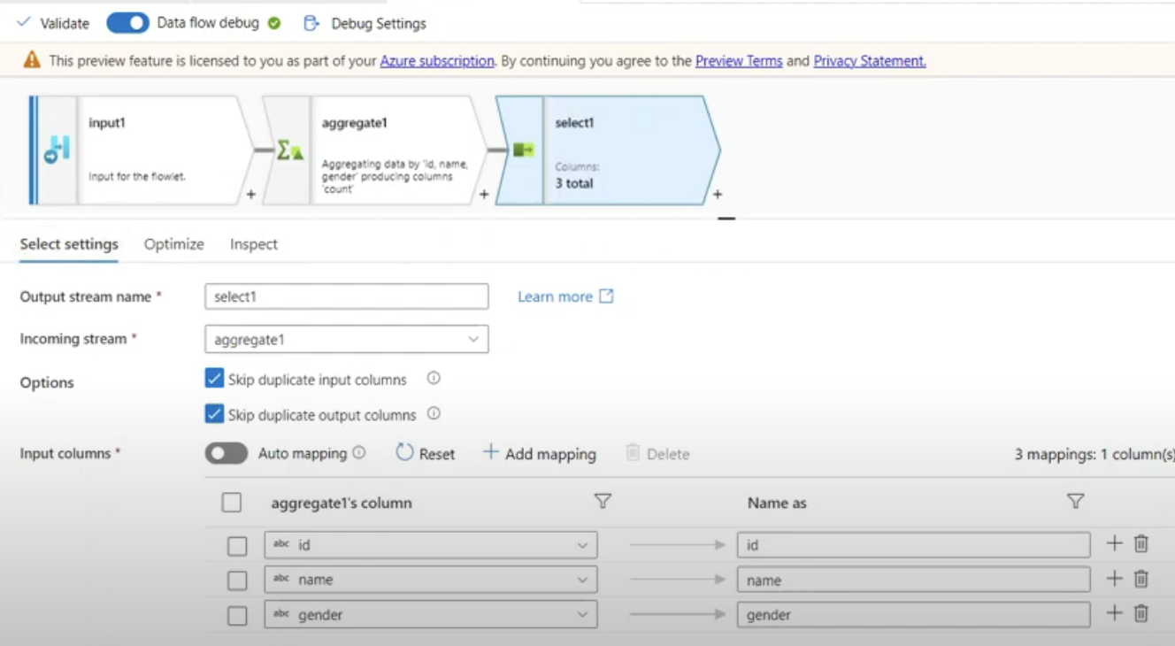

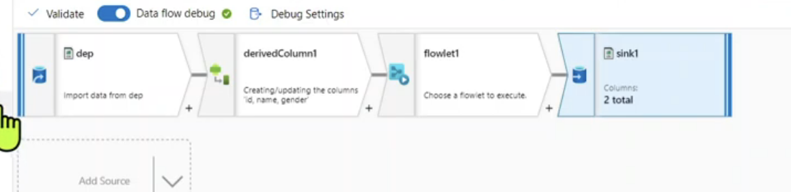

Script Activity:

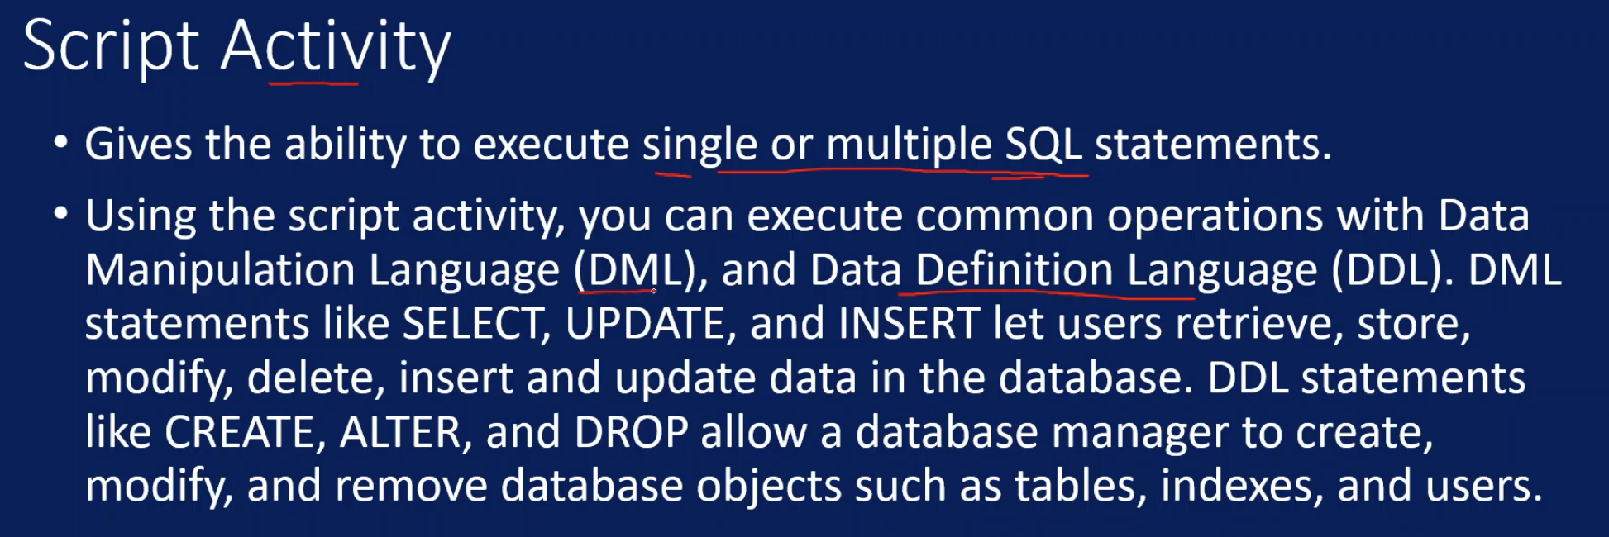

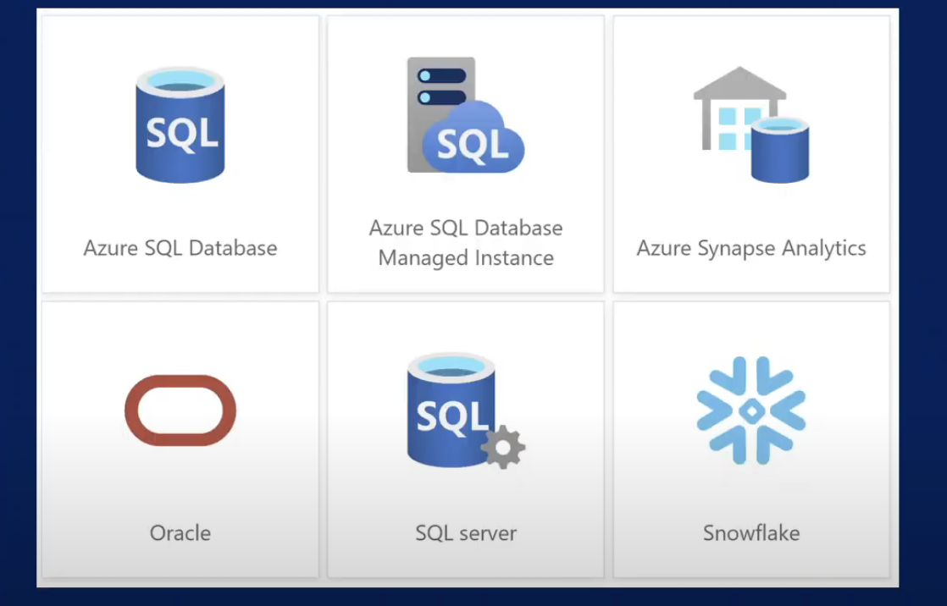

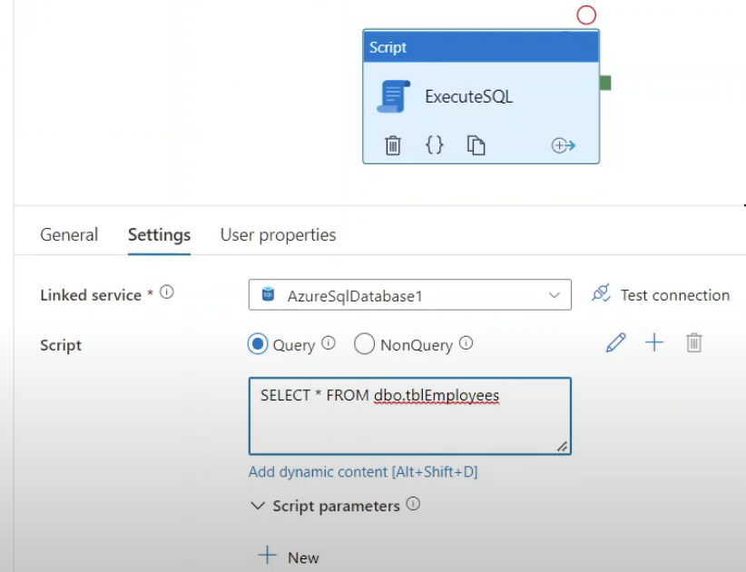

User Defined Functions:

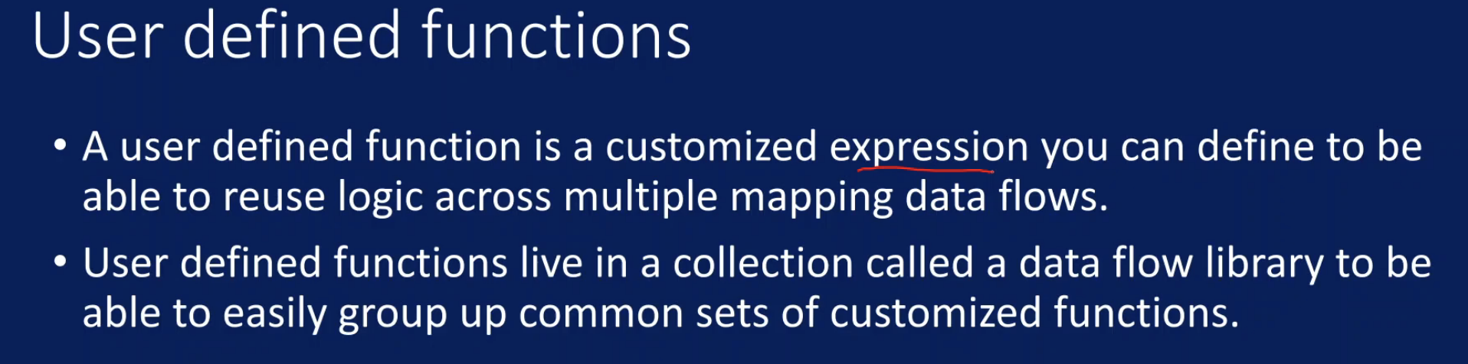

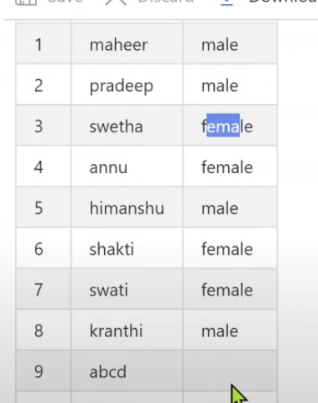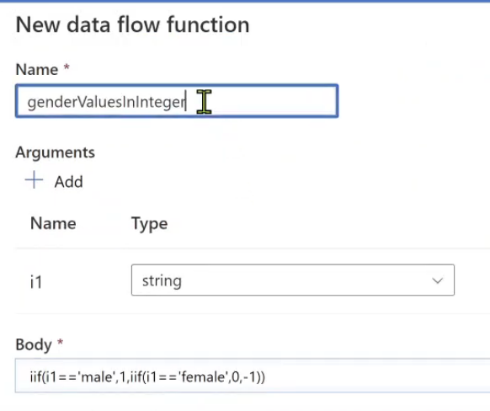

Convert male to 1 n female to 0 and null to -1

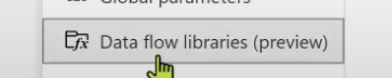

Fuzzy Joins:

Even if there is slight mismatch join should work

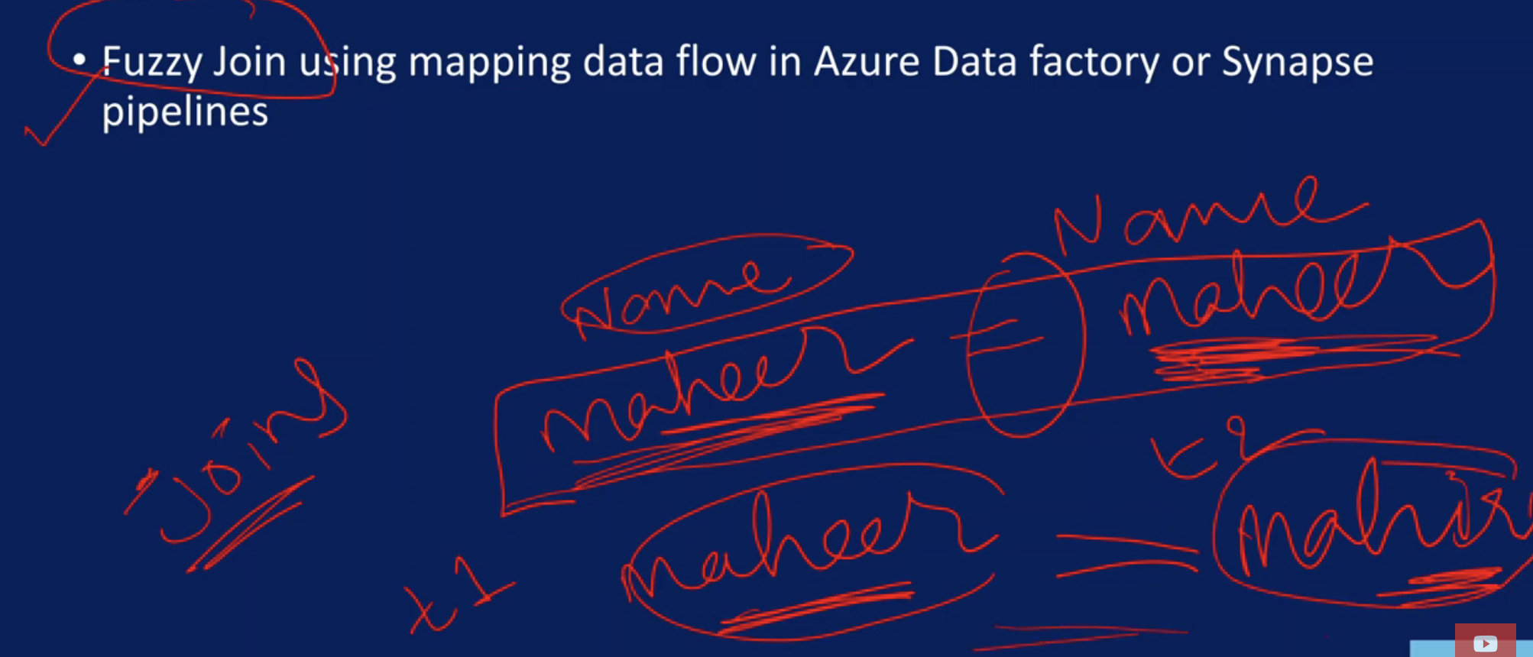

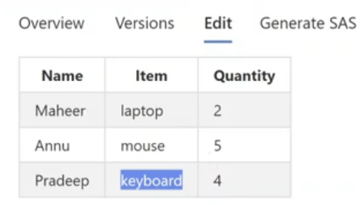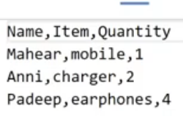

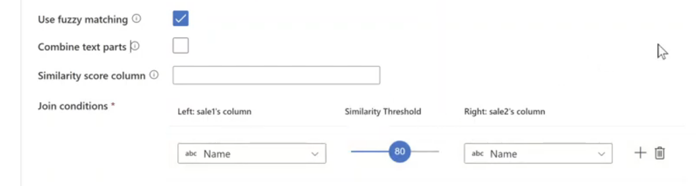

Parametrized Using Advanced:

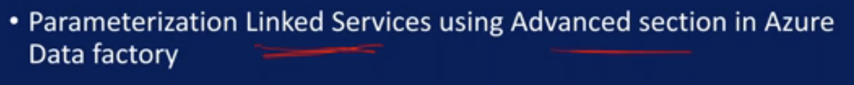

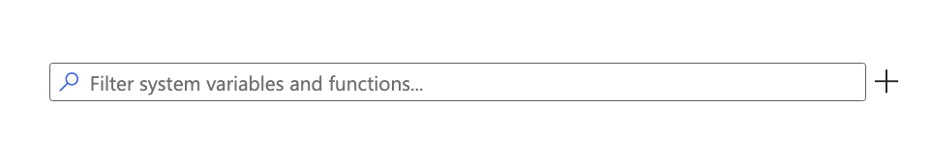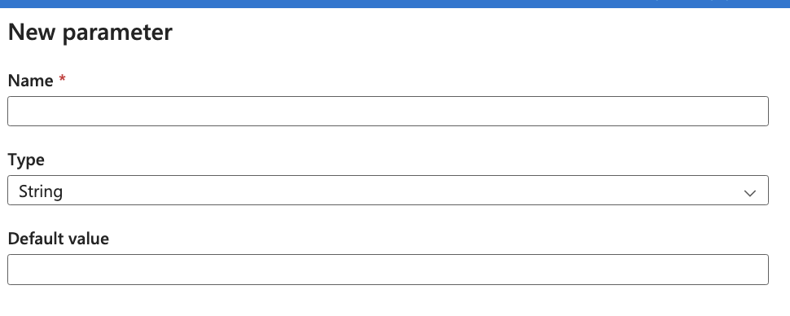

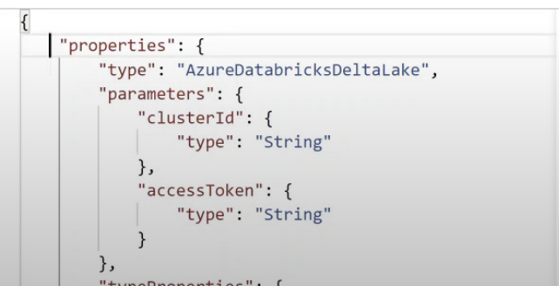

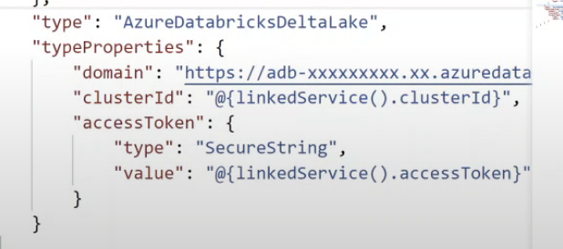

Cast Transformation:

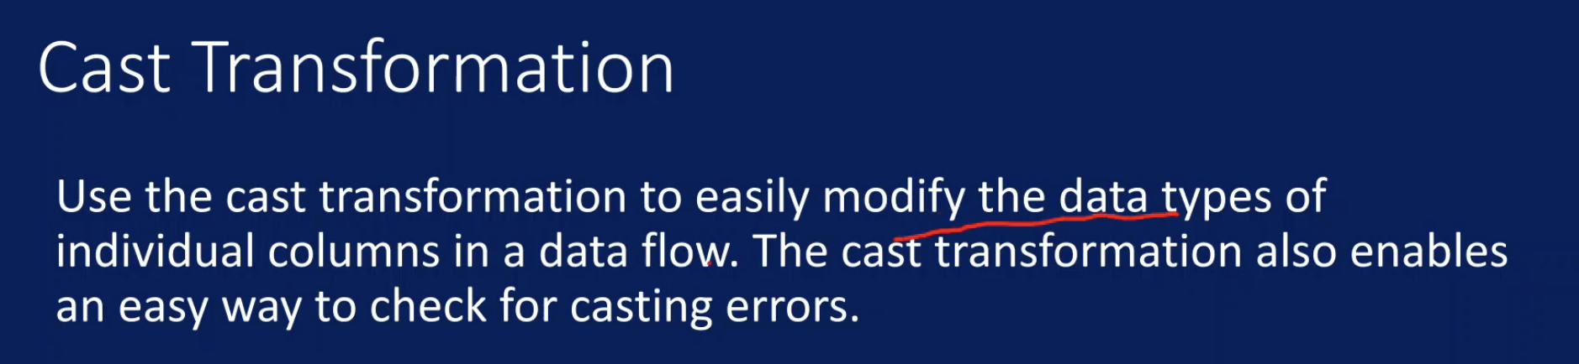

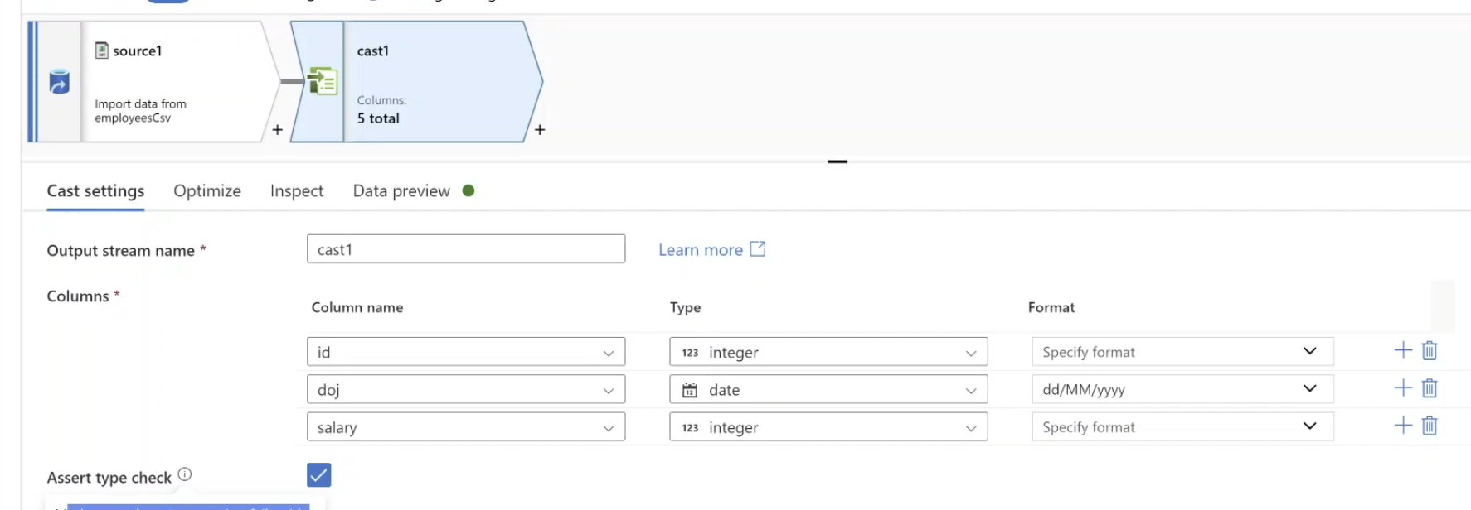

Extract Data from Webpage

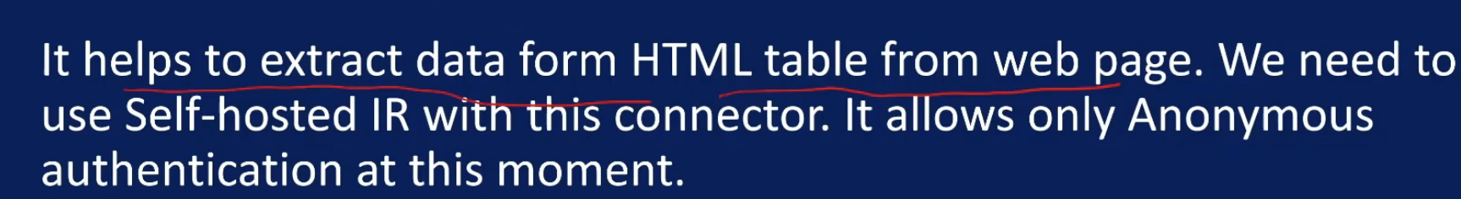

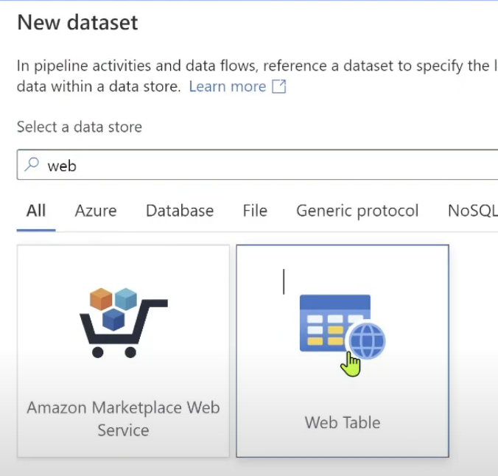

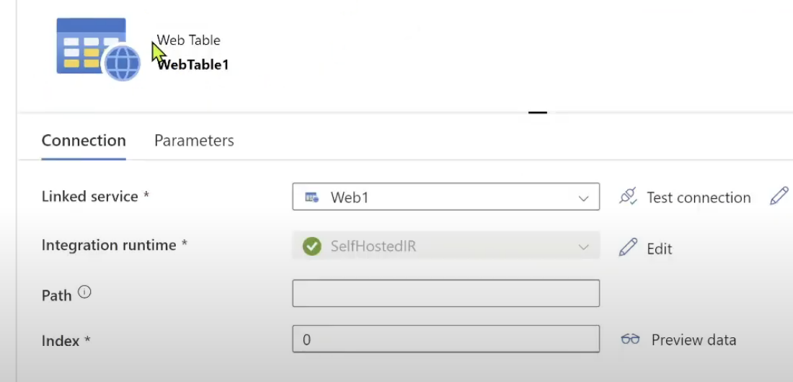

Per Pipeline Billed:



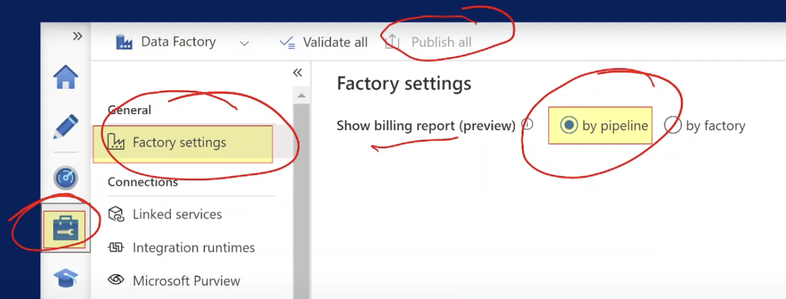

TimeToLive:

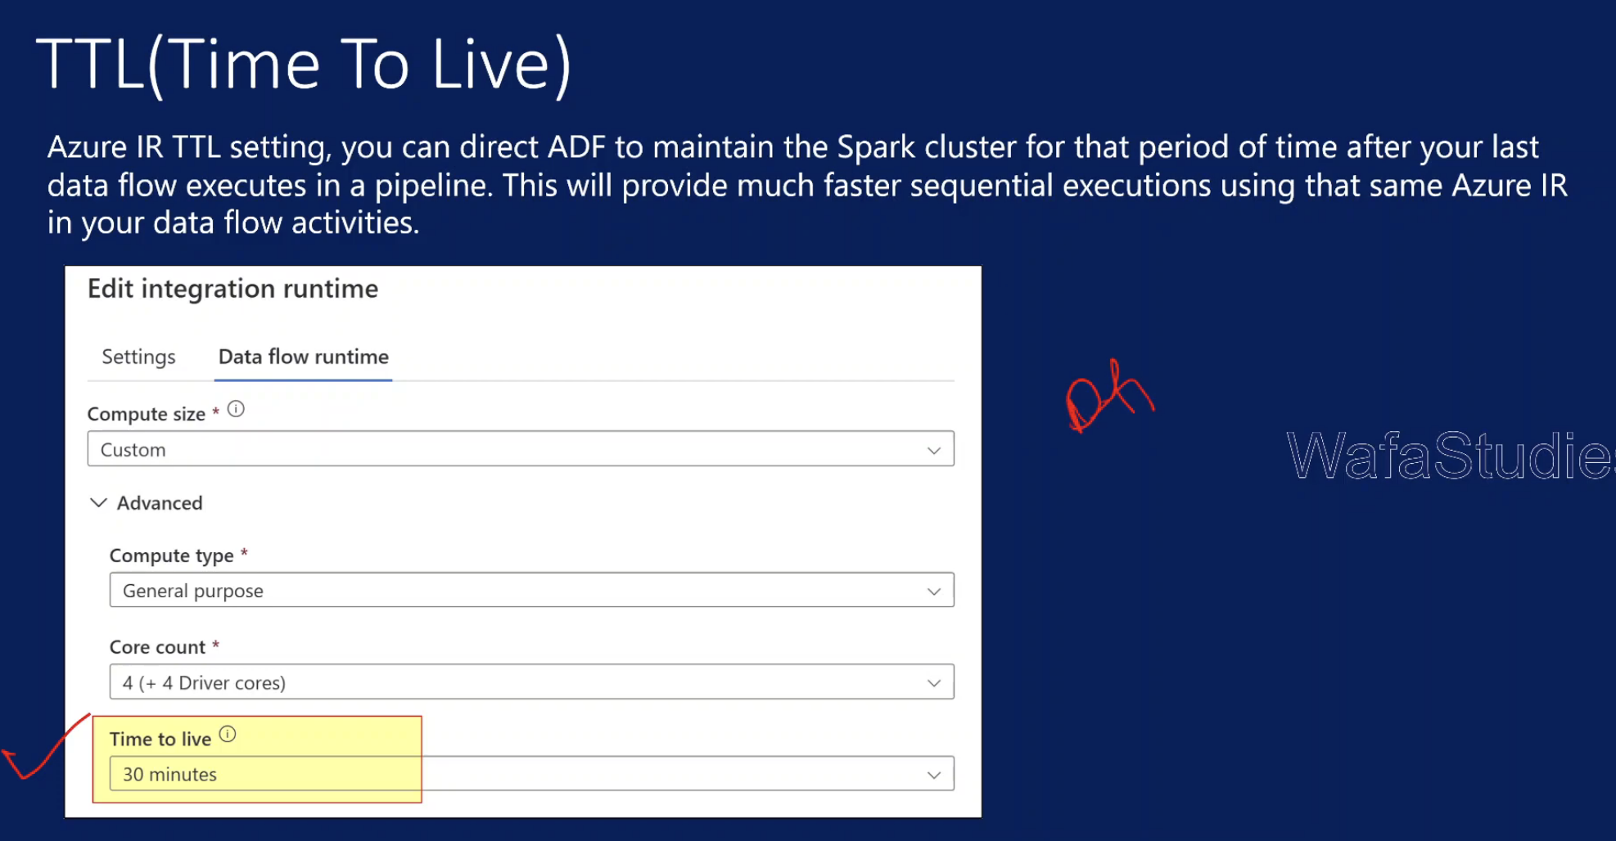

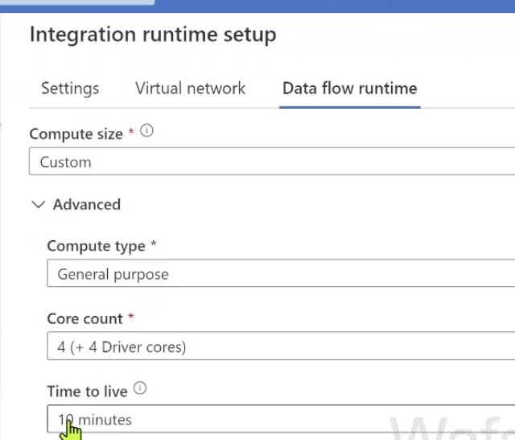

Create Alert Rule:

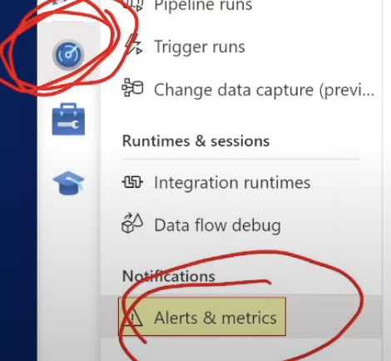

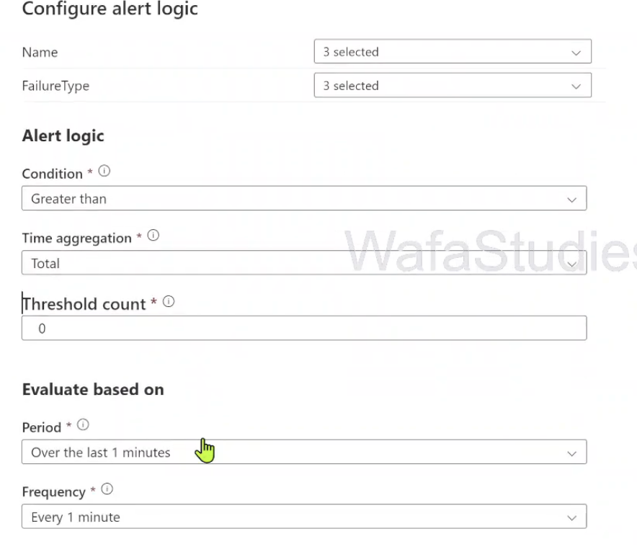

Pipeline Set value:

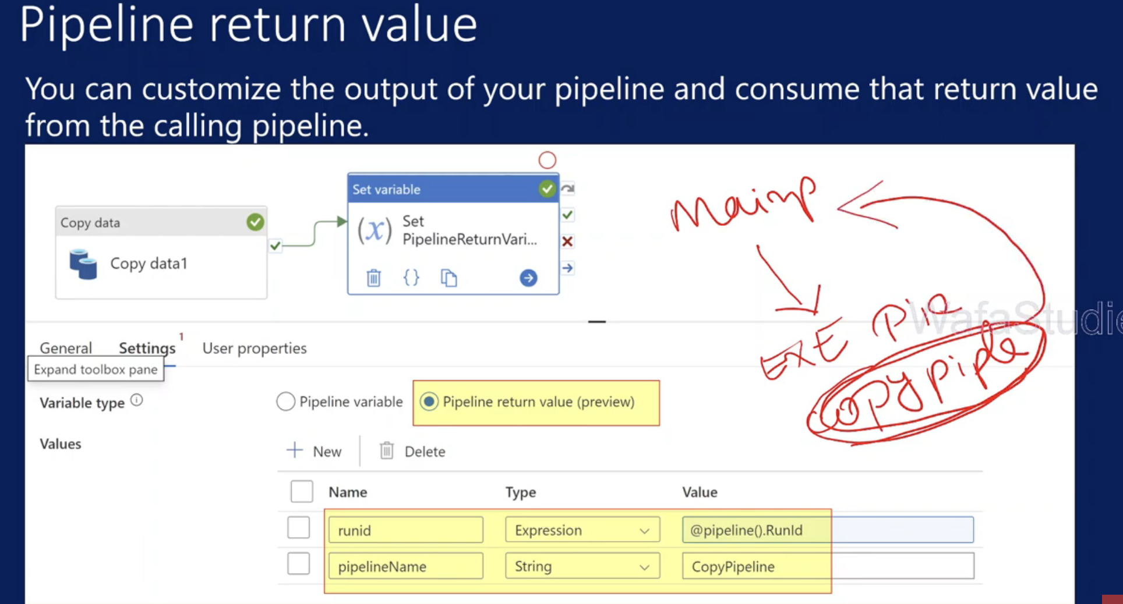

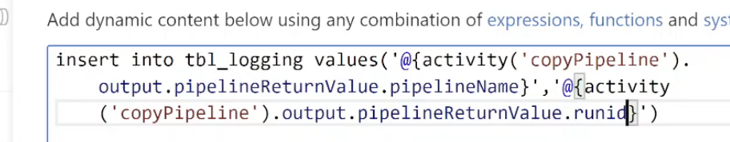

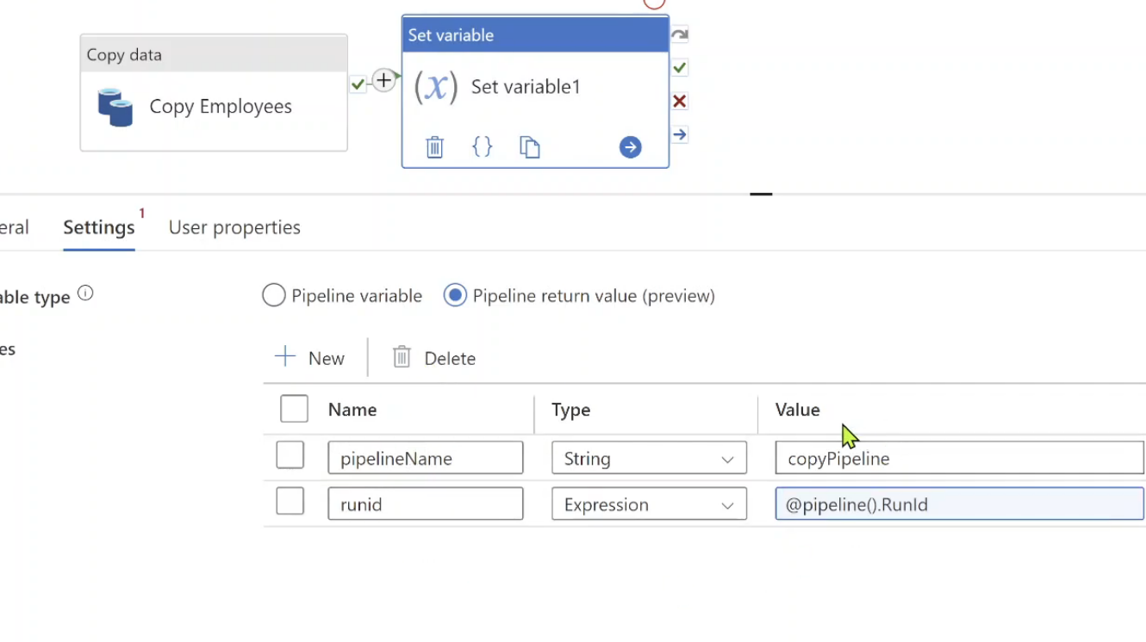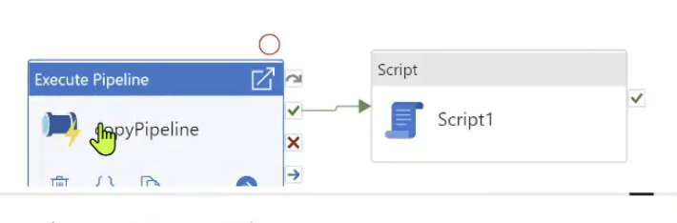

Copy Activity Pagination Rules:

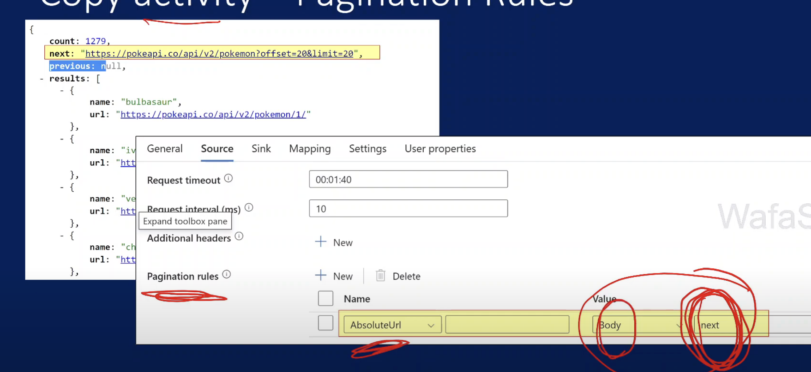

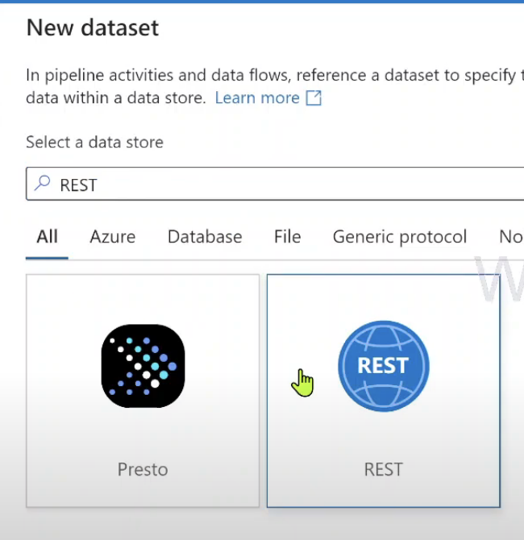

Pagination with Query Paramter

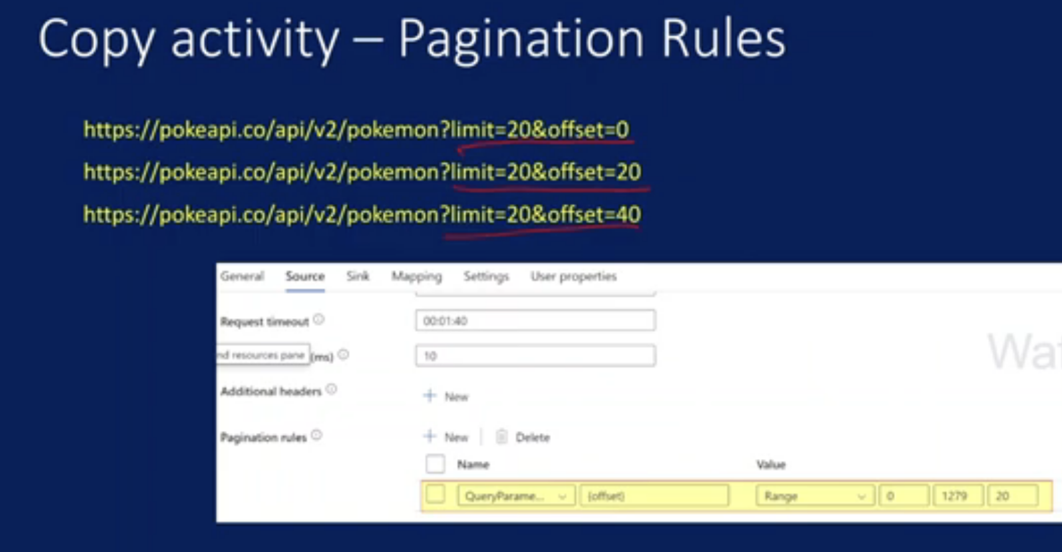

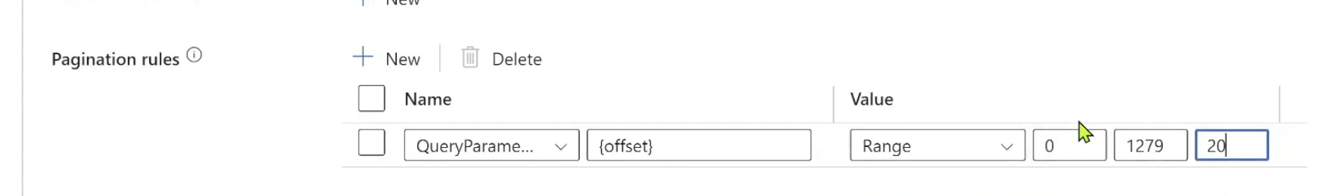

CDC Change Data Capture:

CDC Means any incremental changes in source table needs to be reflected in destination table as well

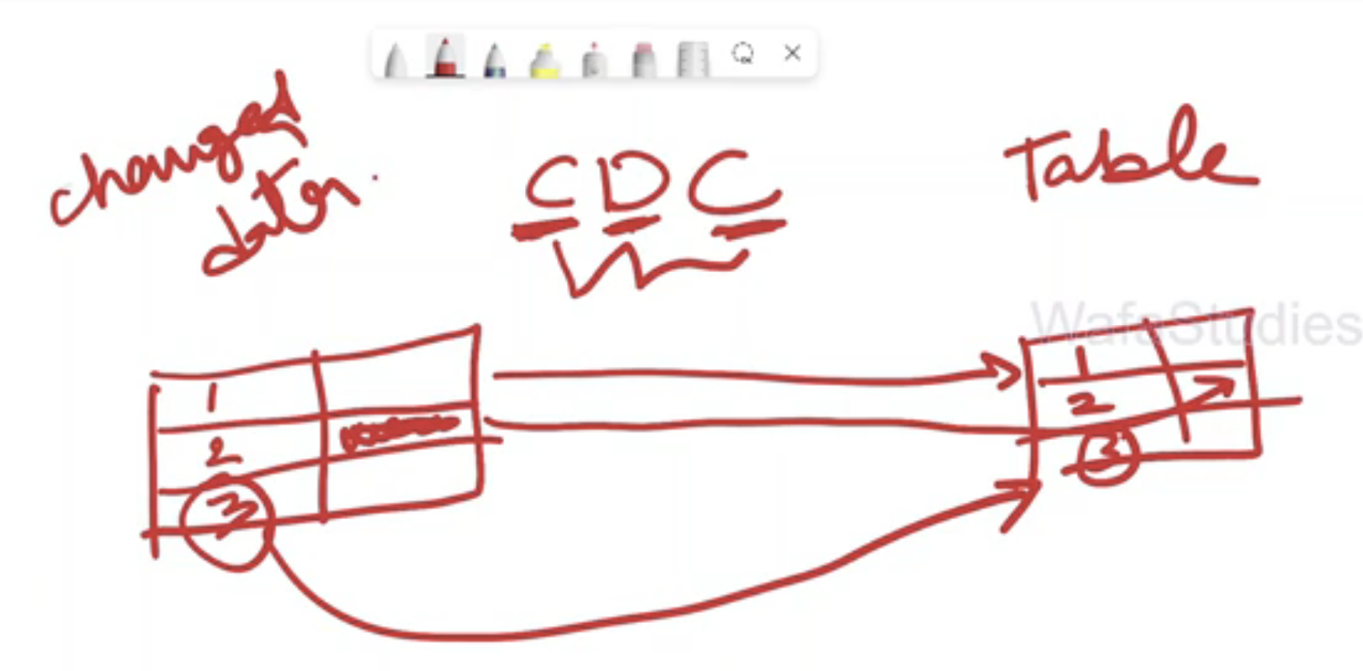

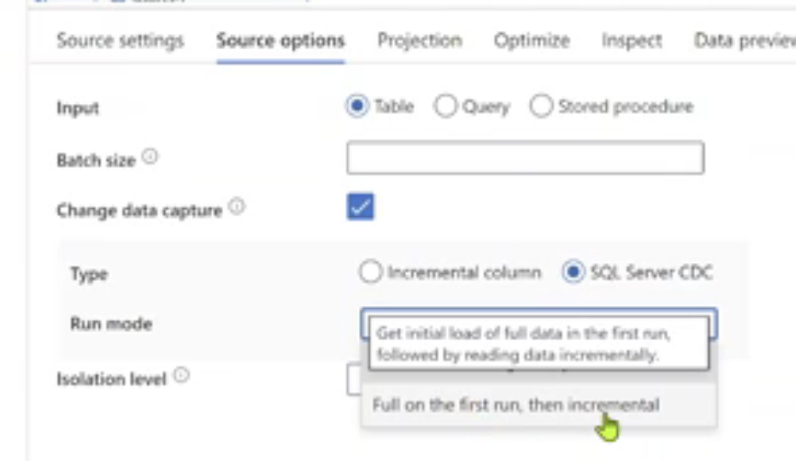

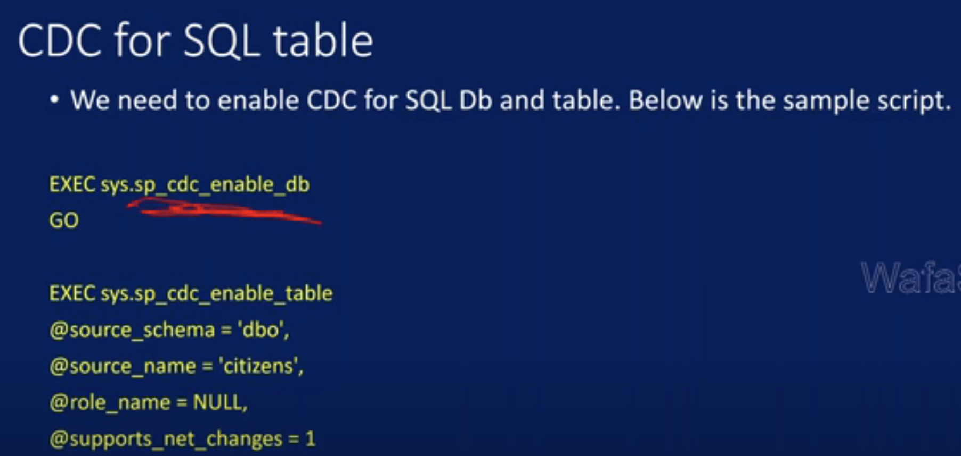

CDC resource:



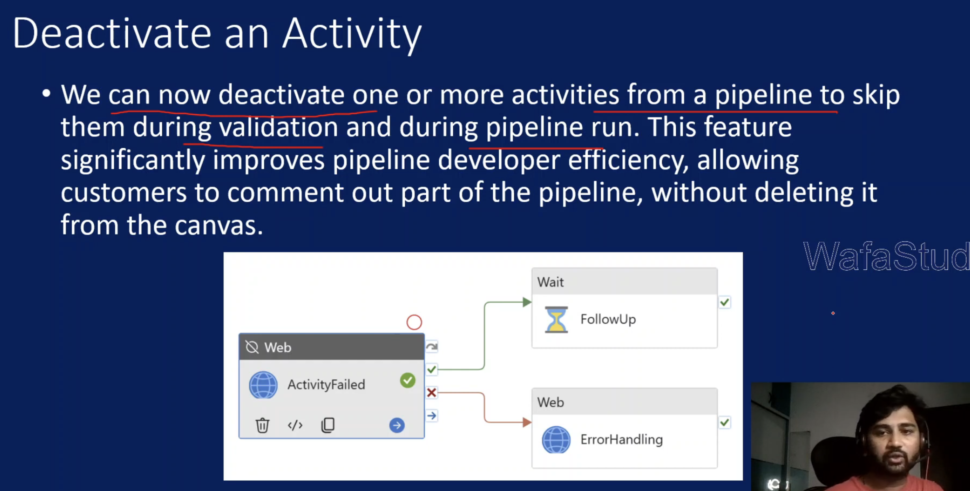

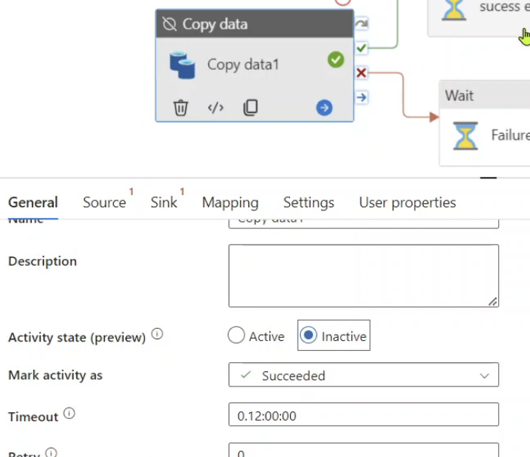

Managed Virtual Network  
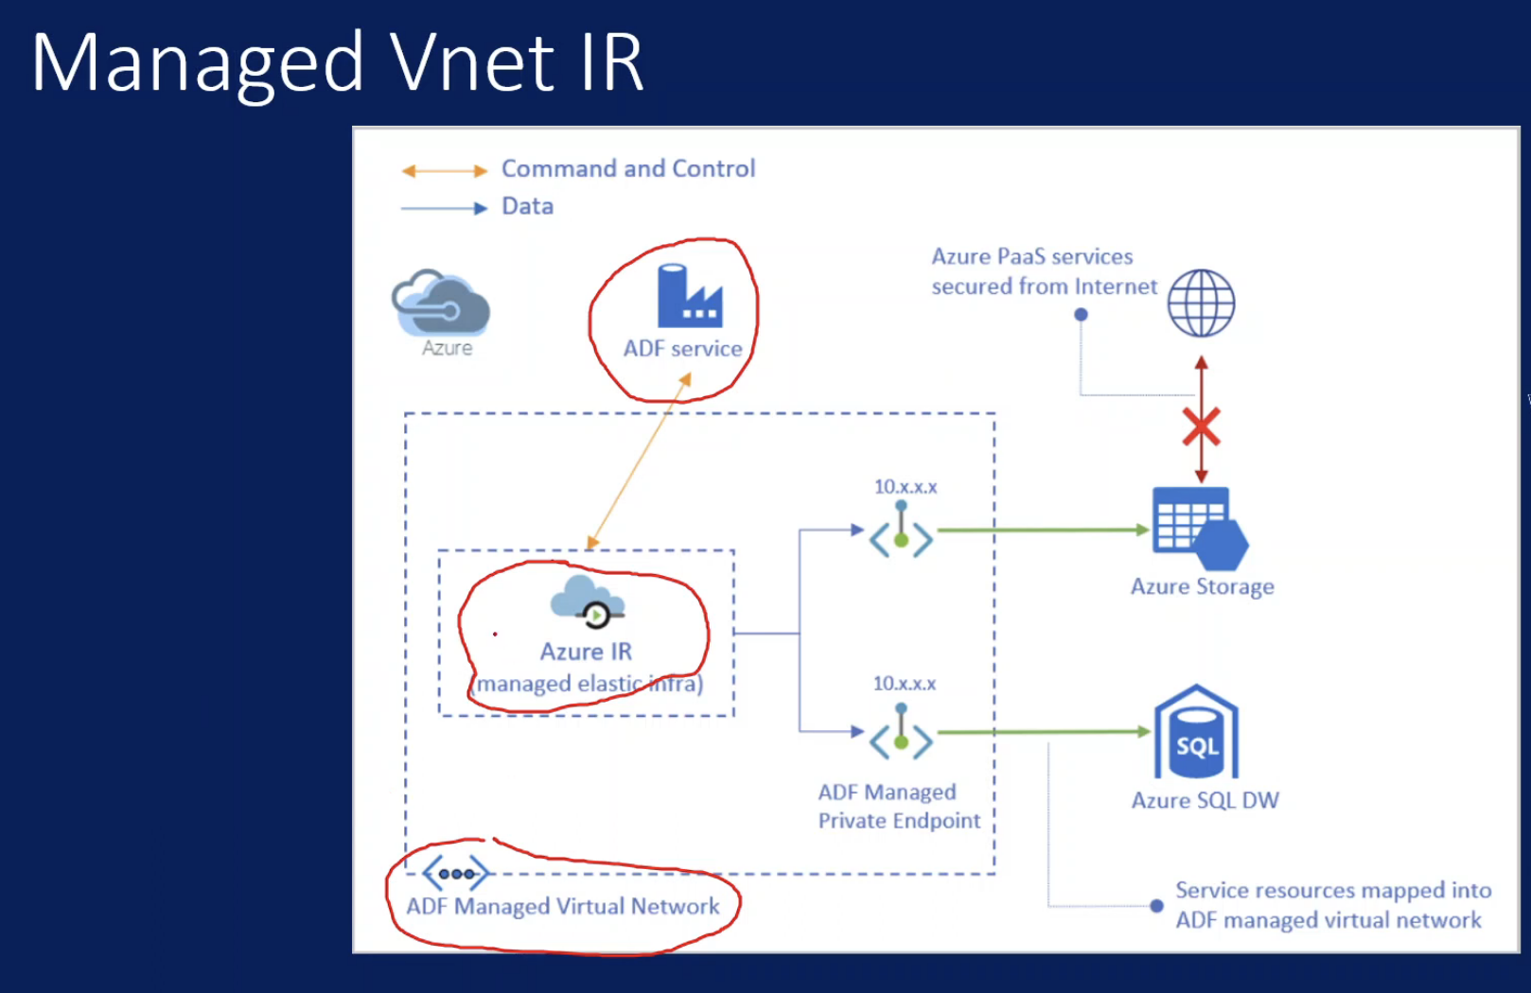

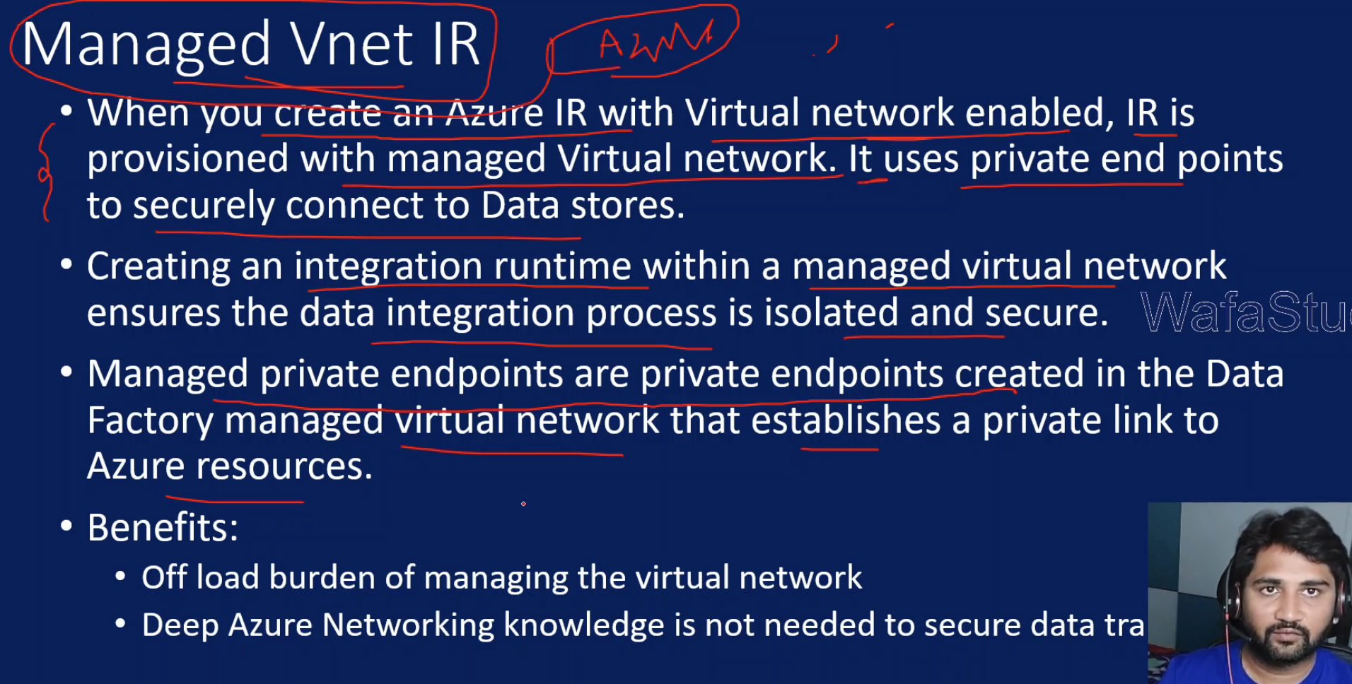

IR & ADF should be in same region

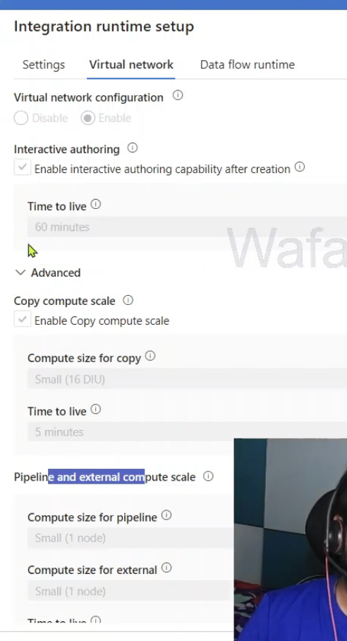

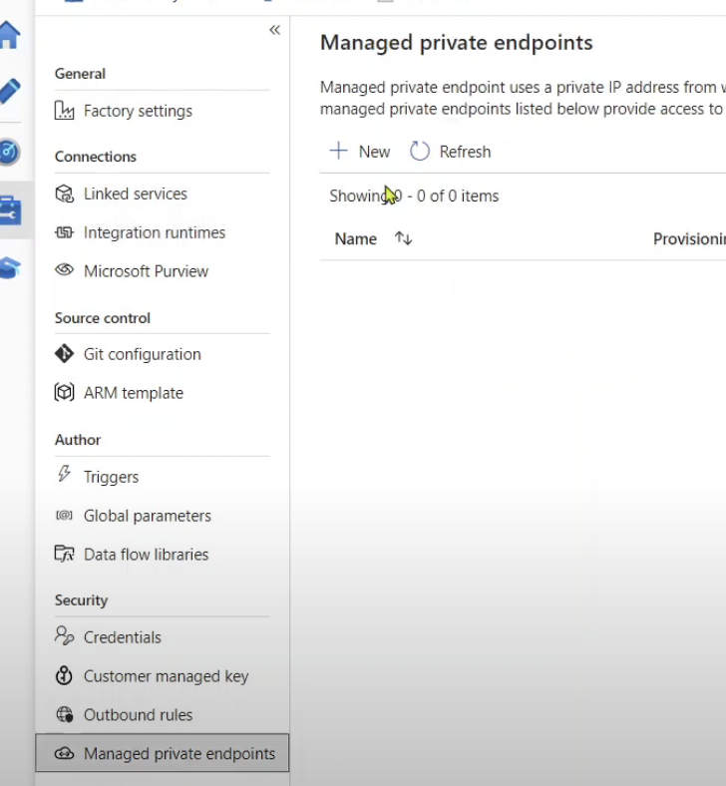

We need to create managed endpoints as well

